1.INTRODUCTION

1.1.PURPOSE OF THE SYSTEM
We provide recruitment classifieds and related services to job seekers and Corporate Customers, (employers and recruitment consultants) on our website, We provide recruitment classifieds and related services to job seekers and Corporate Customers, (employers and recruitment consultants) on our website. Job seekers can upload their resumes on our website. We provide assistance to job seekers in preparing resumes and listing them on our website. For our employer and recruitment consultant customers, we list / advertise - their job vacancies, provide tools to conduct searches in our database of resumes and provide job application screening programs.
The Requesting job recruitment classifieds system is a searching of good job which in turn helps to hire the right qualify of workforce into the organization with services many job recruitment sites in India, with more than 1000 sites and serving more than 50,000 jobseeker and employer. The job revruitment sites still uses an obsolete, terminal-oriented job recruitment classifieds system that has limited the operation expansion and growth, due to telecommunication limitations, lack of interactivity between users and system, high system maintenance costs, poor or inexistent support from some product vendors, as well as a very expensive learning curve for the new users. The new administration’s strategic plan for the next five years focuses on a statewide coverage expansion, but such expansion will be unreachable if the system does not count with a new system strong enough to support the expected high volume operations. The purpose of this system will be reengineer the current system, bringing new technology to the existing one, and one of the main purposes of conducting job sites is to prepare job description and job specification which is turn helps to hire the right quality of workforce into the organization. The general purpose of job sites is to document the requirements of a job and the work performed. Jon and task is performed as a basis for later improvement, including definition of job domain, describing of job, developing performance appraisal, selection system, promotion criteria, training needs assessment, and compensation plans. And the best and most up-to-date advice from genuine job search and career experts. The focus is on avoiding scams and protecting Jobseeker privacy.

1.2.SCOPE OF THE SYSTEM
The system will implement all the necessary functions to perform the right job search and post job from the employer to the jobsite, primarily focused on the jobsite’s expansion planning for the future, being able to support high volume operations. As part of the reengineering process, it will implement improved window user interface, which will redound in a user-friendly environment, both for the Jobseeker as well as for the employer that will access the job site interface that will be built as a part of the solution. The new system will be implemented over the newest network technologies, to enable the job site to perform its expansion strategy conceived for future. This feature will open the doors to integrations with business partners and clients.

1.3. CURRENT SYSTEM
The current system is a limited no of companies add in job recruitment site family based application, in current system collect resume, and collect personal information from visitors and communicate with Jobseeker. Some time not matched profile jobs prefer to Jobseeker and this way not to calculate Jobseeker capabilities.
The current system does not support any direct interactivity between the Jobseeker and employer. All the operations have to be done through an employer only in a based on Jobseeker profile. It has been a competitive disadvantage against other system.

1.4. PROPOSED SYSTEM
The new Job recruitment classifieds System will be developed to satisfy the functional and nonfunctional requirements described below. It will implement all the necessary features to record all the searching operations and transactions performed by both employer and Jobseeker. It will provide a new easy to use user interface, and to provide the most comprehensive listing of employer page links, the best internet-accessible legitimate job search resources and services on the web and best and most up-to-date advice from genuine job search and career experts, and services through the World Wide Web or other secure network communications systems.

2.OBJECTIVE
The objectives of the new job recruitment classifieds system are:
• Develop a new, robust and flexible informatics infrastructure to support the job searching system’s expansion, in terms of high-volume operations.
• Provide the capability to expand add the number of companies in our family, relying on a flexible and cost-effective network.
• Provide a versatile system to manage and record job for Jobseeker management and his resume transactions.
• Build up a brand new job recruitment site interface to attend the Jobseeker and employer through the World Wide Web.
The Job recruitment System project is accepted if at least the following criteria are satisfied:
• The Job recruitment System satisfies the functional requirements.
• The nonfunctional requirements are also satisfied.
Thus summary of my project’s objective is as follows:-
- One can easily view the important date and the event.
- To provide information about a particular time & date...
- To provide secure mode logging.

Thus summary of my project Report objective is as follows:-
- Define the SDLC (software development life cycle) for our project like – requirement analysis, system design, software development/coding testing and documentation with an overall emphasis on the development of reliable software systems. The primary emphasis of the work is to understand and gain the knowledge of the principles of software engineering practices, and develops good understanding of SDLC.
- Use the (DFD, Database Design and ER Diagrams) as analysis technique.
- Also define the complete structure of the project which includes database design and all the jsp pages.
- Process logic of each module
- Number of modules and their description to provide an estimation of the project
- Number of jsp pages and their use, input and output screens and coding.
- Implementaion of the project their will be following layer
    - DB layer (RDBMS)
    - DAO layer (Data access object)
    - Business component layer
    - Work flow layer
    - Presentation layer
- Reports generation
- Testing techniques
- Security procedure
- Input and output screens
- Tools/platform, hardware and software requirement specifications.
- Risk management
- Maintenance of the software.
- Limitation of the project
- Future scope and further enhancement of the project
Bibliography
3.TOOLS/ENVIRONMENT USED
TOOLS USED FOR DEVELOPMENT OF THIS PROJECT ARE AS FOLLOWS:
TOOLS USED:
- HTML,css,jQuery
- DHTML
- JAVA SCRIPT
- SDK, Java 2 Technology Edition, v6.0 SR2
- JSP,java beans
- Macromedia Dreamviewer EDITOR (for design the web page)
- MyEclipse 6.0
- MySql Server 5.5
- Internet Explorer 8.0 SP2 web browser,google crome
- Apache tomcat 6.0.X web server

PLATFORM USED:
- Windows XP

SYSTEM REQUIREMENTS FOR SERVER
SOFTWARE REQUIREMENT:
- Microsoft Windows XP Professional with SP2
- SDK, Java 2 Technology Edition, v6.0 SR2
- Internet Explorer 8.0 SP2 web browser or any Java enabled web browser
- MySql server 5.5
- MyEclipse 6.0
- Apache tomcat 6.0.X web server or any java enabled web server

HARDWARE REQUIREMENT:
- Main Processor Pentium IV
- Hard-disk Capacity 8 G.B
- RAM 256 MB
- Clock Speed 2.8 Hz
- Floppy Drive: 1.44MB
- Keyboard 104 Key
- Monitor V.G.A
- Mouse optical

SYSTEM REQUIREMENTS FOR CLIENT (USER)
SOFTWARE REQUIREMENT:
- Microsoft Windows XP Professional with SP2
- Internet Explorer 8.0 SP2 or any java enabled web browser

HARDWARE REQUIREMENT:
- Main Processor Pentium IV
- RAM 256 MB
- Clock Speed 2.8 Hz
- Floppy Drive: 1.44MB
- Keyboard 104 Key
- Monitor V.G.A
- Mouse optical

4.SYSTEM ANALYSIS
4.1.Identification of need
There is lots of problem faces by job seekers and employers now without recruitment services. Job recruitment system provides a plateform to communicate in one place job seeler and recruiter. Online recruitment classifieds and related services provide facility to search right job any time any where without go out side of any office and also recruiter acess job seeker resume any time and give and manage response of their request.without online recruitment classified we can not think about work independent.job recruitment system provide the facility to business man they have not time to search job with him during business hour.job recruitment system provides two more facilities such as message and email alert this maks the job recruitment in pocket.without this system you contact with your consultant every time and get update but help of this system you get every day news alart of your job related. And apply in a minute and bulid your career with your capable job. And recruiter also work easy and fast. So we can say that we need the job recruitment system for fast moving life.

4.2.Preliminary investigation
I start the investigation from the web site (www.naukri.com, www.Timesjobs.com )
after investigating the web site working procedure we find the following requirements,

SRS (software requirement Specification)and SDLC (software development life cycle)
SRS: I use the SRS for developing our project because the requirement analysis involves obtaining clear and through understanding of the project to be developed. Thus, SRS should be consistent, correct unambiguous and complete document.
The SRS outline is given below:
- Introduction
- Overall Description
- Specific requirement
- Supporting information

SDLC: the Software Development Life Cycle (SDLC) paradigm will apply to study and computerize the existing system. SDLC is a simple approach to designing a project. I use the prototype model for our analysis. In this model after completing the one step we get into the second step. I define the SDLC (software development life cycle) for our project like – requirement analysis, system design, software development/coding testing and documentation with an overall emphasis on the development of reliable software systems. The primary emphasis of the work is to understand and gain the knowledge of the principles of software engineering practices, and develops good understanding of SDLC.

System/Information Engineering
Analysis
Design
Code
Test
Prototype model

REQUIREMENTS OF JOB RECRUITMENT SYSTEM
Administrator:
- Administrator can manage job seekers and employer and also their works.
- Administrator can keep track of things that are going around.
- Administrator does the backup of the system for safety purpose.
- Administrator will have to take action when there is a problem in network.
- Administrator can solve the doubt of the staff if they face any.
- Administrator are responsible for give service number to employer for activate your services.

Employers:
- Employers can register in the system, and get service no to activate your registration.
- Employers can create sub user to manage your work.
- Employers can delete sub user to manage your work.
- Employers can post job to find right candidates.
- Employers can search or access resume of job seeker.
- Employers can manage or give response of their request or resume.
- Employer can contact candidate or job seeker for futher comunication.
- Employer can manage your account just like update your detail and about your company.

Job seekers:
- Job seekers can register itself in the system.
- Job seekers can search job related given data.
- Job seekers can view your job related your profile.
- Job seekers can apply job to make your career.
- Job seekers can update your profile time to time.
- Job seekers can block companies to avoid useless message and email alert.

FUNCTIONAL REQUIREMENTS
The Job searching system will have three basic types of users:
• The Jobseeker will have the register your self and searching job and apply them. And also build a profile and time to time update it. Jobseeker can block companies who many time disturb to Jobseeker.
• The Employer will be responsible for signup in the system and post jobs, access information of Jobseeker and manage their response.
• The system administrator will be responsible of creating the new accounts for Jobseeker, Employer.

NONFUNCTIONAL REQUIREMENTS
Usability requirement: The system has to be user-friendly, and easy to learn and use.
Security requirement: Considering that the client is a financial institution, the network security will be considered as one of the priorities.
Reliability requirement: The system should be highly infallible, fault traceable and transaction-based.

Constraints (“Pseudo requirements”)
Implementation requirements: The system is required to run over window-related operating systems.
Legal requirements: The software will be licensed per branch office running the system, without considering the number of computers on each branch office.
Interface requirements: The user interface will be web-based both for branch employees and for customers. The branch employees will be provided with a user guide document.

HARDWARE REQUIREMENTS
Hardware requirement for this project is a domain name and broadband internet are most important, the system should require PC with internet, FireWall for Network Protection,Hub, switch,and other networking HardWare.
SOFTWARE REQUIREMENTS
Software requirement for the user is normal but should be connected through intranet and the system have web browser. All the task are performed on server, so server need a web server DataBase and working on tcp/ip protocol.

LOGICAL DATABASE REQUIREMENTS
The Logical Database requirements are Database should run on the server.
4.3.Feasibility Study
Technical feasibility

The project Job recruiment management System is technically feasible because we develop a web project and use the java plateform. We know that the java is a most secure programming language for developing web project we can do any web project in java server programming, we can easily design the jsp pages in html with client side scripting with javascript,and run the jsp pages on java enabled web server I use the Tomcat 6.0 web Server.So we can say that the project is technical feasible.

Economic feasibility

The job recuriment project runs on web server or internet, system want to provide facility to his candidates on any way so if we do the cost analysis then the cost of the project is suitable for any job consultant and we see that this type of project runs on inetrnet world wide, so we can say that this project is economically feasible.

Operational feasibility

The job recruitment project is Operational feasible because this project is runs on internet all over the world without any problem this project is beneficial for both job seekers and employer all the working procedure of consulting can be done with this web project. system security, services,Accuracy checked So we can say that this project is operationally feasible.

Time feasibility

I have enough to working with this project so this is time feasible.

4.4.Project planning and scheduling

GANTT CHART OR TIME LINE CHART
Gantt chart is used for the time estimation of the project. A tabular form is maintained where rows indicate the task and column indicates duration. The horizontal bar that spans across column indicates duration of the task.

Phase | Task | 1st month |  | 2nd month |  | 3rd month |  |  | 4th month
I | Requirement analysis
II | Database Design
III | Interface Design
IV | Coding
V | Quality assurance
VI | Test cases
VII | Testing
VIII | System security
IX | Implementation

GANTT CHART FOR ONLINE REMINDER

4.5. control flow diagram, ER diagram, use case

4.5.1.DFD (data flow diagram)
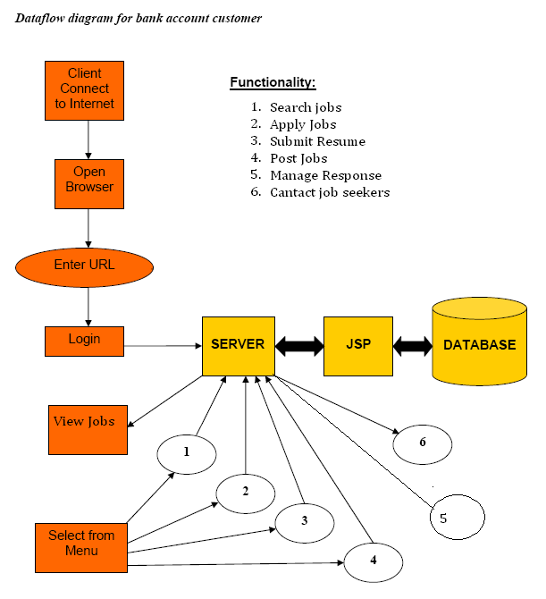
Context level DFD

Jobseeker
Employer
Registration
Login
Context level DFD for (job recruiment system)
Data store
Job Recruitment System
Admin
Search Job
Apply Job
Post Job
Update Resume
Access Resume
Manage Response
First level DFD:
DFD for Registration
Jobseeker
Employer
Registration
Give permission
Give conformation
Data store
Check availability
Job recruiment System
Admin

DFD for job search and apply
Jobseeker
Employer
Search Job
Access Resume
Give conformation
Apply job
Data store

DFD for Post Job
Employer
Jobseeker
Post Job
Browse job
Data store
Job searching System
Access Resume
Access Resume and Manage Response
Employer
Jobseeker
Access resume
Apply job
Manage response
Data store
Job searching System
Upload resume
Jobseeker
Create resume
Upload resume (.doc,.pdf)
Data store
Profile
Jobseeker
4.5.2.USE CASE DIAGRAM
In Job Recruitment System, the actors are as follows:
1.Administrator
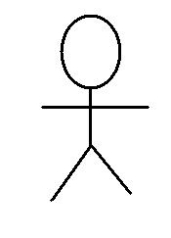 The administrator is the one who is responsible for all the administrative work. He is also responsible for all the backup of the system. He is the one who also looks after the network problems. He can add, edit and delete employer and job seeker profiles, perform functions of employer if they face any problem and solve all the employers queries.
2.Employers
The Employers is the one who is access the feature of system. Employer have right to post job, manage response. Employer have also additional right create,edit,delete sub user to manage your work. The main goal of employers is to manage all the request and resume of job seekers and provide them their best services.

3.Job seekers
The job seekers is the one who can check your account and view your job. He is one who does register in the system, search jobs, apply jobs, submit resume, update resume, block companies etc.

Job seeker reg
Post job
Create sub user
Employer reg
Registered company
Login
Search job
Apply job
Update resume
Search resume
Manage response
Employer
Job seeker
Administrator
<<extends>>
<<includes>>
Overall use case diagram
Now the scenario or use cases (i.e. the functionality) of the system are as shown below:

UC-01) Name:Job seeker sign up
Description: Facilate sign up of job seekers
Actors: Job seekers
Steps:
- job seekers provides login info, first name,
Last name, mail id etc.
- A validation link is sent to jobseeker mailid.
Success condition | Job seeker valid mail link.
Trigger | According to the need of job seekers.
Failure condition | Mail link is not validated.
Exception  (optional) | Mail link is not validated.

UC-02) Name:Employers sign up
Description: Facilate sign up of employer
Actors: Employer
Steps:
- employer provides login info, first name,
Last name, mail id, company name, industry type etc.
- A validation link is sent to employer mailid.
Success condition | employer valid mail link.
Trigger | According to the need of employer.
Failure condition | Mail link is not validated.
Exception  (optional) | Mail link is not validated.

UC-03) Name:Manage user and sub user
Description: Administrator or employer are responsible for adding/editing/deleting user,sub user profile.
Actors: Administrator or employer
Steps:
1.Identify employer or administrator by login. 2.Perform task according to need.
3.Check whether the profile is updated or not.
Success condition | The profile of sub user gets updated.
Trigger | According to the need of administrator or employer.
Failure condition | The profile of user does not updated.
Exception  (optional) | The profile of user does not updated.

UC-04) Name: Take action if network problem
Description: Administrator will take action on any network problem.
Actors: Administrator
Steps:
1. Identify administrator by login.
2. Take action on any network problem.
3. Check whether the problem is solved.
Success condition | The network problem will be solved.
Trigger | If there is any network problem administrator has to react.
Failure condition | The network problem will not be solve.
Exception  (optional) | The network problem will not be solve.

UC-05) Name: Perform functions of employer.
Description: Administrator will perform task of employer if they face any problem.
Actors: Administrator
Steps:
1. Identify administrator by login.
2. Take action on any network problem.
3. Check whether the problem is solved.
Success condition | The problem faced by employer will be solved.
Trigger | If there is any problem faced by employer, administrator helps them.
Failure condition | The problem faced by employer will not be solve.
Exception  (optional) | The problem faced by employer will not be solve.

UC-06) Name: Perform system backup.
Description: Administrator will be responsible for system backup.
Actors: Administrator
Steps:
1. Identify staff, administrator or customer
2. Administrator will start system backup for security purpose.
3. System will be backed up.
Success condition | The backup of system is successfully.
Trigger | Administrator will do system backup for security purposes (ex. System crash).
Failure condition | The backup of system is unsuccessful.
Exception  (optional) | The backup of system is unsuccessful.

UC-07) Name: Update profile
Description: job seeker or employer are responsible for update profile.
Actors: Job seekers and Employer
Steps:
1. Identify employer,job seekers.
2. Perform task according to need.
3. Check whether the profile is updated or not.
Success condition | The profile of employer or job seekers gets updated.
Trigger | According to the need of administrator, employer or job seekers.
Failure condition | The profile of employer or job seekers does not updated.
Exception  (optional) | The profile of employer or job seekers does not updated.

UC-08) Name: Search job
Description: job seeker search job according to profile.
Actors: Job seekers
Steps:
1. Identify job seekers have update profile.
2. Perform task according to need.
3. Check result is perfect or not.
Success condition | Perfect job list display on the screen.
Trigger | According to the result job seekers apply job.
Failure condition | Outdated job list display on the screen.
Exception  (optional) | Outdated job list display on the screen.

UC-09) Name: Apply job
Description: job seeker apply job based on searched result.
Actors: Job seekers.
Steps:
1. Identify result is valid and updated.
2. Perform task according to need.
3. Check job have applied or not.
Success condition | Show message successfully applied.
Trigger | If problem comes contact administrator.
Failure condition | Show message unsuccessfully applied.
Exception  (optional) | Show message unsuccessfully applied.

UC-10) Name: Post job
Description:Employer are responsible for post job.
Actors: Employer
Steps:
1. Identify title, date, qualification, experience, location, description are given.
2. Perform task according to need.
3. Check whether job are posted or not.
Success condition | Show message your jobs successfully posted.
Trigger | If problem comes contact administrator.
Failure condition | Show message your jobs unsuccessfully posted.
Exception  (optional) | Show message your jobs unsuccessfully posted.

UC-11) Name: Search resume
Description: employers search resume according to requirement.
Actors:Employer
Steps:
1. Identify employer have requirement.
2. Perform task according to need.
3. Check result is perfect or not.
Success condition | Perfect resume list display on the screen.
Trigger | According to the result employers contact job seekers.
Failure condition | Outdated resume list display on the screen.
Exception  (optional) | Outdated resume list display on the screen.

UC-12) Name: Manage Response
Description: Employer are responsible for manage response.
Actors: Employer
Steps:
- Identify job seekers is qualified and eligible.
2. Perform task according to need.
3. Send your detail for futher communication.
Success condition | Show list of job seeker whose you sent the detail of job and contacts.
Trigger | According to the need of employer or job seekers.
Failure condition | Job seeker is outdated.
Exception  (optional) | Job seeker is outdated.

Use Case Diagram
Administrator
Manage Employer and Job seekers
Take action if network problem
Give response of quries
Perform function of Employers
Perform system backup
USE CASE DIAGRAM FOR ADMINISTRATOR

Manage sub user
Update profile
Post jobs
Serach resume
Manage Response
Register or sign up
Employers
USE CASE DIAGRAM FOR EMPLOYERS
USE CASE DIGRAM FOR CUSTOMER
Job seekers
Registration in system
Sign Up
Update Profile
Search Job
Apply Job
Block Companies
4.5.3.ER DIAGRAM
Jobseeker
Create
Profile
Has
Job Location
Has
Industry type
Search job
Post job
Job

Function Area
#User id
Password
Name
Address
Contact no
Job title
Info
Resume
#Sr no
Location
Name
#company id
DOB
Has
Fname
Company
Employer id
#Fcode
Employer
Company name
Name
#Industry id
Has
Has
Has
Has
#User id
Password
Name
#Sr no
City
State
Country
#Job id
Description
Description
Industry type
Description

4.5.4 System Layer
Implementation of the project their will be following layer

1) DB layer [RDBMS(Mysql)]
DB layer manage the relation among table eith the help of relational database server.

2) DAO layer
DAO design pattern is used to centerlized the access od data in an application. A DAO represent a class which provide method for persisting business object as well as for obtaining and changing the state of business object.
In an application same business object may be used in different use cases.
When DAO design pattern is used DTO(data transfer object)
Are also used.
DTO represent a simple java bean which contain data of a domain object. DTO are used to transfer data from one layer to another.

Following is the work flow of persistant operation using DAO and DTO.

Business Component
DAO
DTO
DB
DAO is asked to save the data of DAO
Control persistence, or as interface to the database
1.0 A data transfer object is created
Data is persisted
1.1 Save();

3) Business component layer
In each use case certain business rulr are to be satisfy
In the submission of a post some resipient or group is to be selected and their must be some sender.
Usually implementation of business component is provided in the form of java bean which contain business method. Each business method represent the implementation od use case.

4) Work flow Layer
Each request involves some sequence of steps which must be fulfill in order to process it. The component which control the sequence of request processing is called work flow manager. Usually in web application work is control with the help of servlet of filter.

5) Presentation layer
Presentation layer is responsible for presenting the data to the end user, that is this layer responsible for generating for view.
Usually java based application layer is implement in the form of JSP pages.

Following sequence diagram describe all the major component and their intraction from the point of view user sign up use case.

Sequence Diagram of user sign Up
End user
Controler servlet(work flow)
User manager(BC)
User (DTO)
User DAO(DAO)
UserHome JSP(view)
DB
1.0 signup form is submitted
1.1 using the form data DTO is populated
1.2 Business component is asked to handler user sign up
1.3 business component asked to DAO user data to persist
1.4 User data is fetched
1.5 User data is saved
1.6 Name of view component is provided
1.7 View component is invoked
1.8 View is generated for the end user
5.SYSTEM DESIGN
5.1.Modularization Details
Modules and their description
There are mainly three modules
Administrator module
1) Manage employer and job seeker Module: This module manage the operation of employer and job seeker function and their quires. Give activation key to employer to activate employer account. Help of this key employer take facility of all services.
2) Industry and functional area module: Industry and their functional area module help to add, change and increase of functional area and industry type. Help of indurty and functional area you you search a perfect job for your career.
3) Response a problem Module: Reponse a problem module manage and give response of job seekers and employer problem. This module works as a feedback services.
4) User Access Log: Administrator can check the user access Log file when and how many users login the system.

Employer Module
5) Registration Module: Registration module manage the operation of all type of new registration in the system, such as new employer who want to enjoy exclusive service of job recruiment system.
6) Post job Module: Post job module manages the job post by employer such as latest requirement in company inform to jobseeker. This is done by employer. Job contains title, date, expired date, eligibility, description, location etc.
7) Access resume Module: Access resume module manages the resume by employers such as to check jobseeker is qualified to this job. Access jobseeker profile and resume under your requirement.
8) Manage response Module: Manage response module are responsible for replay to the jobseeker about job related information. And send email for information of further activity.
9) Create sub user module: create sub user modele employer manage your work. With the help of this module employer create, edit, delete sub user.

Job seekers Module
10) Registration Module: Registration module manage the operation of all type of new registration in the system, such as new job seekers who want to enjoy exclusive service of job recruiment system.
11) Search job Module: Search job module manage the operation of job search related queries such as search by company, location, function, category and government jobs etc.
12) Apply job Module: Apply job module manages the applied job related task such as match your profile jobs to apply.
13) Update resume Module: Update resume module works on gathering the latest information about your profile, and update latest information.
14) Report a problem Module: Report a problem module provides the environment for every jobseeker and employer to report a problem and your queries about this system.

5.2.Data Integrity and Constraints
In this project we use the data Integrity of database as like the JobID, userID, LoginID, should be unique. Data Integrity is for accuracy and reliability of data.
Data Integrity ensures that information cannot be modified in unexpected way.Loss of data integrity could result from human error, intentional tampering, or evencatastrophic events. Failure to protect the correctness of data may render datauseless, or worse, dangerous. Efforts must be made to ensure the accuracy andsoundness of data at all times. Access control, encryption and digital signatures arethe methods to ensure data integrity
For this the accuracy of data I use the select option list on my web page to select any Date (dd, mmm, yyyy), Time (hh, mm, AM/PM), country etc. Where the user cannot add the other field.
All the tables have the constraints Primary Key, Foreign Key.
In all the table we define the primary key and foreign key.where the foreign key is the reference to the other table primary key.if the primary key value exist then this field accept the value other wise this field reject the value.
We show all the Primary key, foreign keys and NOT NULL property. In Database Designing I use the RDBMS so all the tables’ works on Relational database management system.
Any user must login before doing any operation.if a user have not valid userid and password then the user can not proceed.if the user type the address of the page to the address bar of the browser without login then “unauthorized user” page will be displayed.
5.3.Database Design
TABLES
- Login detail table
- User type
- User profile detail
- Job type
- Job detail
- Industry type
- Employer profile detail
- Company type
- Company detail
- Job location
- Functional area
- Report problem
- University name list

Table’s details

- Login detail table
Column name | Data type | Length
#User Id | int | 4
First name | varchar | 25
Last name | varchar | 25
Email Id | varchar | 25
Password | varchar | 25
User role | int | 20
Hint question | varchar | 50
Hint answer | varchar | 50

- User type
Column name | Data type | Length
#User Type id | int | 5
User Type name | Varchar | 15

- User profile details

Column name | Data type | Length
#serial no | Int | 5
First name | varchar | 15
Last name | varchar | 15
Email id | varchar | 25
Mobile no | varchar | 10
Date of birth | Date/time | 20
Address | Varchar | 50
City | Varchar | 20
Gender | Varchar | 10
Prefer job location | Varchar | 20
Experience | int | 5
Industry | Varchar | 20
Functional area | Varchar | 20
Role | varchar | 20
Basic qualification | varchar | 20
University | varchar | 20
Resume headline | varchar | 20
Resume | blog
Key skill | varchar | 20
Employment status | varchar | 20
Known language | varchar | 20

- job type
Column name | Data type | Length
#job type Id | Int | 10
Job type name | Varchar | 20

- Job detail
Column name | Data type | Length
#Job Id | Int | 5
Job title | Varchar | 50
Company name | Varchar | 50
location | Varchar | 10
Experience | Varchar | 10
Description | varchar | 100
Posted date | Int | 20
- Industry type
Column name | Data type | Length
#Industry type ID | Int | 10
Industry name | Int | 10
Description | Int | 10

- Employer profile detail
Column name | Data type | Length
#serial no | Int | 10
First name | varchar | 15
Last name | varchar | 15
Email id | varchar | 25
Mobile no | varchar | 10
Company name | varchar | 50
Company type | varchar | 20
Address | Varchar | 50
City | Varchar | 20
State | varchar | 20
country | Varchar | 10
Industry type | Varchar | 20

- Company type
Column name | Data type | Length
#Company type id | Int | 10
Name | Varchar | 25
Description | varchar | 50

- Company detail
Column name | Data type | Length
#company Id | Int | 20
Company name | varchar | 50
Company type | varchar | 20
Company functional area | varchar | 25
Company Location | Varchar | 15
Contact no | Int | 15
Address | varchar | 50
- Job location
Column name | Data type | Length
#Serail no | Int | 10
City | varchar | 20
State | varchar | 20
Country | varchar | 20
Description | varchar | 20

- Function area
Column name | Data type | Length
#serial no | Int | 20
Function area name | varchar | 20
Description | varchar | 50
Industry type | varchar | 25

- Report problem
Column name | Data type | Length
#problem id | Int | 10
User name | varchar | 25
Email id | varchar | 25
Post date | Date/time | 20
Queries | varchar | 50
subject | varchar | 25

- Board/university list
Column name | Data type | Length
#serial no | Int | 10
University name | Varchar | 50
Description | varchar | 50

5.4.User interface design
User Interface design deals with personal issues of the software. Interface design is one of the most important parts of software design. It is crucial in a sense that the user interaction with the system takes place through various interface provides by the software product.
- Many user are Novices
- Need ease of use and limited training
- Automatic Monitoring and reporting
We have developed the project on HTML at the front end so the use Interface design is web designing, and client side scripting with JAVASCRIPT which includes many functions and at the backend MySql server 5 so I use the many SQL Reference.
We use the GUI for user Interface design. The advantages of graphical user Interface is.
- Various information can be displayed and allow user to switch to different task directly from the present screen.
- Useful graphical icons and check box, option button and select option reduce typing effort by the user.

The following components are use in our Project for user Interface design.
- Form: - we use two types of form for take information from user and forward to the processing.such as login form,new user form etc.
- Buttons: - I use the button for handle the event such as submit form, login, save changes, delete, reset the form and so on.Buttons may be two types 1)submit and 2)Reset.
- Text Box: - The text box is very important component. We use the text box for show the data after fetching from database and take input from users.the text box may be a password field.
- Hidden: - This is used for such type of field whose value are not show to users but on the page.we use this feature for take the id of reminder which is not visible by users.
- Label: - Labels are use in our project is show the names of other control and heading the form and show the data which is read only the label used to show the data which is read only and user cannot change as like today date.
- Select option: - I use the select option for choose a Item from a list the select option facilitate the user to less typing. Such as select (day month year) from select option.
- Option (radio) Button: - The Option (radio) button we use in the program for selecting one from the many multiple choice. Such as Male/Female.
- Table: - To show all the components or data in a tabular format we use the html tables.
- Division: - To create and align the division.
- Java Applet: - To produce a dynamic effect we use the java applet on our web pages.
- JavaScript alert Box: - for giving the information to the user we use the alert box component.
- CSS :- we use the cascading style sheet for left navigation.
- jQuery: we use JQuery for advance and attractive effect of site design.

6.CODING AND SCREENSHOT

The coding and screen shot are as list below:
Coding Architecture
I have follow nameing and structure convention of class and package name to build a system. Structure of coding are mention below.
Packages are
- com.jobhunt.beans
Job.java
Employer.java
User.java

- Com.jobhunt.dao
JobDao.java
DaoFactory.java
LmsDao.java
UserDao.java
EmployerDao.java

- Com.jobhunt.dispatcher
ControllerServlet.java
CtxListener.java

- Com.jobhunt.managers
UserManager.java
ViewManager.java
JobManager.java
EmployerManager.java

- Com.jonhunt.tages
AddContent.java
ReplaceString.java

- Resources
urlMaping.properties

Coding are:
Job.java
package com.jobhunt.beans;
import java.sql.Date;

public class job {
int jobid;
date doi;
String name,title,location,eligibility,expercience,companyname,description;
public int getJobid() {
return jobid;
}
public void setJobid(int jobid) {
this.jobid = jobid;
}
public date getDoi() {
return doi;
}
public void setDoi(date doi) {
this.doi = doi;
}
public String getName() {
return name;
}
public void setName(String name) {
this.name = name;
}
public String getTitle() {
return title;
}
public void setTitle(String title) {
this.title = title;
}
public String getLocation() {
return location;
}
public void setLocation(String location) {
this.location = location;
}
public String getEligibility() {
return eligibility;
}
public void setEligibility(String eligibility) {
this.eligibility = eligibility;
}
public String getExpercience() {
return expercience;
}
public void setExpercience(String expercience) {
this.expercience = expercience;
}
public String getCompanyname() {
return companyname;
}
public void setCompanyname(String companyname) {
this.companyname = companyname;
}
public String getDescription() {
return description;
}
public void setDescription(String description) {
this.description = description;
}
}

Employer.java
package com.jobhunt.beans;

public class User {
int id;
String loginId,password;
int role;
public static final int jobseeker=1;
public static final int admin=2;
public static final int employer=3;
public int getId() {
return id;
}

public void setId(int id) {
this.id = id;
}

public String getLoginId() {
return loginId;
}

public void setLoginId(String loginId) {
this.loginId = loginId;
}

public String getPassword() {
return password;
}

public void setPassword(String password) {
this.password = password;
}

public int getRole() {
return role;
}

public void setRole(int role) {
this.role = role;
}

}

User.java
package com.jobhunt.beans;

public class employer {
int id;
String name,compamy,add,industrytype,functionarea,emailid;
public int getId() {
return id;
}
public void setId(int id) {
this.id = id;
}
public String getName() {
return name;
}
public void setName(String name) {
this.name = name;
}
public String getCompamy() {
return compamy;
}
public void setCompamy(String compamy) {
this.compamy = compamy;
}
public String getAdd() {
return add;
}
public void setAdd(String add) {
this.add = add;
}
public String getIndustrytype() {
return industrytype;
}
public void setIndustrytype(String industrytype) {
this.industrytype = industrytype;
}
public String getFunctionarea() {
return functionarea;
}
public void setFunctionarea(String functionarea) {
this.functionarea = functionarea;
}
public String getEmailid() {
return emailid;
}
public void setEmailid(String emailid) {
this.emailid = emailid;
}
}

JobDao.java
package com.jobhunt.dao;

import java.sql.*;
import java.util.ArrayList;
import java.util.List;

import com.jobhunt.beans.Course;
import com.jobhunt.beans.User;

public class JobDao extends LmsDao {

public void save (Job job )
{
int id=1;
try
{
Connection con=getConnection();
PreparedStatement stmt=con.prepareStatement("insert into Job values(?,?,?,?,?,?,?,?)");
Statement stmt1=con.createStatement();
ResultSet rset=stmt1.executeQuery("select max(Id) from Job");
if(rset.next())
id=(rset.getInt(1)+1);
rset.close();
stmt.setInt(1,id);
stmt.setString(2,job.getTitle());
stmt.setString(3,job.getDescription());
stmt.setDate(4,new Date(System.currentTimeMillis()));
stmt.setInt(5,job.companyname());
stmt.setInt(6,job.location());
stmt.setInt(7,experience());
stmt.setInt(8,eligibility());
stmt.executeUpdate();
con.close();

}catch(Exception e)
{
System.out.println(e);

}

}
public void update (Job job )
{

try
{
Connection con=getConnection();
PreparedStatement stmt=con.prepareStatement("update job set title=?, description=?, location=? where id=?");
stmt.setString(1,job.getTitle());
stmt.setString(2,job.getDescription());
stmt.setInt(3,job.getLocation());
stmt.setInt(4,job.getId());
stmt.executeUpdate();
con.close();

}catch(Exception e)
{
System.out.println(e);

}

}

public void delete (int id )
{

try
{
Connection con=getConnection();
PreparedStatement stmt=con.prepareStatement("delete from courseMaster where id=?");
stmt.setInt(1,id);
stmt.executeUpdate();
con.close();

}catch(Exception e)
{
System.out.println(e);

}

}

public List<Job> getAllJob ()
{
ArrayList<Job> list=new ArrayList<Job>();
try
{
Connection con=getConnection();
Statement stmt=con.createStatement();
ResultSet rset=stmt.executeQuery("select * from Job");
while(rset.next())
{
job job=new Job();
job.setId(rset.getString(1));
job.setTitle(rset.getString(2));
job.setDescription(rset.getString(3));
job.setDoc(rset.getDate(4));
job.setStatus(rset.getString(5));
job.setLocation(rset.getString(6));
job.setExpercience(rset.getString(7));
job.setEligibility(rset.getString(8));
list.add(job);
}
con.close();

}catch(Exception e)
{
System.out.println(e);

}
return list;

}
public Course find (int id){
Course course=null;

System.out.println("controll come in Userdao class");
try
{
Connection con=this.getConnection();
PreparedStatement stmt=con.prepareStatement("select * from job where id=?");
stmt.setInt(1,id);
ResultSet rset=stmt.executeQuery();
if (rset.next())
{
job job=new Job();
job.setId(rset.getString(1));
job.setTitle(rset.getString(2));
job.setDescription(rset.getString(3));
job.setDoc(rset.getDate(4));
job.setStatus(rset.getString(5));
job.setLocation(rset.getString(6));
job.setExpercience(rset.getString(7));
job.setEligibility(rset.getString(8));

}
con.close();
System.out.println("find() of UserDao completed.");
}catch(Exception e)
{
System.out.println(e);

}
return course;

}

}
DaoFactory.java
package com.jobhunt.dao;

import java.util.HashMap;

public class DaoFactory {
private static HashMap daoMap;
static
{

daoMap=new HashMap();
}
public static LmsDao getDao(String daoClass)
{

LmsDao dao=(LmsDao)daoMap.get(daoClass);
if (dao==null)
{
System.out.println(daoClass +" not found in Map, creating...");
try
{
Class c=Class.forName("com.techmentro.lms.dao."+daoClass);
dao=(LmsDao)c.newInstance();
daoMap.put(daoClass,dao);
System.out.println(daoClass+" created and stored in Map...");

}catch(Exception e)
{
System.out.println(e);

}
}
else
System.out.println(daoClass+" found, returning...");

return dao;
}
}

LmsDao.java
package com.jobhunt.dao;
import java.sql.*;

public abstract class LmsDao {

public Connection getConnection()throws Exception
{

try
{

Class.forName("oracle.jdbc.driver.OracleDriver");
//Class.forName("com.mysql.jdbc.Driver");
Connection con=DriverManager.getConnection("jdbc:oracle:thin:@localhost:1521:xe","lms","lms");
//Connection con=DriverManager.getConnection("jdbc:mysql://localhost:3306/lms","root","root");
return con;

}catch(Exception e)
{
System.out.println("error in dao"+e);
throw(e);

}
}
}

UserDao.java
package com.jobhunt.dao;
import java.sql.*;

import com.jobhunt.beans.User;

public class UserDao extends LmsDao {

public void save (User user )
{
int id=0;
try
{
Connection con=getConnection();
PreparedStatement stmt=con.prepareStatement("insert into UserMaster values(?,?,?,?)");
Statement stmt1=con.createStatement();
ResultSet rset=stmt1.executeQuery("select max(Id) from UserMaster");
rset.next();
id=(rset.getInt(1)+1);
rset.close();
stmt.setInt(1,id);
stmt.setString(2,user.getLoginId());
stmt.setString(3,user.getPassword());
stmt.setInt(4,User.learner);
stmt.executeUpdate();
con.close();

}catch(Exception e)
{
System.out.println(e);

}

}

public boolean findUser (User user){
boolean flag=false;

System.out.println("controll come in Userdao class");
try
{
Connection con=this.getConnection();
PreparedStatement stmt=con.prepareStatement("select * from USERMASTER where loginId=? and password=?");
stmt.setString(1,user.getLoginId());
stmt.setString(2,user.getPassword());
System.out.println("loginId: "+user.getLoginId());
System.out.println("password:"+user.getPassword());
ResultSet rset=stmt.executeQuery();
if (rset.next())
{
flag=true;
user.setId(rset.getInt(1));
user.setRole(rset.getInt(4));

}
con.close();
System.out.println("find() of UserDao completed.");
}catch(Exception e)
{
System.out.println(e);

}
return flag;

}
}
EmployerDao.java
package com.jobhunt.dao;
import java.sql.*;

import com.jobhunt.beans.User;

public class EmployerDao extends LmsDao {

public void save (User user )
{
int id=0;
try
{
Connection con=getConnection();
PreparedStatement stmt=con.prepareStatement("insert into Employer values(?,?,?,?)");
Statement stmt1=con.createStatement();
ResultSet rset=stmt1.executeQuery("select max(Id) from UserMaster");
rset.next();
id=(rset.getInt(1)+1);
rset.close();
stmt.setInt(1,id);
stmt.setString(2,user.getLoginId());
stmt.setString(3,user.getPassword());
stmt.setInt(4,User.learner);
stmt.executeUpdate();
con.close();

}catch(Exception e)
{
System.out.println(e);

}

}

public boolean findUser (User user){
boolean flag=false;

System.out.println("controll come in Userdao class");
try
{
Connection con=this.getConnection();
PreparedStatement stmt=con.prepareStatement("select * from Employer where loginId=? and password=?");
stmt.setString(1,user.getLoginId());
stmt.setString(2,user.getPassword());
System.out.println("loginId: "+user.getLoginId());
System.out.println("password:"+user.getPassword());
ResultSet rset=stmt.executeQuery();
if (rset.next())
{
flag=true;
user.setId(rset.getInt(1));
user.setRole(rset.getInt(4));

}
con.close();
System.out.println("find() of EmployerDao completed.");
}catch(Exception e)
{
System.out.println(e);

}
return flag;

}
}
}

ControllerServlet.java
package com.jobhunt.dispatcher;
import javax.servlet.*;
import javax.servlet.http.*;
import java.io.*;
import java.lang.reflect.Method;
import java.util.Properties;

public class ControllerServlet extends HttpServlet
{

public void doGet(HttpServletRequest request,HttpServletResponse response)throws ServletException,IOException
{
doPost(request,response);
}
public void doPost(HttpServletRequest request,HttpServletResponse response)
{
try{
String uri=request.getRequestURI();
String action=uri.substring(uri.lastIndexOf("/")+1);
System.out.println(uri);
System.out.println(action);
String handlerJsp="/jspPages/"+action+".jsp";
System.out.println("HandlerJsp: "+handlerJsp);
RequestDispatcher rd=request.getRequestDispatcher(handlerJsp);
rd.forward(request,response);

}catch(Exception ex)
{
System.out.println(ex);

}
}
}
CtxListener.java
package com.jobhunt.dispatcher;

import java.io.*;
import java.util.*;
import javax.servlet.*;
public class CtxListener implements ServletContextListener {

public void contextDestroyed(ServletContextEvent c) {

}

public void contextInitialized(ServletContextEvent c) {
ServletContext ctx=c.getServletContext();
String path=ctx.getRealPath("WEB-INF/classes/resources/urlMapping.properties");
Properties p=new Properties();
try{
p.load(new FileInputStream(path));
ctx.setAttribute("mapping",p);
System.out.println("Properties loaded.");
}catch(Exception ex)
{
System.out.println(ex);

}
}

}
UserManager.java
package com.jobhunt.managers;

import com.jobhunt.beans.User;
import com.jobhunt.dao.*;

public class UserManager {

public String login(User user)
{

UserDao dao=(UserDao)DaoFactory.getDao("UserDao");
if (dao.findUser(user))
return (user.getRole()==User.admin)?"adminHome":"jobseekerHome":"employerHome";

else
return "relogin";
}
}
ViewManager.java
package com.jobhunt.managers;

import javax.servlet.*;
import javax.servlet.jsp.PageContext;

public class ViewManager {

public void generateView(String key,PageContext ctx)
{
try{
String url=key+".jsp";
System.out.println("result key: "+key);
System.out.println("url: "+url);
ServletRequest request=ctx.getRequest();
ServletResponse response=ctx.getResponse();
RequestDispatcher rd=request.getRequestDispatcher(url);
rd.forward(request,response);
}catch(Exception ex)
{
System.out.println(ex);

}
}
}
JobManager.java
package com.jobhunt.managers;

import java.util.List;

import javax.servlet.jsp.PageContext;

import com.jobhunt.beans.Course;
import com.jobhunt.dao.JobDao;
import com.jobhunt.dao.DaoFactory;

public class Job {
public void deleteJob(int id)
{
JobDao dao=(JobDao)DaoFactory.getDao("JobDao");
dao.delete(id);

}
public String createJob(Job job)
{

JobDao dao=(JobDao)DaoFactory.getDao("JobDao");
dao.save(job);
return "adminHome";
}
public void modifyJob(Job job)
{

JobDao dao=(JobDao)DaoFactory.getDao("JobDao");
dao.update(course);

}

public String getJob(PageContext ctx)
{

JobDao dao=(JobDao)DaoFactory.getDao("JobDao");
List<Job> list=dao.getAllCourses();
ctx.setAttribute("job", list,PageContext.REQUEST_SCOPE);
return "displayCourses";
}

public String getJob(int id,PageContext ctx)
{
JobDao dao=(JobDao)DaoFactory.getDao("JobDao");
Job job=dao.find(id);
ctx.setAttribute("job", job,PageContext.REQUEST_SCOPE);
return "editJobForm";

}
}

AddContent.java
package com.jobhunt.tags;

import javax.servlet.ServletRequest;
import javax.servlet.jsp.tagext.TagSupport;

public class AddContent extends TagSupport {

String url;

public void setUrl(String url) {
this.url = url;
}
public int doEndTag(){
try{
ServletRequest request=pageContext.getRequest();
String str=(String)request.getAttribute(url);
if(str!=null)
{
pageContext.include(str);
}
}catch(Exception ex)
{
System.out.println(ex);

}
return EVAL_PAGE;
}
}
ReplaceString.java
package com.jobhunt.tags;

import javax.servlet.ServletRequest;
import javax.servlet.jsp.JspWriter;
import javax.servlet.jsp.tagext.TagSupport;

public class ReplaceString extends TagSupport {

private String name;

public void setName(String name) {
this.name = name;
}
public int doEndTag()
{
try{
ServletRequest request=pageContext.getRequest();
String str=(String)request.getAttribute(name);
if(str!=null)
{
JspWriter out=pageContext.getOut();
out.print(str);
}

}catch(Exception ex)
{
System.out.println(ex);

}
return EVAL_PAGE;
}
}
urlMaping.properties
courseCreated=courseCreated.jsp
adminHome=adminHome.jsp
userHome=userHome.jsp
empHome=empHome.jsp
relogin=relogin.jsp

CSS
Style.css
/* Getting the new tags to behave */
article, aside, audio, canvas, command, datalist, details, embed, figcaption, figure, footer, header, hgroup, keygen, meter, nav, output, progress, section, source, video{ display: block; }
mark, rp, rt, ruby, summary, time{ display: inline }

/* Global properties ======================================================== */
body {
background:url(../images/Copy of main-bg.gif) no-repeat 50% 0 #192035;
font-family:Arial, Helvetica, sans-serif;
font-size:100%;
line-height:1.0625em;
color:#737373;
min-width:961px;
}
html { min-width:980px;}
html, body { height:100%;}

/* Global Structure ============================================================= */
#main {
margin: 0 auto;
position: relative;
width: 961px;
font-size:.75em;
}

/* Header */
header{
height:140px;
overflow:hidden;
position:relative;
}

/* Content */
section#content {
background:url(../images/content-tail.gif) 0 0 repeat-x #fff;
padding:15px 0 44px 0;
position:relative;
border-radius:7px;
-moz-border-radius:7px;
-webkit-border-radius:7px;
behavior:url(js/PIE.htc);
}

/* Sidebar */
aside.top{
background:url(../images/aside-bg.gif) 0 0 repeat-x #b9b9b9;
padding:0 20px 0 20px;
font:12px/18px Arial, Helvetica, sans-serif;
color:#484848;
position:relative;
border-radius:7px;
-moz-border-radius:7px;
-webkit-border-radius:7px;
behavior:url(js/PIE.htc);
margin-bottom:1px;
}
aside.top .inner {
padding:11px 15px 37px 0;
}
.divider {
background:url(../images/divider.gif) 100% 0 no-repeat;
}

aside.left {
float:left;
}

/* Left & Right alignment */

.fleft { float:left;}
.fright { float:right;}
.clear { clear:both;}
.colborder {
border-right:1px solid #e7e8e8;
margin-right:-1px;
}

.col-1, .col-2, .col-3 { float:left;}

.alignright { text-align:right;}
.aligncenter { text-align:center;}

.wrapper {
width:100%;
overflow:hidden;
}

/* The inside class provides consistent padding. To be used often! */
.inside{ padding: 20px; }

/*----- form defaults -----*/
input, select, textarea {
font-family:Arial, Helvetica, sans-serif;
font-size:1em;
vertical-align:middle;
font-weight:normal;
}

/*----- other -----*/
.img-indent {
margin:0 20px 0 0;
float:left;
}
.img-box {
width:100%;
overflow:hidden;
padding-bottom:35px;
}
.img-box img {
float:left;
margin:0 20px 0 0;
}

.extra-wrap {
overflow:hidden;
}

p {margin-bottom:17px;}
.p1 { margin-bottom:8px;}
.p2 { margin-bottom:17px;}
.p3 { margin-bottom:26px;}

/*----- txt, links, lines, titles -----*/
a {
color:#e85a00;
outline:none;
}
a:hover{
text-decoration:none;
}

h1 {

}
h2 {
font-size:24px;
line-height:1.2em;
color:#353535;
font-weight:normal;
margin-bottom:.7em;
letter-spacing:-1px;
}
h3 {
font-size:20px;
line-height:1.2em;
color:#353535;
font-weight:normal;
text-transform:uppercase;
font-style:italic;
text-shadow:1px 1px 0 #fff;
position:relative;
zoom:1;
padding:28px 0 23px 59px;
}
h3 img {
position:absolute;
left:0;
top:0;
}
h3 span {
background:url(../images/line-hor.gif) 0 0 repeat-x;
height:1px;
overflow:hidden;
position:absolute;
left:0;
top:58px;
width:100%;
}
h4 {
font-size:15px;
line-height:17px;
font-weight:normal;
color:#2b3755;
font-style:italic;
margin-bottom:1em;
}
h5 {

}
h6 {
font-size:1em;
}

.link1 {
background:url(../images/bull1.gif) no-repeat 0 7px;
padding:0 0 0 7px;
font-weight:bold;
color:#2b3755;
margin-left:3px;
}

.extra-links {
color:#e85a00;
}
.extra-links a {
font-weight:bold;
color:#e85a00;
}

.button {
display:inline-block;
background:url(../images/button.gif) 0 0 repeat-x #e75900;
border:1px solid #e85a00;
font-size:13px;
color:#fff;
text-transform:uppercase;
font-style:italic;
text-shadow:1px 1px 0 #dc3b01;
text-decoration:none;
padding:10px 10px 10px 10px;
position:relative;
border-radius:5px;
-moz-border-radius:5px;
-webkit-border-radius:5px;
behavior:url(js/PIE.htc);
font-weight:bold;
}
.button:hover {
background:#f3970a;
}

/*==================boxes====================*/
.box {
background:url(../images/box-bg.gif) 0 0 repeat-x #e7e8e9;
padding:27px 30px 40px 30px;
position:relative;
border-radius:7px;
-moz-border-radius:7px;
-webkit-border-radius:7px;
behavior:url(js/PIE.htc);
margin-bottom:12px;
color:#2b3755;
}

.address {
float:left;
}
.address dt {
margin-bottom:17px;
}
.address dd {
clear:both;
}
.address dd span {
float:left;
width:90px;
}

/* Header
---------------------------------------- */

/* Logo */
header .logo {
position:absolute;
left:30px;
top:0px;

padding:0 55px 0 0;
}
header .logo h1 {
font-size:42px;
color:#fff;
line-height:1.2em;
font-weight:normal;
text-shadow:1px 1px 0 rgba(0, 0, 0, .9);
letter-spacing:-2px;
}
header .logo h1 a {
color:#fff;
text-decoration:none;
}
header .logo h1 i {
font-style:normal;
color:#449ff9;
}
header .logo span.description {
display:block;
font-size:11px;
text-transform:uppercase;
color:#fff;
font-style:italic;
margin-top:-12px;
}

/* RSS icon */
.rss {
display:block;
position:absolute;
right:31px;
top:54px;
background:url(../images/icon-rss.png) no-repeat 100% 0;
padding:12px 42px 0 0;
color:#fff;
text-shadow:1px 1px 0 rgba(0, 0, 0, .9);
font-size:13px;
}

/* Navigation */
header nav {
position:absolute;
left:0;
top:95px;
}
header nav li {
float:left;
}
header nav li a {
float:left;
width:161px;
height:44px;
line-height:44px;
text-align:center;
background:url(../images/nav-bg.png) no-repeat 0 0;
color:#fff;
text-shadow:1px 1px 0 #11182c;
font-size:13px;
text-decoration:none;
margin-right:-1px;
}
header nav li a:hover,
header nav li a.current {
background:url(../images/nav-bg-act.png) no-repeat 0 0;
text-shadow:1px 1px 0 #f1b955;
color:#27324d;
}

/* Main Banner
---------------------------------------- */
#main-banner {
position:relative;
height:250px;
margin-bottom:1px;

width:961px;
overflow:hidden;

}

/* Intro */
.intro {

width:200px;
height:150px;
position:absolute;
right:85px;
top:40px;
font-size:15px;

}
.intro strong {
display:block;
font-size:33px;
line-height:1em;
font-style:italic;
font-weight:normal;
text-transform:uppercase;
}
.intro span {
display:compact;
font-size:15px;
font-stretch:normal;
font-style:italic;
text-transform:uppercase;

}
.intro .inner {
padding:80px 30px 0 30px;
}

/* Anythin Slider */
.anythingSlider { width: 640px; height: 250px; position: relative; float:left;}
.anythingSlider .wrapper { width: 640px; overflow: auto; height: 250px; position: absolute; top: 0; left: 0; }
.anythingSlider .wrapper ul { width: 9999px; list-style: none; position: absolute; top: 0; left: 0; margin: 0; }
.anythingSlider ul li { display: block; float: left; padding: 0; height: 317px; width: 680px; margin: 0; }
.anythingSlider .arrow { display: block; height: 200px; width: 67px; background: url(../images/arrows.png) no-repeat 0 0; text-indent: -9999px; position: absolute; top: 40px; cursor: pointer; }
.anythingSlider .forward { background-position: 0 0; right: -20px; }
.anythingSlider .back { background-position: -67px 0; left: -20px; }
.anythingSlider .forward:hover { background-position: 0 -200px; }
.anythingSlider .back:hover { background-position: -67px -200px; }

#thumbNav { position: relative; top: 220px; text-align: center; background:url(../images/anything-nav-bg.png) no-repeat 0 0; padding:8px 7px 8px 0; text-align:right; margin-left:2px;}
#thumbNav a {
font: 13px/18px Arial, Helvetica, sans-serif;
display: inline-block;
text-decoration: none;
padding: 0 7px;
height: 18px;
margin: 0 4px 0 0;
background-image: url(../images/cell-tail.gif);
background-repeat: repeat-x;
border:1px solid #000;
text-align: center;
outline: 0;
border-radius: 2px;
-moz-border-radius: 2px;
-webkit-border-radius: 2px;
text-shadow:1px 1px 0 #f1f1f1;
color:#000;
}
#thumbNav a:hover { background: #eee; }
#thumbNav a.cur { background: #e0a213; }

#start-stop {
position:absolute;
left:7px;
bottom:11px;
font: 13px/18px Arial, Helvetica, sans-serif;
display: inline-block;
text-decoration: none;
width:44px;
padding: 0 7px;
height: 18px;
margin: 0 4px 0 0;
background-image: url(../images/cell-tail.gif);
background-repeat: repeat-x;
border:1px solid #000;
text-align: center;
outline: 0;
border-radius: 2px;
-moz-border-radius: 2px;
-webkit-border-radius: 2px;
text-shadow:1px 1px 0 #f1f1f1;
color:#000;
}

/*
Prevents
*/
.anythingSlider .wrapper ul ul { position: static; margin: 0; background: none; overflow: visible; width: auto; border: 0; }
.anythingSlider .wrapper ul ul li { float: none; height: auto; width: auto; background: none; }

/* Content
---------------------------------------- */
#content .indent {
padding:27px 0 0 0;
}
#content .inside {
padding:0 12px 0 15px;
}
#content .inside1 {
padding:0 12px 0 0;
}

article {
border-bottom:1px solid #e7e8e8;
padding-bottom:20px;
margin-bottom:35px;
}
article.last {
border-bottom:none;
padding-bottom:0;
margin-bottom:0;
}

/* Lists */
.list1 li {
background:url(../images/bull1.gif) no-repeat 0 7px;
padding:0 0 14px 12px;
}
.list1 li a {
color:#2b3755;
}

/* News */
.news li {
position:relative;
zoom:1;
padding:0 0 25px 74px;
}
.news li p.date {
position:absolute;
left:0;
top:0;
background:url(../images/date-bg.gif) no-repeat 0 0;
text-align:center;
font-size:12px;
color:#fff;
width:54px;
height:54px;
}
.news li p.date strong {
font-size:30px;
line-height:1em;
font-weight:normal;
display:block;
padding:3px 0 0 0;
}

/* Content
---------------------------------------- */
footer {
color:#3e4e7d;
font-size:12px;
line-height:18px;
padding:15px 0 32px 30px;
}
footer a {
color:#3e4e7d;
text-decoration:none;
}
footer a:hover {
color:#8592bb;
text-decoration:underline;
}

footer nav ul li {
display:inline;
background:url(../images/bull2.gif) no-repeat 0 6px;
padding:0 7px 0 12px;
}
footer nav ul li:first-child {
background:none;
padding-left:0;
}
footer nav ul li a.current {
color:#8592bb;
text-decoration:underline;
}

/*----- forms -----*/
#newsletter-form fieldset {
border:none;
}
#newsletter-form input[type=text] {
border:1px solid #949494;
width:174px;
padding:3px 0 3px 5px;
background:#dbdbdb;
position:relative;
margin-right:2px;
border-radius:3px;
-moz-border-radius:3px;
-webkit-border-radius:3px;
behavior:url(js/PIE.htc);
}
#newsletter-form input[type=submit] {
border:1px solid #949494;
background:url(../images/submit-tail.gif) 0 0 repeat-x #c7c7c7;
position:relative;
border-radius:3px;
-moz-border-radius:3px;
-webkit-border-radius:3px;
behavior:url(js/PIE.htc);
font-size:11px;
color:#2b3755;
text-transform:uppercase;
font-weight:bold;
text-shadow:1px 1px 0 #fff;
cursor:pointer;
width:40px;
text-align:center;
height:23px;
}

#contacts-form fieldset {
border:none;
width:234px;
}
#contacts-form label {
display:block;
height:32px;
overflow:hidden;
}
#contacts-form input {
background:#fff;
width:225px;
padding:2px 5px 2px 6px;
border:none;
border:1px solid #e1e1e1;
color:#7e7e7e;
border-color:#303030 #cecece #e1e1e1 #585858;
}
#contacts-form textarea {
width:225px;
padding:2px 5px 2px 6px;
height:135px;
background:#fff;
overflow:auto;
border:1px solid #e1e1e1;
border-color:#303030 #cecece #e1e1e1 #585858;
color:#7e7e7e;
margin-bottom:24px;
}
#contacts-form .button {
float:right;
margin-left:10px;
}

/*==========================================*/
Gride.css
/*
Variable Grid System.
Learn more ~ http://www.spry-soft.com/grids/
Based on 960 Grid System - http://960.gs/

Licensed under GPL and MIT.
*/

/* Containers
----------------------------------------------------------------------------------------------------*/
.container_12 {
margin-left: auto;
margin-right: auto;
width: 924px;
}

/* Grid >> Global
----------------------------------------------------------------------------------------------------*/

.grid_1,
.grid_2,
.grid_3,
.grid_4,
.grid_5,
.grid_6,
.grid_7,
.grid_8,
.grid_9,
.grid_10,
.grid_11,
.grid_12 {
display:inline;
float: left;
position: relative;
margin-left: 10px;
margin-right: 10px;
}

/* Grid >> Children (Alpha ~ First, Omega ~ Last)
----------------------------------------------------------------------------------------------------*/

.alpha {
margin-left: 0;
}

.omega {
margin-right: 0;
}

/* Grid >> 12 Columns
----------------------------------------------------------------------------------------------------*/

.container_12 .grid_1 {
width:57px;
}

.container_12 .grid_2 {
width:134px;
}

.container_12 .grid_3 {
width:211px;
}

.container_12 .grid_4 {
width:288px;
}

.container_12 .grid_5 {
width:365px;
}

.container_12 .grid_6 {
width:442px;
}

.container_12 .grid_7 {
width:519px;
}

.container_12 .grid_8 {
width:596px;
}

.container_12 .grid_9 {
width:673px;
}

.container_12 .grid_10 {
width:750px;
}

.container_12 .grid_11 {
width:827px;
}

.container_12 .grid_12 {
width:904px;
}

/* Prefix Extra Space >> 12 Columns
----------------------------------------------------------------------------------------------------*/

.container_12 .prefix_1 {
padding-left:77px;
}

.container_12 .prefix_2 {
padding-left:154px;
}

.container_12 .prefix_3 {
padding-left:231px;
}

.container_12 .prefix_4 {
padding-left:308px;
}

.container_12 .prefix_5 {
padding-left:385px;
}

.container_12 .prefix_6 {
padding-left:462px;
}

.container_12 .prefix_7 {
padding-left:539px;
}

.container_12 .prefix_8 {
padding-left:616px;
}

.container_12 .prefix_9 {
padding-left:693px;
}

.container_12 .prefix_10 {
padding-left:770px;
}

.container_12 .prefix_11 {
padding-left:847px;
}

/* Suffix Extra Space >> 12 Columns
----------------------------------------------------------------------------------------------------*/

.container_12 .suffix_1 {
padding-right:77px;
}

.container_12 .suffix_2 {
padding-right:154px;
}

.container_12 .suffix_3 {
padding-right:231px;
}

.container_12 .suffix_4 {
padding-right:308px;
}

.container_12 .suffix_5 {
padding-right:385px;
}

.container_12 .suffix_6 {
padding-right:462px;
}

.container_12 .suffix_7 {
padding-right:539px;
}

.container_12 .suffix_8 {
padding-right:616px;
}

.container_12 .suffix_9 {
padding-right:693px;
}

.container_12 .suffix_10 {
padding-right:770px;
}

.container_12 .suffix_11 {
padding-right:847px;
}

/* Push Space >> 12 Columns
----------------------------------------------------------------------------------------------------*/

.container_12 .push_1 {
left:77px;
}

.container_12 .push_2 {
left:154px;
}

.container_12 .push_3 {
left:231px;
}

.container_12 .push_4 {
left:308px;
}

.container_12 .push_5 {
left:385px;
}

.container_12 .push_6 {
left:462px;
}

.container_12 .push_7 {
left:539px;
}

.container_12 .push_8 {
left:616px;
}

.container_12 .push_9 {
left:693px;
}

.container_12 .push_10 {
left:770px;
}

.container_12 .push_11 {
left:847px;
}

/* Pull Space >> 12 Columns
----------------------------------------------------------------------------------------------------*/

.container_12 .pull_1 {
left:-77px;
}

.container_12 .pull_2 {
left:-154px;
}

.container_12 .pull_3 {
left:-231px;
}

.container_12 .pull_4 {
left:-308px;
}

.container_12 .pull_5 {
left:-385px;
}

.container_12 .pull_6 {
left:-462px;
}

.container_12 .pull_7 {
left:-539px;
}

.container_12 .pull_8 {
left:-616px;
}

.container_12 .pull_9 {
left:-693px;
}

.container_12 .pull_10 {
left:-770px;
}

.container_12 .pull_11 {
left:-847px;
}

/* Clear Floated Elements
----------------------------------------------------------------------------------------------------*/

/* http://sonspring.com/journal/clearing-floats */

.clear {
clear: both;
display: block;
overflow: hidden;
visibility: hidden;
width: 0;
height: 0;
}

/* http://perishablepress.com/press/2008/02/05/lessons-learned-concerning-the-clearfix-css-hack */

.clearfix:after {
clear: both;
content: ' ';
display: block;
font-size: 0;
line-height: 0;
visibility: hidden;
width: 0;
height: 0;
}

.clearfix {
display: inline-block;
}

* html .clearfix {
height: 1%;
}

.clearfix {
display: block;
}
Rset.css
a, abbr, acronym, address, applet, article, aside, audio,
b, blockquote, big, body,
center, canvas, caption, cite, code, command,
datalist, dd, del, details, dfn, dl, div, dt,
em, embed,
fieldset, figcaption, figure, font, footer, form,
h1, h2, h3, h4, h5, h6, header, hgroup, html,
i, iframe, img, ins,
kbd,
keygen,
label, legend, li,
meter,
nav,
object, ol, output,
p, pre, progress,
q,
s, samp, section, small, span, source, strike, strong, sub, sup,
tbody, tfoot, thead, th, tr, tdvideo, tt,
u, ul,
var{
background: transparent;
border: 0 none;
font-size: 100%;
margin: 0;
padding: 0;
border: 0;
outline: 0;
vertical-align: top; }

ol, ul {
list-style:none;
}
blockquote, q {
quotes: none;
}

img {
vertical-align:top;
}
embed {
vertical-align:top;
}

Jquery
Jquery.anythingslider
/*
anythingSlider v1.2

By Chris Coyier: http://css-tricks.com
with major improvements by Doug Neiner: http://pixelgraphics.us/
based on work by Remy Sharp: http://jqueryfordesigners.com/

To use the navigationFormatter function, you must have a function that
accepts two paramaters, and returns a string of HTML text.

index = integer index (1 based);
panel = jQuery wrapped LI item this tab references
@return = Must return a string of HTML/Text

navigationFormatter: function(index, panel){
return index + " Panel"; // This would have each tab with the text 'X Panel' where X = index
}
*/

(function($){

$.anythingSlider = function(el, options){
// To avoid scope issues, use 'base' instead of 'this'
// to reference this class from internal events and functions.
var base = this;

// Access to jQuery and DOM versions of element
base.$el = $(el);
base.el = el;

// Set up a few defaults
base.currentPage = 1;
base.timer = null;
base.playing = false;

// Add a reverse reference to the DOM object
base.$el.data("AnythingSlider", base);

base.init = function(){
base.options = $.extend({},$.anythingSlider.defaults, options);

// Cache existing DOM elements for later
base.$wrapper = base.$el.find('> div').css('overflow', 'hidden');
base.$slider = base.$wrapper.find('> ul');
base.$items = base.$slider.find('> li');
base.$single = base.$items.filter(':first');

// Build the navigation if needed
if(base.options.buildNavigation) base.buildNavigation();

// Get the details
base.singleWidth = base.$single.outerWidth();
base.pages = base.$items.length;

// Top and tail the list with 'visible' number of items, top has the last section, and tail has the first
// This supports the "infinite" scrolling
base.$items.filter(':first').before(base.$items.filter(':last').clone().addClass('cloned'));
base.$items.filter(':last' ).after(base.$items.filter(':first').clone().addClass('cloned'));

// We just added two items, time to re-cache the list
base.$items = base.$slider.find('> li'); // reselect

// Setup our forward/backward navigation
base.buildNextBackButtons();

// If autoPlay functionality is included, then initialize the settings
if(base.options.autoPlay) {
base.playing = !base.options.startStopped; // Sets the playing variable to false if startStopped is true
base.buildAutoPlay();
};

// If pauseOnHover then add hover effects
if(base.options.pauseOnHover) {
base.$el.hover(function(){
base.clearTimer();
}, function(){
base.startStop(base.playing);
});
}

// If a hash can not be used to trigger the plugin, then go to page 1
if((base.options.hashTags == true && !base.gotoHash()) || base.options.hashTags == false){
base.setCurrentPage(1);
};
};

base.gotoPage = function(page, autoplay){
// When autoplay isn't passed, we stop the timer
if(autoplay !== true) autoplay = false;
if(!autoplay) base.startStop(false);

if(typeof(page) == "undefined" || page == null) {
page = 1;
base.setCurrentPage(1);
};

// Just check for bounds
if(page > base.pages + 1) page = base.pages;
if(page < 0 ) page = 1;

var dir = page < base.currentPage ? -1 : 1,
n = Math.abs(base.currentPage - page),
left = base.singleWidth * dir * n;

base.$wrapper.filter(':not(:animated)').animate({
scrollLeft : '+=' + left
}, base.options.animationTime, base.options.easing, function () {
if (page == 0) {
base.$wrapper.scrollLeft(base.singleWidth * base.pages);
page = base.pages;
} else if (page > base.pages) {
base.$wrapper.scrollLeft(base.singleWidth);
// reset back to start position
page = 1;
};
base.setCurrentPage(page);

});
};

base.setCurrentPage = function(page, move){
// Set visual
if(base.options.buildNavigation){
base.$nav.find('.cur').removeClass('cur');
$(base.$navLinks[page - 1]).addClass('cur');
};

// Only change left if move does not equal false
if(move !== false) base.$wrapper.scrollLeft(base.singleWidth * page);

// Update local variable
base.currentPage = page;
};

base.goForward = function(autoplay){
if(autoplay !== true) autoplay = false;
base.gotoPage(base.currentPage + 1, autoplay);
};

base.goBack = function(){
base.gotoPage(base.currentPage - 1);
};

// This method tries to find a hash that matches panel-X
// If found, it tries to find a matching item
// If that is found as well, then that item starts visible
base.gotoHash = function(){
if(/^#?panel-\d+$/.test(window.location.hash)){
var index = parseInt(window.location.hash.substr(7));
var $item = base.$items.filter(':eq(' + index + ')');
if($item.length != 0){
base.setCurrentPage(index);
return true;
};
};
return false; // A item wasn't found;
};

// Creates the numbered navigation links
base.buildNavigation = function(){
base.$nav = $("<div id='thumbNav'></div>").appendTo(base.$el);
base.$items.each(function(i,el){
var index = i + 1;
var $a = $("<a href='#'></a>");

// If a formatter function is present, use it
if( typeof(base.options.navigationFormatter) == "function"){
$a.html(base.options.navigationFormatter(index, $(this)));
} else {
$a.text(index);
}
$a.click(function(e){
base.gotoPage(index);

if (base.options.hashTags)
base.setHash('panel-' + index);

e.preventDefault();
});
base.$nav.append($a);
});
base.$navLinks = base.$nav.find('> a');
};

// Creates the Forward/Backward buttons
base.buildNextBackButtons = function(){
var $forward = $('<a class="arrow forward">&gt;</a>'),
$back = $('<a class="arrow back">&lt;</a>');

// Bind to the forward and back buttons
$back.click(function(e){
base.goBack();
e.preventDefault();
});

$forward.click(function(e){
base.goForward();
e.preventDefault();
});

// Append elements to page
base.$wrapper.after($back).after($forward);
};

// Creates the Start/Stop button
base.buildAutoPlay = function(){

base.$startStop = $("<a href='#' id='start-stop'></a>").html(base.playing ? base.options.stopText : base.options.startText);
base.$el.append(base.$startStop);
base.$startStop.click(function(e){
base.startStop(!base.playing);
e.preventDefault();
});

// Use the same setting, but trigger the start;
base.startStop(base.playing);
};

// Handles stopping and playing the slideshow
// Pass startStop(false) to stop and startStop(true) to play
base.startStop = function(playing){
if(playing !== true) playing = false; // Default if not supplied is false

// Update variable
base.playing = playing;

// Toggle playing and text
if(base.options.autoPlay) base.$startStop.toggleClass("playing", playing).html( playing ? base.options.stopText : base.options.startText );

if(playing){
base.clearTimer(); // Just in case this was triggered twice in a row
base.timer = window.setInterval(function(){
base.goForward(true);
}, base.options.delay);
} else {
base.clearTimer();
};
};

base.clearTimer = function(){
// Clear the timer only if it is set
if(base.timer) window.clearInterval(base.timer);
};

// Taken from AJAXY jquery.history Plugin
base.setHash = function ( hash ) {
// Write hash
if ( typeof window.location.hash !== 'undefined' ) {
if ( window.location.hash !== hash ) {
window.location.hash = hash;
};
} else if ( location.hash !== hash ) {
location.hash = hash;
};

// Done
return hash;
};
// <-- End AJAXY code

// Trigger the initialization
base.init();
};

$.anythingSlider.defaults = {
easing: "swing", // Anything other than "linear" or "swing" requires the easing plugin
autoPlay: true, // This turns off the entire FUNCTIONALY, not just if it starts running or not
startStopped: false, // If autoPlay is on, this can force it to start stopped
delay: 3000, // How long between slide transitions in AutoPlay mode
animationTime: 600, // How long the slide transition takes
hashTags: true, // Should links change the hashtag in the URL?
buildNavigation: true, // If true, builds and list of anchor links to link to each slide
pauseOnHover: true, // If true, and autoPlay is enabled, the show will pause on hover
startText: "Start", // Start text
stopText: "Stop", // Stop text
navigationFormatter: null // Details at the top of the file on this use (advanced use)
};

$.fn.anythingSlider = function(options){
if(typeof(options) == "object"){
return this.each(function(i){
(new $.anythingSlider(this, options));

// This plugin supports multiple instances, but only one can support hash-tag support
// This disables hash-tags on all items but the first one
options.hashTags = false;
});
} else if (typeof(options) == "number") {

return this.each(function(i){
var anySlide = $(this).data('AnythingSlider');
if(anySlide){
anySlide.gotoPage(options);
}
});
}
};

})(jQuery);

Validation.js
// JavaScript Document

function validateform()
{
var regex=/^[A-Za-z]*$/;
if(document.register.txtname.value=="")
{
document.getElementById("errname").innerHTML="name is required";
return false;
}
else if(regex.test(document.register.txtname.value)==false)
{
document.getElementById("errname").innerHTML="Name can contain only alphabets";
return false;
}
else
{
document.getElementById("errname").innerHTML="";
}

var regex=/^([a-zA-Z0-9_\.\-])+\@(([a-zA-Z0-9\-])+\.)+([a-zA-Z0-9]{2,4})+$/;

if(document.register.txtmail.value=="")
{
document.getElementById("errmail").innerHTML="EmailId is required";
return false;
}
else if(regex.test(document.register.txtmail.value)==false)
{
document.getElementById("errmail").innerHTML="EmialId must be in format";
return false;
}
else
{
document.getElementById("errmail").innerHTML="";
}

var regex=/^([www])+([.])(([a-z])+\.)+([a-z]{2,4})*$/;
if(document.register.txtpass.value=="")
{
document.getElementById("errpass").innerHTML="Website is required";
return false;
}
else if(regex.test(document.register.txtpass.value)==false)
{
document.getElementById("errpass").innerHTML="Website must be in format";
}
else
{
document.getElementById("errpass").innerHTML="";
}

if(document.register.txtarea.value=="")
{
document.getElementById("errarea").innerHTML="Message is required";
return false;
}
else
{
document.getElementById("errarea").innerHTML="";
}

}
6.1.Login Module
6.1.1.Index.jsp
This is the first page Login page appears when the user open the project.this page is responsilble for login the user and maintain user type ofter successfully login this page move the control to corresponding user page,for example if a administrator make login then the control move to the admin.jsp. but if the user or officer user type make login then the control move to their corresponding home page.if the login fails then this page show the message login user or password incorrect on the same page.
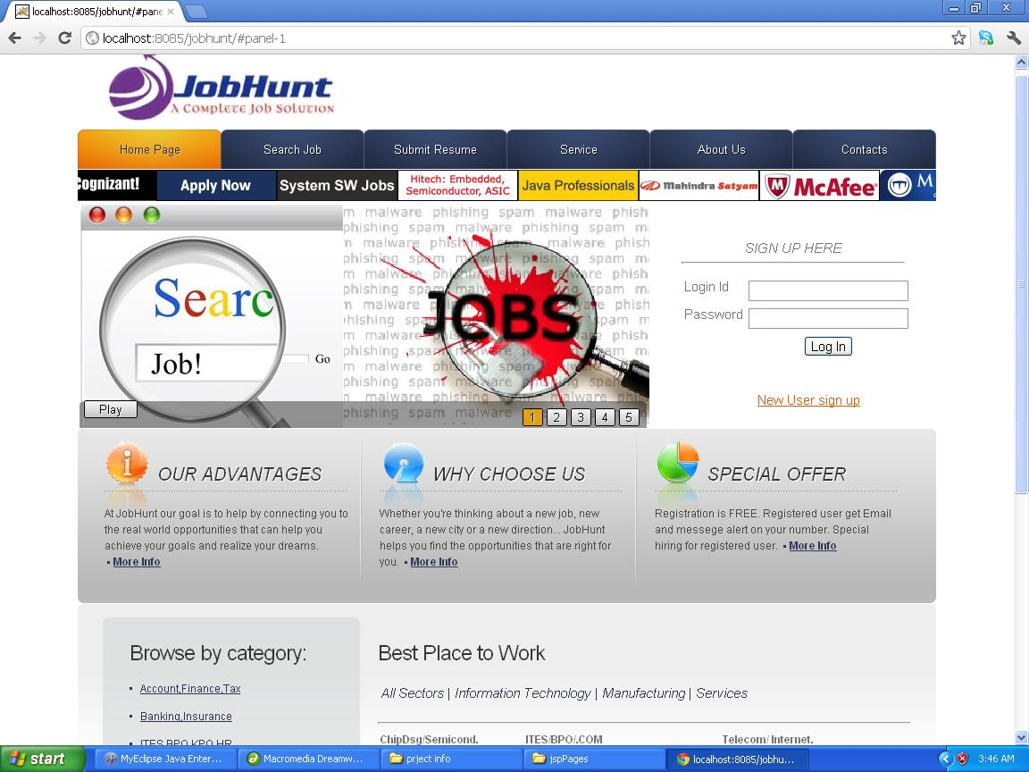
Login.jsp
<%@ page import="com.jobhunt.managers.*" %>
<jsp:useBean id="user" class="com.jobhunt.beans.User" scope="session"/>
<jsp:setProperty name="user" property="loginId" />
<jsp:setProperty name="user" property="password" />
<%
System.out.println("In login.jsp");
UserManager manager=new UserManager();
String result=manager.login(user);
ViewManager vm=new ViewManager();
System.out.println("Invoking viewManager for "+result);
vm.generateView(result,pageContext);
%>

<!DOCTYPE html>
<html lang="en">
<head>
<title></title>
<meta charset="utf-8">
<link rel="stylesheet" href="css/reset.css" type="text/css" media="all">
<link rel="stylesheet" href="css/grid.css" type="text/css" media="all">
<link rel="stylesheet" href="css/style.css" type="text/css" media="all">
<script type="text/javascript" src="js/jquery-1.4.2.min.js" ></script>
<script type="text/javascript" src="js/jquery.anythingslider.js"></script>
<script type="text/javascript" src="js/jquery.easing.1.2.js"></script>
<script type="text/javascript">

function formatText(index, panel) {
return index + "";
}

$(function () {

$('.anythingSlider').anythingSlider({
easing: "easeInOutExpo", // Anything other than "linear" or "swing" requires the easing plugin
autoPlay: true, // This turns off the entire FUNCTIONALY, not just if it starts running or not.
delay: 3000, // How long between slide transitions in AutoPlay mode
startStopped: false, // If autoPlay is on, this can force it to start stopped
animationTime: 600, // How long the slide transition takes
hashTags: true, // Should links change the hashtag in the URL?
buildNavigation: true, // If true, builds and list of anchor links to link to each slide
pauseOnHover: true, // If true, and autoPlay is enabled, the show will pause on hover
startText: "Play", // Start text
stopText: "Stop" // Stop text
});
});
</script>

</head>
<body>
<div id="main">
<!-- header -->
<header>
<div class="logo">
<div ><img src="images/final logo.jpg"></div>
</div>
<nav>
<ul>
<li><a href="index.html" class="current">Home Page</a></li>
<li><a href="jspPages/searchjob.jsp">Search Job</a></li>
<li><a href="jspPages/register.jsp">Submit Resume</a></li>
<li><a href="jspPages/services.jsp">Service</a></li>
<li><a href="jspPages/aboutus.jsp">About Us</a></li>
<li><a href="jspPages/contacts.jsp">Contacts</a></li>
</ul>
</nav>
</header>

<div ><marquee > <img src="images/company name/cognizant28june.gif"><img src="images/company name/hexaware-135x35-201211-1.gif"><img src="images/company name/ibm_panel_092011.gif"><img src="images/company name/infojan10new.gif"><img src="images/company name/lninfotech14_122011.gif"><img src="images/company name/mahindra6sep.gif"><img src="images/company name/mcafee135x35-5apr11.gif"><img src="images/company name/mphasis-135x35-081111.gif"><img src="images/company name/hcl_new.gif"></marquee></div>

<section id="main-banner">

<div class="anythingSlider">
<div class="wrapper">
<ul>
<li><img src="images/slide1.jpeg" alt=""></li>
<li><img src="images/slide2.jpeg" alt=""></li>
<li><img src="images/slide3.jpeg" alt=""></li>
<li><img src="images/slide4.png" alt=""></li>
<li><img src="images/slide5.png" alt=""></li>
</ul>
</div>
</div>
<div class="intro" >
<div align="center" style="width:250px; height:40px;"><span >Sign Up Here</span><hr></div>
<form action="actions/login" method="post">
<table height="96" >

<tr>
<td>Login Id</td>
<td><input type="text" name="loginid"></td>
</tr>
<tr>
<td>Password</td>
<td><input type="password" name="password"></td>
</tr>
<tr>
<td></td>
<td><div align="center">
<input type="submit" name="submit" value="Log In">
</div></td>
</tr>

</table>
</form>
<div align="right">
<p>&nbsp;</p>
<a href="jspPages/register.jsp">New User sign up</a>
</div>
</div>
</section>
<aside class="top">
<div class="container_12">
<div class="wrapper">
<div class="grid_4 divider">
<div class="inner">
<h3><img src="images/icon1.png" alt="">Our advantages<span></span></h3>
At JobHunt our goal is to help by connecting you to the real world opportunities that can help you achieve your goals and realize your dreams. <a href="#" class="link1">More Info</a>
</div>
</div>
<div class="grid_4 divider">
<div class="inner">
<h3><img src="images/icon2.png" alt="">why choose us<span></span></h3>
Whether you're thinking about a new job, new career, a new city or a new direction... JobHunt helps you find the opportunities that are right for you. <a href="#" class="link1">More Info</a>
</div>
</div>
<div class="grid_4">
<div class="inner">
<h3><img src="images/icon3.png" alt="">Special Offer<span></span></h3>
Registration is FREE. Registered user get Email and messege alert on your number. Special hiring for registered user. <a href="#" class="link1">More Info</a>
</div>
</div>
</div>
</div>
</aside>
<div class="wrapper">
<!-- content -->
<section id="content">
<div class="container_12">
<div class="wrapper">
<aside class="grid_4">
<div class="box">
<h2>Browse by category:</h2>
<ul class="list1">
<li><a href="#">Account,Finance,Tax</a></li>
<li><a href="#">Banking,Insurance</a></li>
<li><a href="#">ITES,BPO,KPO,HR</a></li>
<li><a href="#">Marketing,Advertising</a></li>
<li><a href="#">Engineering Design,Sales</a></li>
<li><a href="#">IT-Software & Hardware</a></li>
<li><a href="#">Architeture, Interior Design</a></li>
<li><a href="#">Hotel,Restaurants</a></li>
<li><a href="#">Journalism</a></li>
<li><a href="#">Consulting</a></li>
</ul>
<div class="extra-links">
<a href="#">Read more</a> &nbsp;| &nbsp;<a href="#">Get rss feeds</a>
</div>
</div>
</aside>
<div class="grid_8">
<div class="indent">
<div>
<table>
<tr><h2>Best Place to Work</h2></tr>
<tr><td><h4>All Sectors |</h4></td>
<td><h4>Information Technology |</h4></td>
<td><h4>Manufacturing |</h4></td>
<td><h4>Services</h4></td></tr>
</table><hr>
<table><td>
<ul><li><h5>ChipDsg/Semicond.</h5><hr></li>
<li>ST ERICSSON</li>
<li>AppliedMicro</li>
<li>Broadcom</li>
<li>Intel</li>
<li>LSI</li>
<li>NVIDIA</li>
<li>PathPartner Technology</li>
<li>QUALCOMM</li>
<li>Rambus</li>
<li>SanDisk</li>
</ul></td><td>&nbsp;&nbsp;&nbsp;&nbsp;&nbsp;&nbsp;&nbsp;&nbsp;</td>
<td>
<ul><li><h5>ITES/BPO/.COM</h5><hr></li>
<li>Hutchison Global Services</li>
<li>Caliber Point Business Solutions</li>
<li>Encore Capital Group</li>
<li>Ienergizer</li>
<li>Respondez (A SPANCO company)</li>
<li>Shell Business Service</li>
<li>SourceHOV</li>
<li>EMERSON INNOVATION CENTER</li>
<li>Kennametal India Ltd</li>
<li>TIBCO Software</li>
</ul></td><td>&nbsp;&nbsp;&nbsp;&nbsp;&nbsp;&nbsp;&nbsp;&nbsp;</td>
<td>
<ul><li><h5>Telecom/ Internet.</h5><hr></li>
<li>Alcatel-Lucent</li>
<li>ARICENT</li>
<li>Ciena</li>
<li>Cisco Systems</li>
<li>Excelacom Technologies</li>
<li>LG Soft India</li>
<li>Motorola Mobility India</li>
<li>Reliance Communications</li>
<li>Sandvine</li>
<li>Valmont Industries</li>
</ul></td>
</table>
</div>
</div>
</div>
</div>
</div>
</section>
</div>
<footer>
<nav>
<ul>
<li><a href="index.html" class="current">Home Page</a></li>
<li><a href="index-1.html">About Us</a></li>
<li><a href="index-2.html">Solutions</a></li>
<li><a href="index-3.html">Partners</a></li>
<li><a href="index-4.html">Clients</a></li>
<li><a href="index-5.html">Contacts</a></li>
</ul>
</nav>
Consultex &copy; 2010 &bull; <a href="index-6.html">Privacy Policy</a>
</footer>
</div>
</body>
</html>

6.1.2 search jobs.jsp
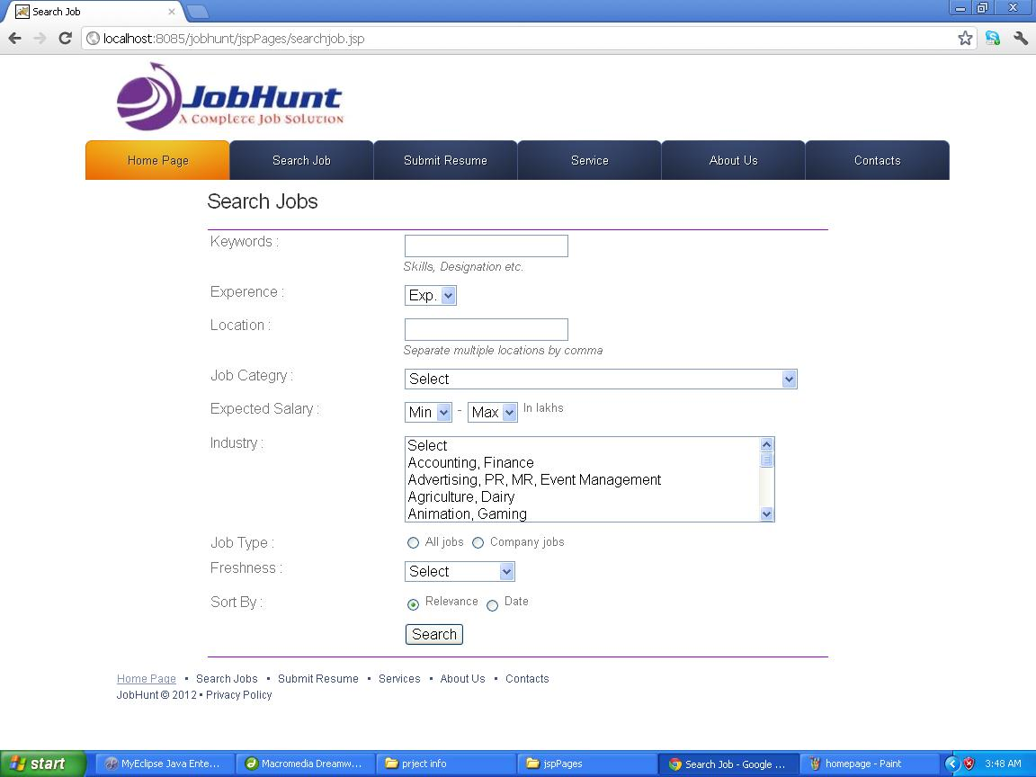
Search.jsp
<%@ page import="com.jobhunt.managers.*" %>
<jsp:useBean id="user" class="com.jobhunt.beans.User" scope="session"/>
<jsp:setProperty name="job" property="keyword" />
<jsp:setProperty name="job" property="location" />
<jsp:setProperty name="job" property="expercience" />
<jsp:setProperty name="job" property="eligibility" />
<jsp:setProperty name="job" property="industrytype" />
<jsp:setProperty name="job" property="category" />

<%
System.out.println("In search.jsp");
JobManager manager=new JobManager();
String result=manager.login(job);
ViewManager vm=new ViewManager();
System.out.println("Invoking viewManager for "+result);
vm.generateView(result,pageContext);
%>

<%@ page contentType="text/html; charset=iso-8859-1" language="java" import="java.sql.*" errorPage="" %>
<!DOCTYPE html PUBLIC "-//W3C//DTD XHTML 1.0 Transitional//EN" "http://www.w3.org/TR/xhtml1/DTD/xhtml1-transitional.dtd">
<html xmlns="http://www.w3.org/1999/xhtml">
<head>
<meta http-equiv="Content-Type" content="text/html; charset=iso-8859-1" />
<title>Search Job</title>
<link rel="stylesheet" href="../css/reset.css" type="text/css" media="all">
<link rel="stylesheet" href="../css/style.css" type="text/css" media="all">
<style type="text/css">
<!--
.style2 {font-size: x-large; color: #000000;}
.style4 {font-size: small}
-->
</style>
</head>

<body>
<%@ include file="header.html"%>
<form method="get" action="search.jsp">
<div style=" margin-top:10px; margin-left:230px;"><h2>Search Jobs</h2></div>
<table width="690" height="476" align="center" bordercolor="#9900CC" frame="hsides">

<tr>
<td width="198">Keywords :</td>
<td width="378"><label>
<input type="text" name="textfield" />
<br />
<em class="dispBlk style4">Skills, Designation etc.</em></label></td>
</tr>
<tr>
<td>Experence :</td>
<td><select name="qe" id="expSL">
<option value="" selected="selected">Exp.</option>
<option value="0">0</option>
<option value="1">1</option>
<option value="2">2</option>
<option value="3">3</option>
<option value="4">4</option>
<option value="5">5</option>
<option value="6">6</option>
<option value="7">7</option>
<option value="8">8</option>
<option value="9">9</option>
<option value="10">10</option>
<option value="11">11</option>
<option value="12">12</option>
<option value="13">13</option>
<option value="14">14</option>
<option value="15">15</option>
<option value="16">16</option>
<option value="17">17</option>
<option value="18">18</option>
<option value="19">19</option>
<option value="20">20</option>
<option value="21">21</option>
<option value="22">22</option>
<option value="23">23</option>
<option value="24">24</option>
<option value="25">25</option>
<option value="26">26</option>
<option value="27">27</option>
<option value="28">28</option>
<option value="29">29</option>
<option value="30">30</option>
</select>
</td>
</tr>
<tr>
<td>Location :</td>
<td><label>
<input type="text" name="textfield2" />
<br />
<em class="dispBlk style4">Separate multiple locations by comma</em></label></td>
</tr>
<tr>
<td>Job Categry : </td>
<td><span class="errR">
<select name="qf[]" onchange="removeError(new Array('qp','ql','eo','idqi'),'form',1);" id="fareaSL">
<option value="" selected="selected">Select</option>
<optgroup label="Top Categories"></optgroup>
<option value="1">Accounts, Finance, Tax, Company Secretary, Audit</option>
<option value="6">Financial Services, Banking, Investments, Insurance</option>
<option value="8">ITES, BPO, KPO, LPO, Customer Service, Operations</option>
<option value="12">HR, Recruitment, Administration, IR</option>
<option value="15">Marketing, Advertising, MR, PR, Media Planning</option>
<option value="19">Production, Manufacturing, Maintenance</option>
<option value="20">Site Engineering, Project Management</option>
<option value="21">Engineering Design, R&amp;D</option>
<option value="22">Sales, Retail, Business Development</option>
<option value="24">IT Software - All Jobs</option>
<optgroup label="IT Software Categories"></optgroup>
<option value="24.01">Application Programming, Maintenance</option>
<option value="24.02">Client / Server Programming</option>
<option value="24.03">DBA, Datawarehousing</option>
<option value="24.04">ERP, CRM</option>
<option value="24.05">Embedded, EDA, VLSI, ASIC, Chip Design</option>
<option value="24.06">Network Administration, Security</option>
<option value="24.08">QA &amp; Testing</option>
<option value="24.09">System Programming</option>
<option value="24.10">Telecom Software</option>
<option value="24.11">Systems, EDP, MIS</option>
<option value="24.12">eCommerce, Internet Technologies</option>
<option value="24.13">Mainframe</option>
<option value="24.14">Mobile</option>
<option value="24.15">Middleware</option>
<option value="24.07">Other</option>
<optgroup label="More Categories"></optgroup>
<option value="catid_2">Top Management - IT Jobs</option>
<option value="catid_1">Top Management - Non IT</option>
<option value="2">Architecture, Interior Design</option>
<option value="3">Design, Creative, User Experience</option>
<option value="4">Hotels, Restaurants</option>
<option value="5">Journalism, Editing, Content</option>
<option value="7">Strategy, Management Consulting, Corporate Planning</option>
<option value="9">Self Employed, Entrepreneur, Independent Consultant</option>
<option value="10">Export, Import, Merchandising</option>
<option value="11">Executive Assistant, Front Office, Data Entry</option>
<option value="13">Legal, Regulatory, Intellectual Property</option>
<option value="14">Supply Chain, Logistics, Purchase, Materials</option>
<option value="16">Medical, Healthcare, R&amp;D, Pharmaceuticals, Biotechnology</option>
<option value="18">Packaging</option>
<option value="36">Teaching, Education, Training, Counselling</option>
<option value="37">IT Hardware, Technical Support, Telecom Engineering</option>
<option value="42">Fashion Designing, Merchandising</option>
<option value="43">TV, Films, Production, Broadcasting</option>
<option value="44">Travel, Tours, Ticketing, Airlines</option>
<option value="45">Defence Forces, Security Services</option>
<option value="catid_28">Government, Defence</option>
<option value="catid_29">Overseas, International Jobs</option>
<option value="catid_57">Retail, Wholesale</option>
<option value="catid_31">Pharma, Biotechnology, Clinical Research</option>
<option value="catid_22">Freshers</option>
<option value="41">Others</option>
</select>
</span></td>
</tr>
<tr>
<td>Expected Salary : </td>
<td><select name="qm" id="minSalSL" onchange="change_qx('on');" ;="">
<option value="-1">Min</option>
<option value="12477">&lt; .5</option>
<option value="1">1</option>
<option value="2">2</option>
<option value="3">3</option>
<option value="4">4</option>
<option value="5">5</option>
<option value="6">6</option>
<option value="7">7</option>
<option value="8">8</option>
<option value="9">9</option>
<option value="10">10</option>
<option value="11">11</option>
<option value="12">12</option>
<option value="13">13</option>
<option value="14">14</option>
<option value="15">15</option>
<option value="16">16</option>
<option value="17">17</option>
<option value="18">18</option>
<option value="19">19</option>
<option value="20">20</option>
<option value="21">21</option>
<option value="22">22</option>
<option value="23">23</option>
<option value="24">24</option>
<option value="25">25</option>
<option value="26">26</option>
<option value="27">27</option>
<option value="28">28</option>
<option value="29">29</option>
<option value="30">30</option>
<option value="31">31</option>
<option value="32">32</option>
<option value="33">33</option>
<option value="34">34</option>
<option value="35">35</option>
<option value="36">36</option>
<option value="37">37</option>
<option value="38">38</option>
<option value="39">39</option>
<option value="40">40</option>
<option value="41">41</option>
<option value="42">42</option>
<option value="43">43</option>
<option value="44">44</option>
<option value="45">45</option>
<option value="46">46</option>
<option value="47">47</option>
<option value="48">48</option>
<option value="49">49</option>
<option value="50">50</option>
</select>
-
<select name="qx" id="maxSalSL">
<option value="-1" selected="selected">Max</option>
</select>
<span class="style4">In lakhs </span></td>
</tr>
<tr>
<td>Industry : </td>
<td><span class="errR">
<select name="qi[]" id="idqi" size="5" class="list" multiple="multiple" onchange="removeError(new Array('ql','qp','eo','idqi'),'form',1); return checkCat(this,2);">
<option value="">Select</option>
<option value="8">Accounting, Finance</option>
<option value="32">Advertising, PR, MR, Event Management</option>
<option value="33">Agriculture, Dairy</option>
<option value="56">Animation, Gaming</option>
<option value="30">Architecture, Interior Design</option>
<option value="4">Automobile, Auto Anciliary, Auto Components</option>
<option value="46">Aviation, Aerospace, Aeronautical</option>
<option value="14">Banking, Financial Services, Broking</option>
<option value="7">BPO, Call Centre, ITeS</option>
<option value="50">Brewery, Distillery</option>
<option value="60">Ceramics, Sanitary Ware</option>
<option value="6">Chemicals, PetroChemical, Plastics, Rubber</option>
<option value="12">Construction, Engineering, Cement, Metals</option>
<option value="10">Consumer Electronics, Appliances, Durables</option>
<option value="18">Courier, Transportation, Freight , Warehousing</option>
<option value="42">Government, Defence</option>
<option value="26">Education, Teaching, Training</option>
<option value="55">Electricals, Switchgear</option>
<option value="13">Export, Import</option>
<option value="47">Facility Management</option>
<option value="41">Fertilizers, Pesticides</option>
<option value="9">FMCG, Foods, Beverage</option>
<option value="57">Food Processing</option>
<option value="31">Fresher, Trainee, Entry Level</option>
<option value="35">Gems, Jewellery</option>
<option value="49">Glass, Glassware</option>
<option value="61">Heat Ventilation, Air Conditioning</option>
<option value="2">Travel, Hotels, Restaurants, Airlines, Railways</option>
<option value="16">Industrial Products , Heavy Machinery</option>
<option value="17">Insurance</option>
<option value="25">IT Software, Software Services</option>
<option value="15">IT Hardware, Networking</option>
<option value="48">KPO, Research, Analytics</option>
<option value="27">Telecom, ISP</option>
<option value="36">Legal</option>
<option value="19">Media, Entertainment, Internet</option>
<option value="20">Medical, Healthcare, Hospitals</option>
<option value="54">Mining, Quarrying</option>
<option value="37">NGO, Social Services, Regulators, Industry Associations</option>
<option value="21">Office Equipment, Automation</option>
<option value="23">Oil and Gas, Energy, Power, Infrastructure</option>
<option value="43">Pulp and Paper</option>
<option value="22">Pharma, Biotechnology, Clinical Research</option>
<option value="38">Packaging, Printing</option>
<option value="58">Publishing</option>
<option value="39">Real Estate, Property</option>
<option value="34">Recruitment, Staffing</option>
<option value="24">Retail, Wholesale</option>
<option value="40">Security, Law Enforcement</option>
<option value="28">Semiconductors, Electronics</option>
<option value="44">Shipping, Marine</option>
<option value="53">Iron and Steel</option>
<option value="52">Strategy, Management Consulting</option>
<option value="3">Textiles, Garments, Fashion, Accessories</option>
<option value="45">Tyres</option>
<option value="51">Water Treatment, Waste Management</option>
<option value="59">Wellness, Fitness, Sports</option>
<option value="29">Other</option>
</select>
</span></td>
</tr>
<tr>
<td>Job Type : </td>
<td><label>
<input name="radiobutton" type="radio" value="radiobutton" />
<span class="style4">All jobs</span>
<input name="radiobutton" type="radio" value="radiobutton" />
<span class="style4">Company jobs</span></label></td>
</tr>
<tr>
<td>Freshness :</td>
<td><select name="qo">
<option value="" selected="selected">Select</option>
<option value="30">&lt; 30 Days old</option>
<option value="15">&lt; 15 Days old</option>
<option value="7">&lt; 7 Days old</option>
<option value="2">&lt; 3 Days old</option>
<option value="1">1 Day</option>
</select></td>
</tr>
<tr>
<td>Sort By : </td>
<td><input type="radio" name="qs" id="relV" class="rad" value="r" checked="checked" />
<span class="style4"> Relevance
<label>
<input name="radiobutton" type="radio" value="radiobutton" />
Date</label>
</span></td>
</tr>
<tr>
<td>&nbsp;</td>
<td><label>
<input type="submit" name="Submit" value="Search" />
</label></td>
</tr>
</table>
</form>
<%@ include file="footer.html"%>
</body>
</html>

6.1.3 submit resume.jsp
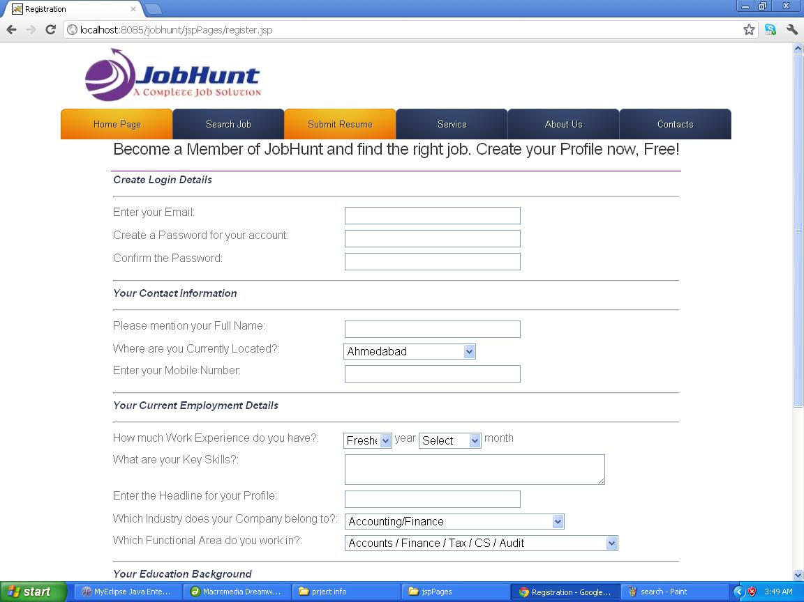
Reg.jsp
<%@ page import="com.jobhunt.Dao.*" %>
<jsp:useBean id="user" class="com.jobhunt.dto.User" scope="application"/>
<jsp:setProperty property="*" name="user"/>
<%
UserDao dao=(UserDao)DaoFactory.getDao("UserDao");
boolean flag=dao.insert(user);
HttpSession sion=request.getSession();
sion.setAttribute("msg1","<b>Thankyou User Your sucessfully Registered</b>");
System.out.println("thankyou Mr. you account is successfully created");
request.setAttribute("msg"," Thankyou Mr "+user.getName()+" your account is sucessfully creatted");
%>
<jsp:forward page="../index.jsp?p=body"/>

Register.jsp
<%@ page contentType="text/html; charset=iso-8859-1" language="java" import="java.sql.*" errorPage="" %>
<!DOCTYPE html PUBLIC "-//W3C//DTD XHTML 1.0 Transitional//EN" "http://www.w3.org/TR/xhtml1/DTD/xhtml1-transitional.dtd">
<html xmlns="http://www.w3.org/1999/xhtml">
<head>
<meta http-equiv="Content-Type" content="text/html; charset=iso-8859-1" />
<title>Registration</title>
<link rel="stylesheet" href="../css/reset.css" type="text/css" media="all">
<link rel="stylesheet" href="../css/style.css" type="text/css" media="all">
</head>

<body>
<%@ include file="header.html"%>
<div align="center" ><h2>Become a Member of JobHunt and find the right job. Create your Profile now, Free!</h2></div>
<form method="get" action="reg.jsp">
<table width="817" frame="hsides" align="center" bordercolor="#990099">
<tr>
<td colspan="2"><h4><strong>Create Login Details</strong></h4>
<hr ></td>
</tr>

<tr>
<td width="297">Enter your Email: </td>
<td width="440"><label>
<input name="textfield" type="text" size="30" />
</label></td>
</tr>
<tr>
<td> Create a Password for your account: </td>
<td><input name="textfield" type="text" size="30" /></td>
</tr>
<tr>
<td> Confirm the Password: </td>
<td><input name="textfield" type="text" size="30" /></td>
</tr>
<tr>
<td colspan="2"><hr><h4><strong>Your Contact Information</strong></h4>
<hr ></td>
</tr>
<tr>
<td> Please mention your Full Name: </td>
<td><input name="textfield" type="text" size="30" /></td>
</tr>
<tr>
<td>Where are you Currently Located?: </td>
<td><label>
<select name="CITY" id="city" style="width:190px" class="" onkeydown="return trapKey(event,this)">
<option value="-1" label="Select">Select</option>
<optgroup label="----Top Metropolitan Cities----" style="background-color: rgb(208, 224, 241); ">Top Metropolitan Cities</optgroup>
<option value="2" selected="selected" label="Ahmedabad">Ahmedabad</option>
<option value="3" label="Bengaluru / Bangalore">Bengaluru / Bangalore</option>
<option value="4" label="Chandigarh">Chandigarh</option>
<option value="5" label="Chennai">Chennai</option>
<option value="6" label="Delhi">Delhi</option>
<option value="7" label="Gurgaon">Gurgaon</option>
<option value="8" label="Hyderabad / Secunderabad">Hyderabad / Secunderabad</option>
<option value="9" label="Kolkata">Kolkata</option>
<option value="10" label="Mumbai">Mumbai</option>
<option value="11" label="Noida">Noida</option>
<option value="12" label="Pune">Pune</option>
<optgroup label="----Andhra Pradesh----" style="background-color: rgb(208, 224, 241); ">Andhra Pradesh</optgroup>
<option value="14" label="Anantapur">Anantapur</option>
<option value="15" label="Guntakal">Guntakal</option>
<option value="16" label="Guntur">Guntur</option>
<option value="17" label="Hyderabad / Secunderabad">Hyderabad / Secunderabad</option>
<option value="18" label="Kakinada">Kakinada</option>
<option value="19" label="Kurnool">Kurnool</option>
<option value="20" label="Nellore">Nellore</option>
<option value="21" label="Nizamabad">Nizamabad</option>
<option value="22" label="Rajahmundry">Rajahmundry</option>
<option value="24" label="Tirupati">Tirupati</option>
<option value="25" label="Vijayawada">Vijayawada</option>
<option value="26" label="Visakhapatnam">Visakhapatnam</option>
<option value="27" label="Warangal">Warangal</option>
<option value="28" label="Andhra Pradesh - Other">Andhra Pradesh - Other</option>
<optgroup label="----Arunachal Pradesh----" style="background-color: rgb(208, 224, 241); ">Arunachal Pradesh</optgroup>
<option value="30" label="Itanagar">Itanagar</option>
<option value="31" label="Arunachal Pradesh - Other">Arunachal Pradesh - Other</option>
<optgroup label="----Assam----" style="background-color: rgb(208, 224, 241); ">Assam</optgroup>
<option value="33" label="Guwahati">Guwahati</option>
<option value="34" label="Silchar">Silchar</option>
<option value="35" label="Assam - Other">Assam - Other</option>
<optgroup label="----Bihar----" style="background-color: rgb(208, 224, 241); ">Bihar</optgroup>
<option value="37" label="Bhagalpur">Bhagalpur</option>
<option value="38" label="Patna">Patna</option>
<option value="39" label="Bihar - Other">Bihar - Other</option>
<optgroup label="----Chhattisgarh----" style="background-color: rgb(208, 224, 241); ">Chhattisgarh</optgroup>
<option value="41" label="Bhillai">Bhillai</option>
<option value="42" label="Bilaspur">Bilaspur</option>
<option value="43" label="Raipur">Raipur</option>
<option value="44" label="Chhattisgarh - Other">Chhattisgarh - Other</option>
<optgroup label="----Goa----" style="background-color: rgb(208, 224, 241); ">Goa</optgroup>
<option value="46" label="Panjim / Panaji">Panjim / Panaji</option>
<option value="48" label="Vasco Da Gama">Vasco Da Gama</option>
<option value="49" label="Goa - Other">Goa - Other</option>
<optgroup label="----Gujarat----" style="background-color: rgb(208, 224, 241); ">Gujarat</optgroup>
<option value="51" label="Ahmedabad">Ahmedabad</option>
<option value="52" label="Anand">Anand</option>
<option value="53" label="Ankleshwar">Ankleshwar</option>
<option value="55" label="Bharuch">Bharuch</option>
<option value="56" label="Bhavnagar">Bhavnagar</option>
<option value="57" label="Bhuj">Bhuj</option>
<option value="58" label="Gandhinagar">Gandhinagar</option>
<option value="59" label="Gir">Gir</option>
<option value="60" label="Jamnagar">Jamnagar</option>
<option value="61" label="Kandla">Kandla</option>
<option value="62" label="Porbandar">Porbandar</option>
<option value="63" label="Rajkot">Rajkot</option>
<option value="64" label="Surat">Surat</option>
<option value="65" label="Vadodara / Baroda">Vadodara / Baroda</option>
<option value="66" label="Valsad">Valsad</option>
<option value="67" label="Vapi">Vapi</option>
<option value="68" label="Gujarat - Other">Gujarat - Other</option>
<optgroup label="----Haryana----" style="background-color: rgb(208, 224, 241); ">Haryana</optgroup>
<option value="70" label="Ambala">Ambala</option>
<option value="71" label="Chandigarh">Chandigarh</option>
<option value="72" label="Faridabad">Faridabad</option>
<option value="73" label="Gurgaon">Gurgaon</option>
<option value="74" label="Hisar">Hisar</option>
<option value="75" label="Karnal">Karnal</option>
<option value="76" label="Kurukshetra">Kurukshetra</option>
<option value="77" label="Panipat">Panipat</option>
<option value="78" label="Rohtak">Rohtak</option>
<option value="79" label="Haryana - Other">Haryana - Other</option>
<optgroup label="----Himachal Pradesh----" style="background-color: rgb(208, 224, 241); ">Himachal Pradesh</optgroup>
<option value="81" label="Dalhousie">Dalhousie</option>
<option value="82" label="Dharmasala">Dharmasala</option>
<option value="83" label="Kulu/Manali">Kulu/Manali</option>
<option value="84" label="Shimla">Shimla</option>
<option value="85" label="Himachal Pradesh - Other">Himachal Pradesh - Other</option>
<optgroup label="----Jammu &amp; Kashmir----" style="background-color: rgb(208, 224, 241); ">Jammu &amp; Kashmir</optgroup>
<option value="87" label="Jammu">Jammu</option>
<option value="88" label="Srinagar">Srinagar</option>
<option value="89" label="Jammu and Kashmir - Other">Jammu and Kashmir - Other</option>
<optgroup label="----Jharkhand----" style="background-color: rgb(208, 224, 241); ">Jharkhand</optgroup>
<option value="91" label="Bokaro">Bokaro</option>
<option value="92" label="Dhanbad">Dhanbad</option>
<option value="93" label="Jamshedpur">Jamshedpur</option>
<option value="94" label="Ranchi">Ranchi</option>
<option value="95" label="Jharkhand - Other">Jharkhand - Other</option>
<optgroup label="----Karnataka----" style="background-color: rgb(208, 224, 241); ">Karnataka</optgroup>
<option value="97" label="Bengaluru / Bangalore">Bengaluru / Bangalore</option>
<option value="98" label="Belgaum">Belgaum</option>
<option value="99" label="Bellary">Bellary</option>
<option value="100" label="Bidar">Bidar</option>
<option value="101" label="Dharwad">Dharwad</option>
<option value="102" label="Gulbarga">Gulbarga</option>
<option value="103" label="Hubli">Hubli</option>
<option value="104" label="Kolar">Kolar</option>
<option value="105" label="Mangalore">Mangalore</option>
<option value="106" label="Mysoru / Mysore">Mysoru / Mysore</option>
<option value="107" label="Karnataka - Other">Karnataka - Other</option>
<optgroup label="----Kerala----" style="background-color: rgb(208, 224, 241); ">Kerala</optgroup>
<option value="109" label="Calicut">Calicut</option>
<option value="110" label="Cochin">Cochin</option>
<option value="111" label="Ernakulam">Ernakulam</option>
<option value="112" label="Kannur">Kannur</option>
<option value="113" label="Kochi">Kochi</option>
<option value="114" label="Kollam">Kollam</option>
<option value="115" label="Kottayam">Kottayam</option>
<option value="116" label="Kozhikode">Kozhikode</option>
<option value="117" label="Palakkad">Palakkad</option>
<option value="118" label="Palghat">Palghat</option>
<option value="119" label="Thrissur">Thrissur</option>
<option value="120" label="Trivandrum">Trivandrum</option>
<option value="121" label="Kerala - Other">Kerala - Other</option>
<optgroup label="----Madhya Pradesh----" style="background-color: rgb(208, 224, 241); ">Madhya Pradesh</optgroup>
<option value="123" label="Bhopal">Bhopal</option>
<option value="124" label="Gwalior">Gwalior</option>
<option value="125" label="Indore">Indore</option>
<option value="126" label="Jabalpur">Jabalpur</option>
<option value="127" label="Ujjain">Ujjain</option>
<option value="128" label="Madhya Pradesh - Other">Madhya Pradesh - Other</option>
<optgroup label="----Maharashtra----" style="background-color: rgb(208, 224, 241); ">Maharashtra</optgroup>
<option value="130" label="Ahmednagar">Ahmednagar</option>
<option value="131" label="Aurangabad">Aurangabad</option>
<option value="132" label="Jalgaon">Jalgaon</option>
<option value="133" label="Kolhapur">Kolhapur</option>
<option value="134" label="Mumbai">Mumbai</option>
<option value="135" label="Mumbai Suburbs">Mumbai Suburbs</option>
<option value="136" label="Nagpur">Nagpur</option>
<option value="137" label="Nasik">Nasik</option>
<option value="138" label="Navi Mumbai">Navi Mumbai</option>
<option value="139" label="Pune">Pune</option>
<option value="140" label="Solapur">Solapur</option>
<option value="141" label="Maharashtra - Other">Maharashtra - Other</option>
<optgroup label="----Manipur----" style="background-color: rgb(208, 224, 241); ">Manipur</optgroup>
<option value="143" label="Imphal">Imphal</option>
<option value="144" label="Manipur - Other">Manipur - Other</option>
<optgroup label="----Meghalaya----" style="background-color: rgb(208, 224, 241); ">Meghalaya</optgroup>
<option value="146" label="Shillong">Shillong</option>
<option value="147" label="Meghalaya - Other">Meghalaya - Other</option>
<optgroup label="----Mizoram----" style="background-color: rgb(208, 224, 241); ">Mizoram</optgroup>
<option value="149" label="Aizawal">Aizawal</option>
<option value="150" label="Mizoram - Other">Mizoram - Other</option>
<optgroup label="----Nagaland----" style="background-color: rgb(208, 224, 241); ">Nagaland</optgroup>
<option value="152" label="Dimapur">Dimapur</option>
<option value="153" label="Nagaland - Other">Nagaland - Other</option>
<optgroup label="----Orissa----" style="background-color: rgb(208, 224, 241); ">Orissa</optgroup>
<option value="155" label="Bhubaneshwar">Bhubaneshwar</option>
<option value="156" label="Cuttack">Cuttack</option>
<option value="157" label="Paradeep">Paradeep</option>
<option value="158" label="Puri">Puri</option>
<option value="159" label="Rourkela">Rourkela</option>
<option value="160" label="Orissa - Other">Orissa - Other</option>
<optgroup label="----Punjab----" style="background-color: rgb(208, 224, 241); ">Punjab</optgroup>
<option value="162" label="Amritsar">Amritsar</option>
<option value="163" label="Bathinda">Bathinda</option>
<option value="164" label="Chandigarh">Chandigarh</option>
<option value="165" label="Jalandhar">Jalandhar</option>
<option value="166" label="Ludhiana">Ludhiana</option>
<option value="167" label="Mohali">Mohali</option>
<option value="168" label="Pathankot">Pathankot</option>
<option value="169" label="Patiala">Patiala</option>
<option value="170" label="Punjab - Other">Punjab - Other</option>
<optgroup label="----Rajasthan----" style="background-color: rgb(208, 224, 241); ">Rajasthan</optgroup>
<option value="172" label="Ajmer">Ajmer</option>
<option value="173" label="Jaipur">Jaipur</option>
<option value="174" label="Jaisalmer">Jaisalmer</option>
<option value="175" label="Jodhpur">Jodhpur</option>
<option value="176" label="Kota">Kota</option>
<option value="177" label="Udaipur">Udaipur</option>
<option value="178" label="Rajasthan - Other">Rajasthan - Other</option>
<optgroup label="----Sikkim----" style="background-color: rgb(208, 224, 241); ">Sikkim</optgroup>
<option value="180" label="Gangtok">Gangtok</option>
<option value="181" label="Sikkim - Other">Sikkim - Other</option>
<optgroup label="----Tamil Nadu----" style="background-color: rgb(208, 224, 241); ">Tamil Nadu</optgroup>
<option value="183" label="Chennai">Chennai</option>
<option value="184" label="Coimbatore">Coimbatore</option>
<option value="185" label="Cuddalore">Cuddalore</option>
<option value="186" label="Erode">Erode</option>
<option value="187" label="Hosur">Hosur</option>
<option value="188" label="Madurai">Madurai</option>
<option value="189" label="Nagercoil">Nagercoil</option>
<option value="190" label="Ooty">Ooty</option>
<option value="191" label="Salem">Salem</option>
<option value="192" label="Thanjavur">Thanjavur</option>
<option value="193" label="Tirunalveli">Tirunalveli</option>
<option value="194" label="Trichy">Trichy</option>
<option value="195" label="Tuticorin">Tuticorin</option>
<option value="196" label="Vellore">Vellore</option>
<option value="197" label="Tamil Nadu - Other">Tamil Nadu - Other</option>
<optgroup label="----Tripura----" style="background-color: rgb(208, 224, 241); ">Tripura</optgroup>
<option value="199" label="Agartala">Agartala</option>
<option value="200" label="Tripura - Other">Tripura - Other</option>
<optgroup label="----Union Territories----" style="background-color: rgb(208, 224, 241); ">Union Territories</optgroup>
<option value="202" label="Chandigarh">Chandigarh</option>
<option value="203" label="Dadra &amp; Nagar Haveli - Silvassa">Dadra &amp; Nagar Haveli - Silvassa</option>
<option value="204" label="Daman &amp; Diu">Daman &amp; Diu</option>
<option value="205" label="Delhi">Delhi</option>
<option value="206" label="Pondicherry">Pondicherry</option>
<optgroup label="----Uttar Pradesh----" style="background-color: rgb(208, 224, 241); ">Uttar Pradesh</optgroup>
<option value="208" label="Agra">Agra</option>
<option value="209" label="Aligarh">Aligarh</option>
<option value="210" label="Allahabad">Allahabad</option>
<option value="211" label="Bareilly">Bareilly</option>
<option value="212" label="Faizabad">Faizabad</option>
<option value="213" label="Ghaziabad">Ghaziabad</option>
<option value="214" label="Gorakhpur">Gorakhpur</option>
<option value="215" label="Kanpur">Kanpur</option>
<option value="216" label="Lucknow">Lucknow</option>
<option value="217" label="Mathura">Mathura</option>
<option value="218" label="Meerut">Meerut</option>
<option value="219" label="Moradabad">Moradabad</option>
<option value="220" label="Noida">Noida</option>
<option value="221" label="Varanasi / Banaras">Varanasi / Banaras</option>
<option value="222" label="Uttar Pradesh - Other">Uttar Pradesh - Other</option>
<optgroup label="----Uttaranchal----" style="background-color: rgb(208, 224, 241); ">Uttaranchal</optgroup>
<option value="224" label="Dehradun">Dehradun</option>
<option value="225" label="Roorkee">Roorkee</option>
<option value="226" label="Uttaranchal - Other">Uttaranchal - Other</option>
<optgroup label="----West Bengal----" style="background-color: rgb(208, 224, 241); ">West Bengal</optgroup>
<option value="228" label="Asansol">Asansol</option>
<option value="229" label="Durgapur">Durgapur</option>
<option value="230" label="Haldia">Haldia</option>
<option value="231" label="Kharagpur">Kharagpur</option>
<option value="232" label="Kolkata">Kolkata</option>
<option value="233" label="Siliguri">Siliguri</option>
<option value="234" label="West Bengal - Other">West Bengal - Other</option>
<optgroup label="----Other----" style="background-color: rgb(208, 224, 241); ">Other</optgroup>
<option value="9999" label="Other">Other</option>
</select>
</label></td>
</tr>
<tr>
<td> Enter your Mobile Number: </td>
<td><input name="textfield" type="text" size="30" /></td>
</tr>
<tr>
<td colspan="2"><hr><h4><strong>Your Current Employment Details</strong></h4>
<hr ></td>
</tr>
<tr>
<td> How much Work Experience do you have?: </td>
<td><label>
<select style="width: 70px;" name="EXPYEAR" id="expyear" class="">
<option value="-1">Select</option>
<option value="99" selected="selected">Fresher</option>
<option value="0" label="0">0</option>
<option value="1" label="1">1</option>
<option value="2" label="2">2</option>
<option value="3" label="3">3</option>
<option value="4" label="4">4</option>
<option value="5" label="5">5</option>
<option value="6" label="6">6</option>
<option value="7" label="7">7</option>
<option value="8" label="8">8</option>
<option value="9" label="9">9</option>
<option value="10" label="10">10</option>
<option value="11" label="11">11</option>
<option value="12" label="12">12</option>
<option value="13" label="13">13</option>
<option value="14" label="14">14</option>
<option value="15" label="15">15</option>
<option value="16" label="16">16</option>
<option value="17" label="17">17</option>
<option value="18" label="18">18</option>
<option value="19" label="19">19</option>
<option value="20" label="20">20</option>
<option value="21" label="21">21</option>
<option value="22" label="22">22</option>
<option value="23" label="23">23</option>
<option value="24" label="24">24</option>
<option value="25" label="25">25</option>
<option value="26" label="26">26</option>
<option value="27" label="27">27</option>
<option value="28" label="28">28</option>
<option value="29" label="29">29</option>
<option value="30" label="30">30</option>
<option value="31">30+</option>
</select>
year
<strong id="expmonthtop" class="stgnor">
<select style="width: 90px;" name="EXPMONTH" id="expmonth" class="">
<option value="-1" selected="selected">Select</option>
<option value="0" label="0">0</option>
<option value="1" label="1">1</option>
<option value="2" label="2">2</option>
<option value="3" label="3">3</option>
<option value="4" label="4">4</option>
<option value="5" label="5">5</option>
<option value="6" label="6">6</option>
<option value="7" label="7">7</option>
<option value="8" label="8">8</option>
<option value="9" label="9">9</option>
<option value="10" label="10">10</option>
<option value="11" label="11">11</option>
</select>
</strong>
month

</label></td>
</tr>
<tr>
<td> What are your Key Skills?: </td>
<td><label>
<textarea name="skill" cols="50" id="skill"></textarea>
</label></td>
</tr>
<tr>
<td>Enter the Headline for your Profile: </td>
<td><input name="textfield" type="text" size="30" /></td>
</tr>
<tr>
<td> Which Industry does your Company belong to?: </td>
<td><label>
<select name="industry" id="industry">
<option>Hotels/Restaurants/Airlines/Travel</option>
<option>Textiles/Garments/Accessories</option>
<option>Auto/Auto Ancillary</option>
<option>Chemicals/PetroChemical/Plastic/Rubber</option>
<option selected="selected">Accounting/Finance</option>
<option>FMCG/Foods/Beverage</option>
<option>Construction/Engineering/Cement/Metals</option>
<option>Banking/Financial Services/Broking</option>
<option>Export/Import</option>
<option>IT-Hardware &amp; Networking</option>
<option>Industrial Products/Heavy Machinery</option>
<option>Courier/Transportation/Freight</option>
<option>Media/Dotcom/Entertainment</option>
<option>Office Equipment/Automation</option>
<option>Oil and Gas/Power/Infrastructure/Energy</option>
<option>IT-Software/Software Services</option>
<option>Education/Teaching/Training</option>
<option>Architecture/Interior Designing</option>
<option>Agriculture/Dairy</option>
<option>NGO/Social Services</option>
<option>KPO / Research /Analytics</option>
<option>Electricals / Switchgears</option>
<option>Wellness/Fitness/Sports</option>
<option>Heat Ventilation Air Conditioning</option>
</select>
</label></td>
</tr>
<tr>
<td>Which Functional Area do you work in?: </td>
<td><label>
<select name="function" id="function">
<option>Accounts / Finance / Tax / CS / Audit</option>
<option>Architecture / Interior Design</option>
<option>Web / Graphic Design / Visualiser</option>
<option>Hotels / Restaurants</option>
<option>Content / Journalism</option>
<option>Banking / Insurance</option>
<option>ITES / BPO / KPO / Customer Service / Operations</option>
<option>Self Employed / Consultants</option>
<option>Pharma / Biotech / Healthcare / Medical / R&amp;D</option>
<option>Site Engineering / Project Management</option>
<option>IT- Hardware / Telecom / Technical Staff / Support</option>
<option>Fashion / Garments / Merchandising</option>
<option>TV / Films / Production</option>
<option>Ticketing / Travel / Airlines</option>
<option>Guards / Security Services</option>
<option>IT Software- Application Programming / Maintenance</option>
<option>IT Software - Client Server</option>
<option>IT Software - Mobile</option>
<option>IT Software - Middleware</option>
<option>IT Software- E-Commerce / Internet Technologies</option>
</select>
</label></td>
</tr>
<tr>
<td colspan="2"><hr><h4><strong>Your Education Background</strong></h4>
<hr ></td>
</tr>
<tr>
<td> Please select your Basic Education: </td>
<td><label>
<select name="UGCOURSE" id="ugcourse" style="width:180px;" class="">
<option value="-1" label="Select">Select</option>
<option value="1" label="Not Pursuing Graduation">Not Pursuing Graduation</option>
<option value="2" selected="selected" label="B.A">B.A</option>
<option value="3" label="B.Arch">B.Arch</option>
<option value="4" label="BCA">BCA</option>
<option value="5" label="B.B.A">B.B.A</option>
<option value="6" label="B.Com">B.Com</option>
<option value="7" label="B.Ed">B.Ed</option>
<option value="8" label="BDS">BDS</option>
<option value="9" label="BHM">BHM</option>
<option value="10" label="B.Pharma">B.Pharma</option>
<option value="11" label="B.Sc">B.Sc</option>
<option value="12" label="B.Tech/B.E.">B.Tech/B.E.</option>
<option value="13" label="LLB">LLB</option>
<option value="14" label="MBBS">MBBS</option>
<option value="15" label="Diploma">Diploma</option>
<option value="16" label="BVSC">BVSC</option>
<option value="9999" label="Other">Other</option>
</select>
</label></td>
</tr>
<tr>
<td> Please select your Masters Education: </td>
<td><label>
<select name="PGCOURSE" id="pgcourse" style="width:180px;" class="">
<option value="-1" label="Select">Select</option>
<option value="1" label="CA">CA</option>
<option value="2" label="CS">CS</option>
<option value="3" label="ICWA">ICWA</option>
<option value="4" label="Integrated PG">Integrated PG</option>
<option value="5" label="LLM">LLM</option>
<option value="6" label="M.A">M.A</option>
<option value="7" label="M.Arch">M.Arch</option>
<option value="8" label="M.Com">M.Com</option>
<option value="9" label="M.Ed">M.Ed</option>
<option value="10" label="M.Pharma">M.Pharma</option>
<option value="11" label="M.Sc">M.Sc</option>
<option value="12" label="M.Tech">M.Tech</option>
<option value="13" label="MBA/PGDM">MBA/PGDM</option>
<option value="14" label="MCA">MCA</option>
<option value="15" label="MS">MS</option>
<option value="16" label="PG Diploma">PG Diploma</option>
<option value="17" label="MVSC">MVSC</option>
<option value="18" label="MCM">MCM</option>
<option value="9999" label="Other">Other</option>
</select>
</label></td>
</tr>
<tr>
<td> Please select your Doctorate Education: </td>
<td><label>
<select class="textboxnits" name="PPGCOURSE" id="ppgcourse" style="width:180px;">
<option value="-1" label="Select">Select</option>
<option value="1" label="Ph.D/Doctorate">Ph.D/Doctorate</option>
<option value="2" label="MPHIL">MPHIL</option>
<option value="9999" label="Other">Other</option>
</select>
</label></td>
</tr>
<tr>
<td colspan="2"><hr><h4><strong>Please upload a Resume if you have one ready</strong></h4>
<hr ></td>
</tr>
<tr>
<td> Upload your Resume Document: </td>
<td><label>
<textarea name="resume" cols="50" id="resume"></textarea>
</label></td>
</tr>
<tr>
<td colspan="2"><label>
<div align="center">
<input type="submit" name="Submit" value="Create my Account" />
</div>
</label></td>
</tr>
</table>
</form>
<%@ include file="footer.html"%>
</body>
</html>

6.1.4 services.jsp
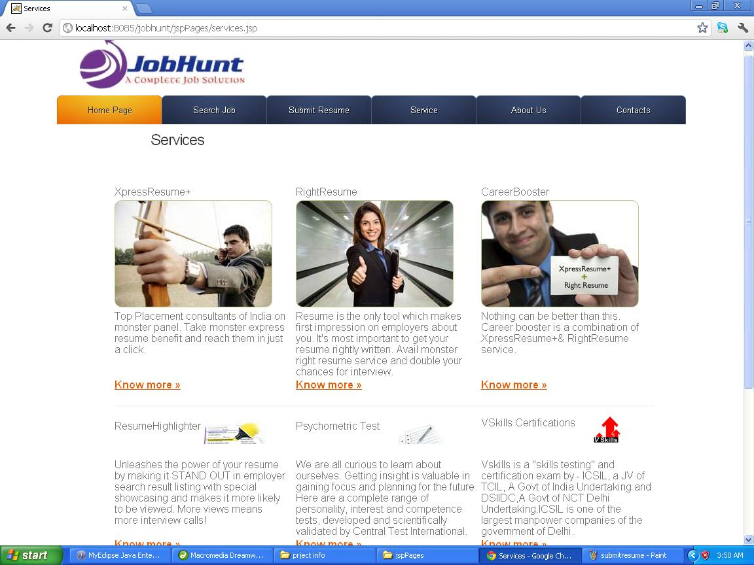
<%@ page contentType="text/html; charset=iso-8859-1" language="java" import="java.sql.*" errorPage="" %>
<!DOCTYPE html PUBLIC "-//W3C//DTD XHTML 1.0 Transitional//EN" "http://www.w3.org/TR/xhtml1/DTD/xhtml1-transitional.dtd">
<html xmlns="http://www.w3.org/1999/xhtml">
<head>
<meta http-equiv="Content-Type" content="text/html; charset=iso-8859-1" />
<title>Services</title>
<style type="text/css">
<!--
.style3 {font-size: 16px}
-->
</style>
</head>

<body>
<%@ include file="header.html"%>
<div style=" margin-top:10px; margin-left:230px;"><h2>Services</h2></div>
<div style="margin-left:140px;">
<table width="930" border="0" cellpadding="0" cellspacing="0">
<tbody><tr class="bg_grey">
<td width="11" align="left" valign="top">&nbsp;</td>
<td width="908" class="bg_grey"><img src="./Career Center - All Career Tips, Resume Services, Job Tips, Salary Negotiation Tips, A Complete guide to your Career_files/trans.gif" width="1" height="11"></td>
<td width="11" align="right" valign="top">&nbsp;</td>
</tr>
<tr>
<td class="bg_grey">&nbsp;</td>
<td width="908" valign="top"><table width="889" border="0" cellpadding="0" cellspacing="0">
<tbody><tr>
<td width="4" align="left" valign="top">&nbsp;</td>
<td width="899" valign="top">&nbsp;</td>
<td width="10" align="right" valign="top">&nbsp;</td>
</tr>
<tr>
<td>&nbsp;</td>
<td align="center" style="padding:5px 20px 5px 20px;"><table width="841" border="0" cellpadding="0" cellspacing="0">
<tbody><tr>
<td width="277" align="left" class="txt_13 bold" style="padding-bottom:5px; padding-left:0px;"><span class="txt_green">Xpress</span>Resume+</td>
<td width="17" class="txt_13 bold">&nbsp;</td>
<td width="277" align="left" class="txt_13 bold" style="padding-bottom:5px; padding-left:0px;"><span class="txt_green">Right</span>Resume</td>
<td width="6" class="txt_13 bold">&nbsp;</td>
<td width="264" align="left" class="txt_13 bold" style="padding-bottom:5px; padding-left:0px;"><span class="txt_green">Career</span>Booster</td>
</tr>
<tr>
<td><a href="http://expressresume.monsterindia.com/index.html"><img width="241" height="164" border="0" src="../images/img_xpressresume.jpg"></a></td>
<!-- <td><a href="http://www.monsterindia.com/resume_highlighter/index.html"><img src="http://media.monsterindia.com/v2.1/careerservices/img_xpressresume.jpg" width="241" height="164" /></a></td>-->

<td>&nbsp;</td>
<td><a href="http://resumeservice.monsterindia.com/index.html"><img width="241" height="164" border="0" src="../images/img_rightresume.jpg"></a></td>
<td>&nbsp;</td>

<td><a href="http://careerbooster.monsterindia.com/index.html"><img width="241" height="164" border="0" src="../images/img_careerbooster.jpg"></a></td>
</tr>
<tr>
<td align="left" valign="top" style="padding-top:4px;">Top Placement consultants of India on monster panel. Take monster express resume benefit and reach them in just a click. </td>
<td valign="top">&nbsp;</td>
<td align="left" valign="top" style="padding-top:4px;">Resume is the only tool which makes first impression on employers about you. It's most important to get your resume rightly written. Avail monster right resume service and double your chances for interview.</td>
<td valign="top">&nbsp;</td>
<td align="left" valign="top" style="padding-top:4px;">Nothing can be better than this. Career booster is a combination of XpressResume+&amp; RightResume service.</td>
</tr>
<tr>
<td align="left" valign="top" style="padding-top:4px;"><a href="http://expressresume.monsterindia.com/index.html" class="txt_purple"><strong>Know more » </strong></a></td>
<td valign="top">&nbsp;</td>
<td align="left" valign="top" style="padding-top:4px;"><a href="http://resumeservice.monsterindia.com/index.html" class="txt_purple"><strong>Know more »</strong></a> </td>
<td valign="top">&nbsp;</td>
<td align="left" valign="top" style="padding-top:4px;"><a href="http://careerbooster.monsterindia.com/index.html" class="txt_purple"><strong>Know more »</strong></a> </td>
</tr>
<tr>
<td colspan="5" align="left" valign="top" style="border-bottom:#eeeeee 1px solid;"><img src="./Career Center - All Career Tips, Resume Services, Job Tips, Salary Negotiation Tips, A Complete guide to your Career_files/trans.gif" width="1" height="22"></td>
</tr>

<tr>
<td colspan="5" align="left" valign="top">&nbsp;</td>
</tr>

<tr>
<td style="padding-top: 4px; padding-bottom: 0px; padding-left: 0px;" valign="bottom" align="left"><span class="txt_13 bold"><span class="txt_green">Resume</span>Highlighter <a href="http://www.monsterindia.com/resume_highlighter/index.html"><img src="../images/img_resumehighlighter.jpg" width="94" align="absmiddle" border="0" height="37"></a></span></td>
<td valign="top">&nbsp;</td>
<td span="span" class="txt_13 bold" style="padding-bottom: 0px; padding-left: 0px;" valign="bottom" align="left"><span class="txt_green style3">Psychometric </span><span class="style3">Test </span>&nbsp;&nbsp; &nbsp;<span class="txt_13 bold" style="padding-bottom: 0px; padding-left: 0px;"><a href="http://www.monsterindia.com/psychometrictest/index.html"><img src="../images/img_psychometric.jpg" width="82" align="absmiddle" border="0" height="37" /></a></span></td>
<td valign="top">&nbsp;</td>
<td valign="bottom" align="left" style="padding-bottom: 0px; padding-left: 0px;" class="txt_13 bold" span="span"><span class="txt_green style3">VSkills </span><span class="style3"> Certifications</span>&nbsp; &nbsp;&nbsp; &nbsp;&nbsp;<span style="padding-bottom: 0px; padding-left: 0px;" class="txt_13 bold"><a href="http://www.monsterindia.com/vskills/index.html"><img border="0" align="absmiddle" style="padding-bottom: 2px;" src="../images/img_vskills.gif"></a></span></td>
<!--<td span="span" class="txt_13 bold" style="padding-bottom: 0px; padding-left: 0px;" valign="bottom" align="left"><span class="txt_green">Career</span>Astrology&nbsp;&nbsp;&nbsp;&nbsp;&nbsp; <a href="http://www.monsterindia.com/career_astrology/index.html"><img src="http://media.monsterindia.com/v2.1/careerservices/img_careerastrology.jpg" width="89" align="absmiddle" border="0" height="37"></a></td>-->
</tr>
<tr>
<td align="left" valign="bottom" class="bg_green2">&nbsp;</td>
<td valign="top">&nbsp;</td>
<td align="left" valign="bottom" span="span" class="bg_green2" style="padding-bottom:0px; padding-left:0px;">&nbsp;</td>
<td valign="top">&nbsp;</td>
<td align="left" valign="bottom" span="span" class="bg_green2" style="padding-bottom:0px; padding-left:0px;">&nbsp;</td>
</tr>
<tr>
<td align="left" valign="top" style="padding-top:5px;">Unleashes the power of your resume by making it STAND OUT in employer search result listing with special showcasing and makes it more likely to be viewed. More views means more interview calls!</td>
<td valign="top">&nbsp;</td>
<td align="left" valign="top" style="padding-top:5px;">We are all curious to learn about ourselves. Getting insight is valuable in gaining focus and planning for the future. Here are a complete range of personality, interest and competence tests, developed and scientifically validated by Central Test International.</td>
<td valign="top">&nbsp;</td>
<td align="left" valign="top" style="padding-top:5px;">Vskills is a "skills testing" and certification exam by - ICSIL, a JV of TCIL, A Govt of India Undertaking and DSIIDC,A Govt of NCT Delhi Undertaking.ICSIL is one of the largest manpower companies of the government of Delhi.</td>
</tr>
<tr>
<td align="left" valign="top" style="padding-top:4px;"><a href="http://monsterindia.com/resume_highlighter/index.html" class="txt_purple"><strong>Know more » </strong></a></td>
<td valign="top">&nbsp;</td>
<td align="left" valign="top" style="padding-top:4px;"><a href="http://www.monsterindia.com/psychometrictest/index.html" class="txt_purple"><strong>Know more »</strong></a> </td>
<td valign="top">&nbsp;</td>
<td align="left" valign="top" style="padding-top:4px;"><a href="http://www.monsterindia.com/vskills/index.html" class="txt_purple"><strong>Know more »</strong></a> </td>
</tr>
<tr>
<td colspan="5" align="left" valign="top">&nbsp;</td>
</tr>

<!-- <tr>
<td colspan="5" align="left" valign="top" style="border-bottom:#eeeeee 1px solid;"><img src="http://media.monsterindia.com/v2.1/trans.gif" width="1" height="22" /></td>
</tr>-->

<tr>
<td colspan="5" align="left" valign="top">&nbsp;</td>
</tr>

<tr>
<td style="padding-bottom: 0px; padding-left: 0px;" class="txt_13 bold" span="span" align="left" valign="bottom"><span class="txt_green style3">24x7 </span><span class="style3"> Certifications</span>&nbsp; &nbsp;&nbsp;&nbsp; &nbsp;&nbsp;&nbsp;<span style="padding-bottom: 0px; padding-left: 0px;" class="txt_13 bold"><a href="http://www.monsterindia.com/24x7/index.html"><img style="padding-bottom: 2px;" src="../images/img_vskills.gif" align="absmiddle" border="0"></a></span></td>

<td></td>

<td colspan="4" rowspan="4" align="right" style="line-height:16px;"><table width="100%" border="0" align="right" cellpadding="0" cellspacing="0" class="border_grey">
<tbody><tr>
<form name="frmSearchJobs" method="post" action="http://jobsearch.monsterindia.com/searchresult.html" onsubmit="return validateSearchForm(this);"></form><td width="176" style="background:url(http://media.monsterindia.com/v2.1/jobsearch/jobsearch_mobile_up1.jpg) no-repeat right 1px; "><table width="100%" border="0" cellspacing="0" cellpadding="0">
<tbody><tr>
<td align="left" class="txt_13 bold" style="padding-left:10px; padding-top:10px;">Search Jobs </td>
</tr>
<tr>
<td align="left" style="padding-left:10px; padding-top:15px;" width="179"><input id="fts_id" name="fts" type="text" class="Small" size="27" value="Keywords" onblur="if(this.value==&#39;&#39;) { this.value = &#39;Keywords&#39;; }" onfocus="javascript:validateSearchForm(document.forms[0]);"> </td>
<td align="left" style=" padding-left:5px; padding-top:15px;" width="155"><select class="small" name="loc"><option value=""> - Select Location - </option><option value="196">Anywhere</option><option value="1">Ahmedabad</option><option value="2">Bangalore</option><option value="3">Chennai</option><option value="4">Delhi</option><option value="199">Delhi Region</option><option value="5">Gurgaon</option><option value="6">Hyderabad</option><option value="7">Kolkata</option><option value="8">Mumbai</option><option value="9">Noida</option><option value="10">Pune</option><option value="11">Agartala</option><option value="12">Agra</option><option value="13">Ahmednagar</option><option value="14">Aizawal</option><option value="15">Ajmer</option><option value="474">Alappuzha / Alleppey</option><option value="16">Aligarh</option><option value="17">Allahabad</option><option value="18">Ambala</option><option value="19">Amritsar</option><option value="20">Anand</option><option value="21">Ankleshwar</option><option value="22">Asansol</option><option value="23">Aurangabad</option><option value="483">Baddi</option><option value="24">Bhagalpur</option><option value="25">Bareilly</option><option value="26">Baroda / Vadodara</option><option value="27">Belgaum</option><option value="28">Bellary</option><option value="29">Bharuch</option><option value="30">Bhatinda</option><option value="31">Bhavnagar</option><option value="32">Bhilaigarh</option><option value="33">Bhopal</option><option value="34">Bhubaneshwar</option><option value="35">Bhuj</option><option value="36">Bidar</option><option value="37">Bilaspur</option><option value="38">Bokaro</option><option value="40">Chandigarh</option><option value="87">Cochin / Kochi / Ernakulam</option><option value="41">Coimbatore</option><option value="42">Cuttack</option><option value="43">Dalhousie</option><option value="44">Daman</option><option value="45">Dehradun</option><option value="46">Dhanbad</option><option value="47">Dharamsala</option><option value="48">Dharwad</option><option value="49">Dispur</option><option value="50">Durgapur</option><option value="52">Erode</option><option value="53">Faizabad</option><option value="54">Faridabad</option><option value="55">Gandhinagar</option><option value="56">Gangtok</option><option value="57">Ghaziabad</option><option value="58">Goa</option><option value="59">Gorakhpur</option><option value="60">Gulbarga</option><option value="61">Guntur</option><option value="62">Guwahati</option><option value="63">Gwalior</option><option value="64">Haldia</option><option value="65">Hisar</option><option value="66">Hosur</option><option value="67">Hubli</option><option value="475">Idukki</option><option value="68">Imphal</option><option value="69">Indore</option><option value="70">Itanagar</option><option value="71">Jabalpur</option><option value="72">Jaipur</option><option value="73">Jaisalmer</option><option value="74">Jalandhar</option><option value="75">Jalgaon</option><option value="76">Jammu</option><option value="77">Jamnagar</option><option value="78">Jamshedpur</option><option value="79">Jodhpur</option><option value="80">Kakinada</option><option value="81">Kandla</option><option value="82">Kannur</option><option value="83">Kanpur</option><option value="84">Karnal</option><option value="476">Kasargod</option><option value="85">Kavaratti</option><option value="86">Kharagpur</option><option value="88">Kohima</option><option value="89">Kolar</option><option value="90">Kolhapur</option><option value="91">Kollam</option><option value="92">Kota</option><option value="93">Kottayam</option><option value="39">Kozhikode / Calicut</option><option value="94">Kulu/Manali</option><option value="95">Kurnool</option><option value="96">Kurukshetra</option><option value="97">Lucknow</option><option value="98">Ludhiana</option><option value="99">Madurai</option><option value="477">Malappuram</option><option value="100">Mangalore</option><option value="101">Mathura</option><option value="102">Meerut</option><option value="103">Mohali</option><option value="104">Moradabad</option><option value="105">Mysore</option><option value="106">Nagercoil</option><option value="107">Nagpur</option><option value="108">Nasik</option><option value="109">Nellore</option><option value="110">Nizamabad</option><option value="111">Ooty</option><option value="112">Pallakad</option><option value="484">Panchkula</option><option value="113">Panipat</option><option value="114">Paradeep</option><option value="478">Pathanamthitta</option><option value="115">Pathankot</option><option value="116">Patiala</option><option value="117">Patna</option><option value="118">Pondicherry</option><option value="119">Porbandar</option><option value="120">Port Blair</option><option value="121">Puri</option><option value="122">Quilon</option><option value="123">Raipur</option><option value="124">Rajamundry</option><option value="125">Rajkot</option><option value="126">Ranchi</option><option value="127">Rohtak</option><option value="128">Roorkee</option><option value="129">Rourkela</option><option value="130">Salem</option><option value="131">Shillong</option><option value="132">Shimla</option><option value="482">Shimoga</option><option value="133">Sholapur</option><option value="134">Silchar</option><option value="135">Siliguri</option><option value="136">Silvassa</option><option value="480">Sonipat / Sonepat</option><option value="137">Srinagar</option><option value="138">Surat</option><option value="139">Thanjavur</option><option value="140">Thrissur / Trissur</option><option value="143">Thiruvananthapuram / Trivandrum</option><option value="141">Tirunalveli</option><option value="142">Tirupati</option><option value="144">Trichy</option><option value="145">Tuticorin</option><option value="146">Udaipur</option><option value="147">Ujjain</option><option value="149">Valsad</option><option value="150">Vapi</option><option value="151">Varanasi</option><option value="152">Vellore</option><option value="153">Vijayawada</option><option value="154">Visakhapatnam</option><option value="155">Warangal</option><option value="479">Wayanad</option><option value="481">Yamunanagar</option><option value="198">Other India</option><option value="485">Afghanistan</option><option value="156">Australia</option><option value="158">Bahrain</option><option value="157">Bangladesh</option><option value="159">Belgium</option><option value="160">Canada</option><option value="161">China</option><option value="250">Egypt</option><option value="164">France</option><option value="165">Germany</option><option value="204">Gulf</option><option value="166">Hongkong</option><option value="167">Indonesia</option><option value="486">Iraq</option><option value="168">Ireland</option><option value="169">Japan</option><option value="238">Jordan</option><option value="170">Kuwait</option><option value="237">Lebanon</option><option value="252">Macau</option><option value="171">Malaysia</option><option value="172">Maldives</option><option value="173">Mauritius</option><option value="174">Mexico</option><option value="175">Nepal</option><option value="176">Netherlands</option><option value="177">New Zealand</option><option value="178">Oman</option><option value="179">Pakistan</option><option value="249">Philippines</option><option value="180">Qatar</option><option value="181">Russia</option><option value="182">Saudi Arabia</option><option value="183">Singapore</option><option value="184">South Africa</option><option value="185">South Korea</option><option value="186">Spain</option><option value="187">SriLanka</option><option value="188">Sweden</option><option value="189">Switzerland</option><option value="253">Taiwan</option><option value="190">Thailand</option><option value="191">UK</option><option value="192">United Arab Emirates</option><option value="193">US</option><option value="254">Vietnam</option><option value="194">Yemen</option><option value="195">Zimbabwe</option><option value="197">Other International</option></select></td>
<td align="left" style="padding-top:15px; padding-left:10px;"><input name="Submit22" type="submit" class="Small" value="GO" onclick="javascript:actionForm();"></td>
</tr>
<tr>
<td align="center" style=" padding-top:15px;">&nbsp;</td>
</tr>
</tbody></table></td>
</tr>
</tbody></table></td>
</tr>
<tr>
<td align="left" valign="bottom" class="bg_green2">&nbsp;</td>
</tr>

<tr>
<td style="padding-top: 5px;" align="left" valign="top">24x7 Learning is India's premier Talent Lifecycle Management Company, providing eLearning services and offering Higher Education programs.</td>
</tr>
<tr>
<td align="left" valign="top" style="padding-top:4px;"><a href="http://www.monsterindia.com/24x7/index.html" class="txt_purple"><strong>Know more »</strong></a></td>
</tr>
</tbody></table></td>
<td align="right">&nbsp;</td>
</tr>
<tr>
<td align="left" valign="bottom">&nbsp;</td>
<td valign="bottom">&nbsp;</td>
<td align="right" valign="bottom">&nbsp;</td>
</tr>
</tbody></table></td>
<td class="bg_grey">&nbsp;</td>
</tr>
<tr>
<td width="11" align="left" valign="bottom" class="bg_grey">&nbsp;</td>
<td valign="bottom" class="bg_grey"><img src="./Career Center - All Career Tips, Resume Services, Job Tips, Salary Negotiation Tips, A Complete guide to your Career_files/trans.gif" width="1" height="11"></td>
<td width="11" align="right" valign="bottom" class="bg_grey">&nbsp;</td>
</tr>
</tbody></table>
</div>
<%@ include file="footer.html"%>
</body>
</html>
6.1.5 aboutus.jsp
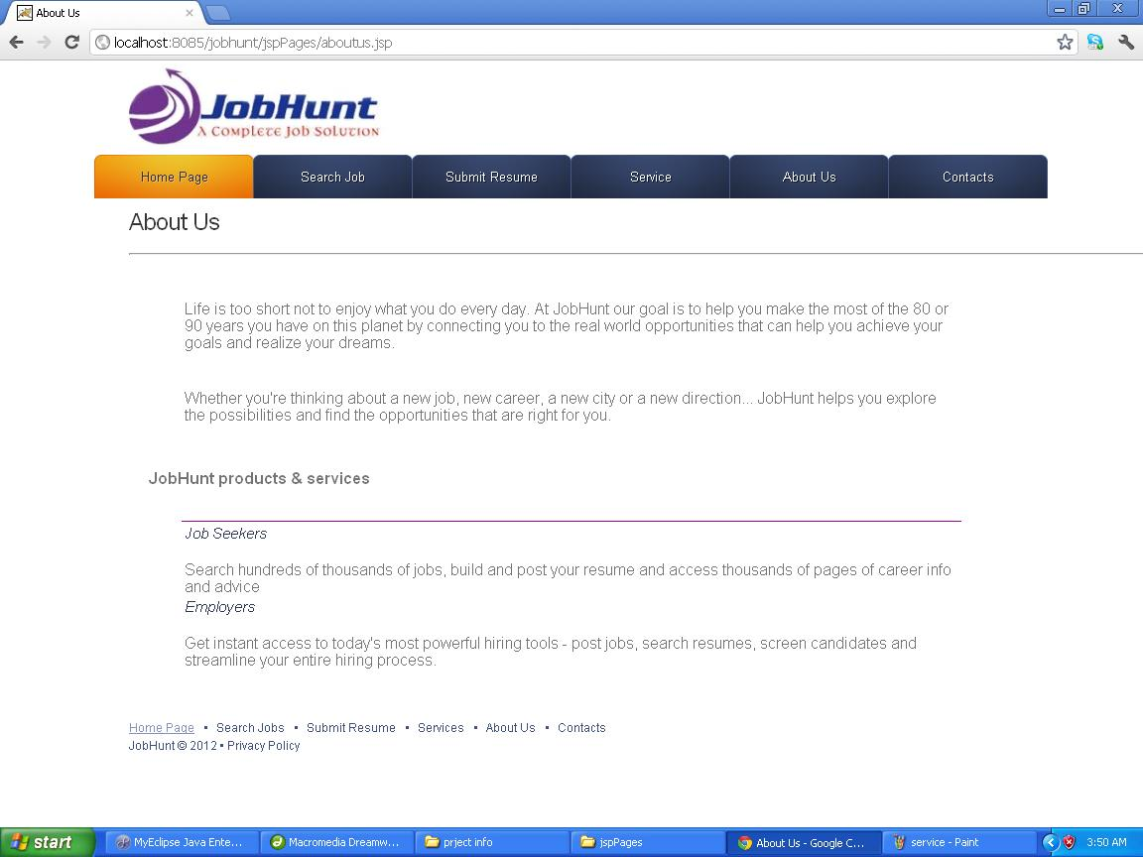
<%@ page contentType="text/html; charset=iso-8859-1" language="java" import="java.sql.*" errorPage="" %>
<!DOCTYPE html PUBLIC "-//W3C//DTD XHTML 1.0 Transitional//EN" "http://www.w3.org/TR/xhtml1/DTD/xhtml1-transitional.dtd">
<html xmlns="http://www.w3.org/1999/xhtml">
<head>
<meta http-equiv="Content-Type" content="text/html; charset=iso-8859-1" />
<title>About Us</title>
</head>

<body>
<%@ include file="header.html"%>
<div style=" margin-top:10px; margin-left:130px;"><h2>About Us</h2><hr ></div>
<div>
<p>&nbsp;</p>
<table width="786" height="165" align="center" >
<tr>
<td>Life is too short not to enjoy what you do every day. At JobHunt our goal is to help you make the most of the 80 or 90 years you have on this planet by connecting you to the real world opportunities that can help you achieve your goals and realize your dreams.</td>
</tr>

<tr>
<td>Whether you're thinking about a new job, new career, a new city or a new direction... JobHunt helps you explore the possibilities and find the opportunities that are right for you.</td>
</tr>

</table>
<div style="margin-left:150px; margin-top:10px;">
<h5>JobHunt products & services</h5>
</div>
<p>&nbsp;</p>
<table width="786" align="center" frame="above" bordercolor="#990099">
<tr><td><h4>Job Seekers</h4></td></tr>
<tr><td>Search hundreds of thousands of jobs, build and post your resume and access thousands of pages of career info and advice </td></tr>

<tr><td><h4>Employers</h4></td></tr>
<tr><td>Get instant access to today's most powerful hiring tools - post jobs, search resumes, screen candidates and streamline your entire hiring process.</td></tr>
</table>

</div>
<p>&nbsp;</p>
<p>
<%@ include file="footer.html"%>
</p>
<p>&nbsp;</p>
</body>
</html>
6.1.6 contacts.jsp
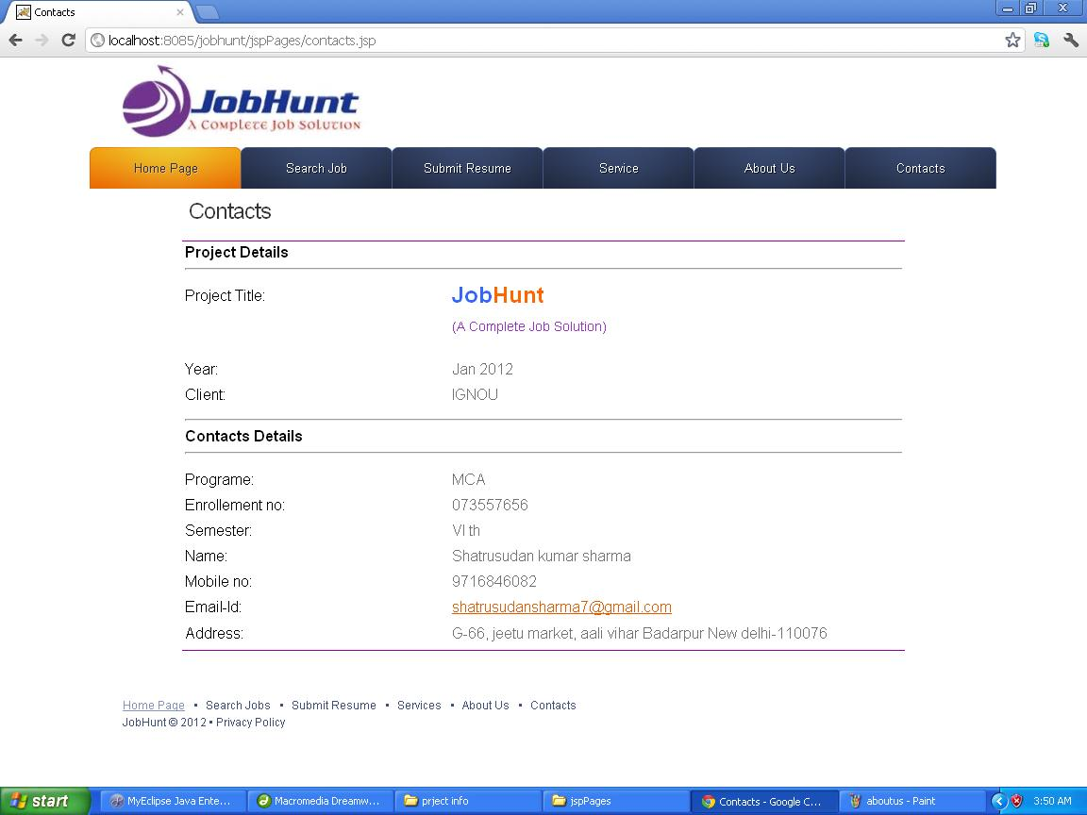

<%@ page contentType="text/html; charset=iso-8859-1" language="java" import="java.sql.*" errorPage="" %>
<!DOCTYPE html PUBLIC "-//W3C//DTD XHTML 1.0 Transitional//EN" "http://www.w3.org/TR/xhtml1/DTD/xhtml1-transitional.dtd">
<html xmlns="http://www.w3.org/1999/xhtml">
<head>
<meta http-equiv="Content-Type" content="text/html; charset=iso-8859-1" />
<title>Contacts</title>
<style type="text/css">
<!--
.style1 {color: #3366FF}
.style2 {color: #FF6600}
.style3 {
font-size: 14px;
color: #9933CC;
}
.style4 {
font-size: 24px;
font-weight: bold;
}
.style5 {
color: #000000;
font-weight: bold;
}
.style6 {color: #000000}
-->
</style>
</head>

<body>
<%@ include file="header.html"%>
<div style=" margin-top:10px; margin-left:200px;"><h2>Contacts</h2></div>
<div><table width="766" height="435" align="center" bordercolor="#990099" frame="hsides">
<tr>
<td colspan="2"><span class="style5">Project Details </span>
<hr ></td>
</tr>
<tr>
<td width="239"><span class="style6">Project Title: </span></td>
<td width="408"><p class="style4"><span class="style1">Job</span><span class="style2">Hunt</span></p>
<p class="style3">(A Complete Job Solution)</p></td>
</tr>
<tr>
<td><span class="style6">Year:</span></td>
<td>Jan 2012</td>
</tr>
<tr>
<td><span class="style6">Client:</span></td>
<td>IGNOU</td>
</tr>
<tr>
<td colspan="2"><hr >
<span class="style5">Contacts Details </span>
<hr ></td>
</tr>
<tr>
<td width="239"><span class="style6">Programe:</span></td>
<td>MCA</td>
</tr>
<tr>
<td><span class="style6">Enrollement no: </span></td>
<td>073557656</td>
</tr>
<tr>
<td><span class="style6">Semester:</span></td>
<td>VI th </td>
</tr>
<tr>
<td><span class="style6">Name:</span></td>
<td>Shatrusudan kumar sharma </td>
</tr>
<tr>
<td><span class="style6">Mobile no: </span></td>
<td>9716846082</td>
</tr>
<tr>
<td><span class="style6">Email-Id:</span></td>
<td><a href="#">shatrusudansharma7@gmail.com</a></td>
</tr>
<tr>
<td><span class="style6">Address:</span></td>
<td>G-66, jeetu market, aali vihar Badarpur New delhi-110076 </td>
</tr>
</table>
</div>

<p>&nbsp;</p>
<p>
<%@ include file="footer.html"%>
</p>
</body>
</html>
6.1.7 admin home.jsp
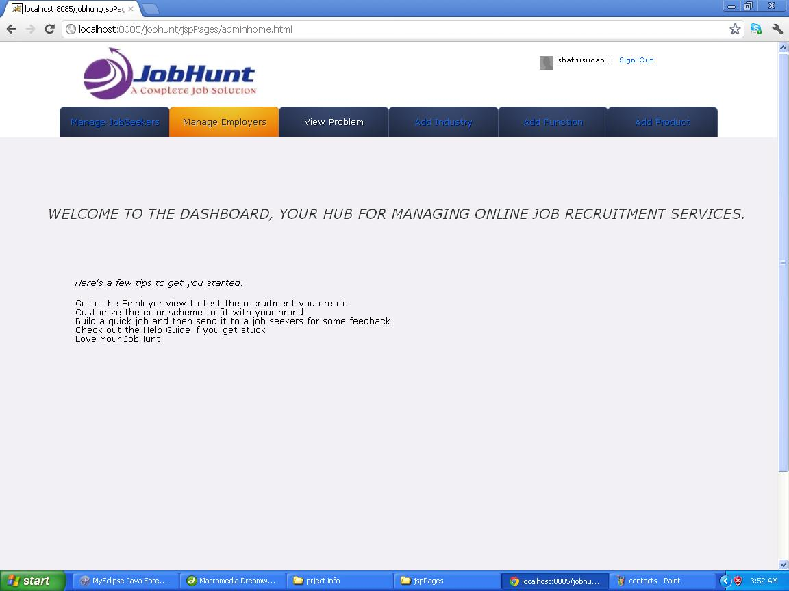
<jsp:useBean id="user" class="com.techmentro.lms.beans.User" scope="session"/>
<!DOCTYPE html>
<html lang="en">
<head>
<title></title>
<meta charset="utf-8">
<link rel="stylesheet" href="../css/reset.css" type="text/css" media="all">
<link rel="stylesheet" href="../css/grid.css" type="text/css" media="all">
<link rel="stylesheet" href="../css/style.css" type="text/css" media="all">
<link href="../css/v3.css" rel="stylesheet" type="text/css">
<link href="../css/theme.css" rel="stylesheet" type="text/css">
</head>
<body>
<div id="main">
<!-- header -->
<header>
<div class="logo">
<div ><img src="../images/final logo.jpg"></div>
</div>
<div style="margin-left:700px; margin-top:20px;"class="nav">
<a href=""><img src="../images/avatar.png" alt="" class="mini-pic" border="0"></a>
<span class="">shatrusudan </span>&nbsp;|&nbsp;

<a href="../actions/logout">Sign-Out</a>
</div>
<nav>
<ul>
<li><a href="managejs.jsp">Manage JobSeekers</a></li>
<li><a href="manageemp.jsp" class="current">Manage Employers</a></li>
<li><a href="addcat.jsp">View Problem</a></li>
<li><a href="addind.jsp">Add Industry</a></li>
<li><a href="addfun.jsp">Add Function</a></li>
<li><a href="addp.jsp">Add Product</a></li>
</ul>
</nav>
</header>
</div>

<div id="page-body">
<p>&nbsp;</p>
<p>&nbsp;</p>

<h3>
Welcome to the dashboard, your hub for managing online Job Recruitment Services.</h3>
<p>&nbsp;</p>
<p>&nbsp;</p>
<div style="margin-left:100px;">
<p class="italic">
Here's a few tips to get you started:</p>
<ul>
<li>Go to the Employer view to test the recruitment you create</li>
<li>Customize the color scheme to fit with your brand</li>
<li>Build a quick job and then send it to a job seekers for some feedback</li>
<li>Check out the Help Guide if you get stuck</li>
<li>Love Your JobHunt!</li>
</ul>

</div>

</div>
</body>
</html>
6.1.8 manage jobseeker.jsp
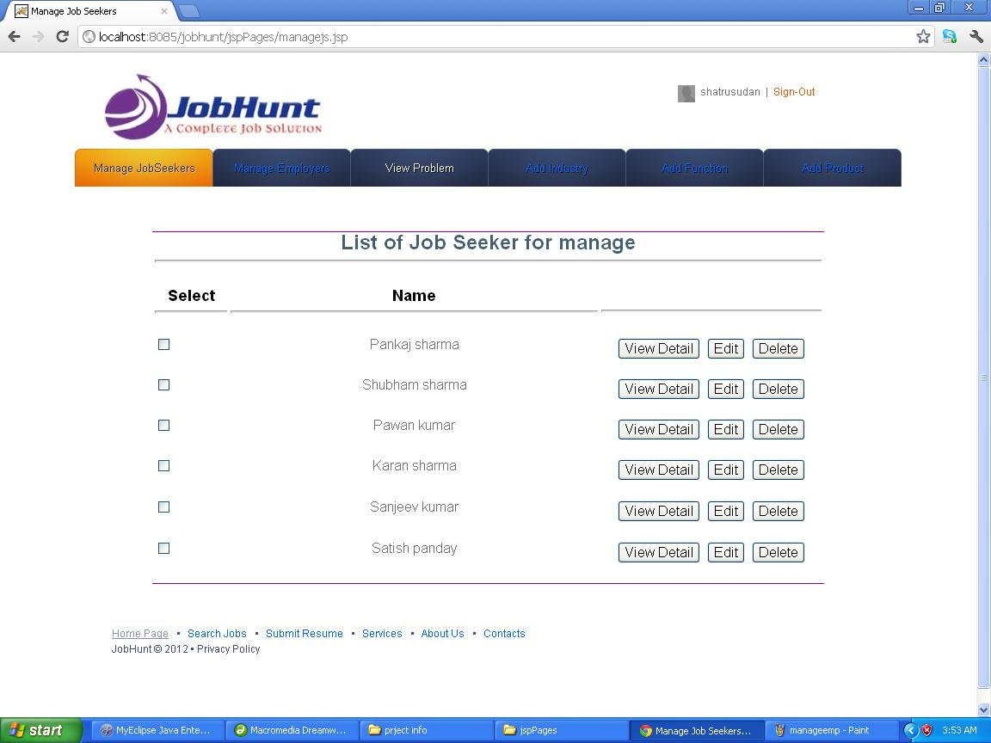

<%@ page import="com.jobhunt.beans.*" %>
<%@ page import="java.util.*" %>

<%
List<js> list=(List<js>)request.getAttribute("jobseeker");
Iterator<js> itr=list.iterator();
%>
<table width="100%" height="50%">
<tr>
<td width="15%">Title</td><td width="25%">Description</td><td width="10%">DOC</td>
<td width="10%">name</td><td width="10%">name</td><td width="5%">Learners</td>
<td width="10%">location</td><td width="15%">location</td>
</tr>
<%
while(itr.hasNext())
{
js js=itr.next();
%>
<tr>
<td width="15%"><%=js.getTitle() %> </td><td width="25%"><%=js.getDescription() %></td><td width="10%"><%=js.getDoc() %></td>
<td width="10%"><%=js.getStatus() %></td><td width="10%"><%=js.getFee() %></td><td width="5%"><%=js.getLearners() %></td>
<td width="10%"><%=js.getLessons() %></td><td width="15%"><a href="<%="editCourse?id="+js.getId() %>">edit</a> <a href="<%="deleteCourse?id="+js.getId() %>">delete</a></td>
</tr>
<%
}

%>
</table>

6.1.9 manage employer.jsp
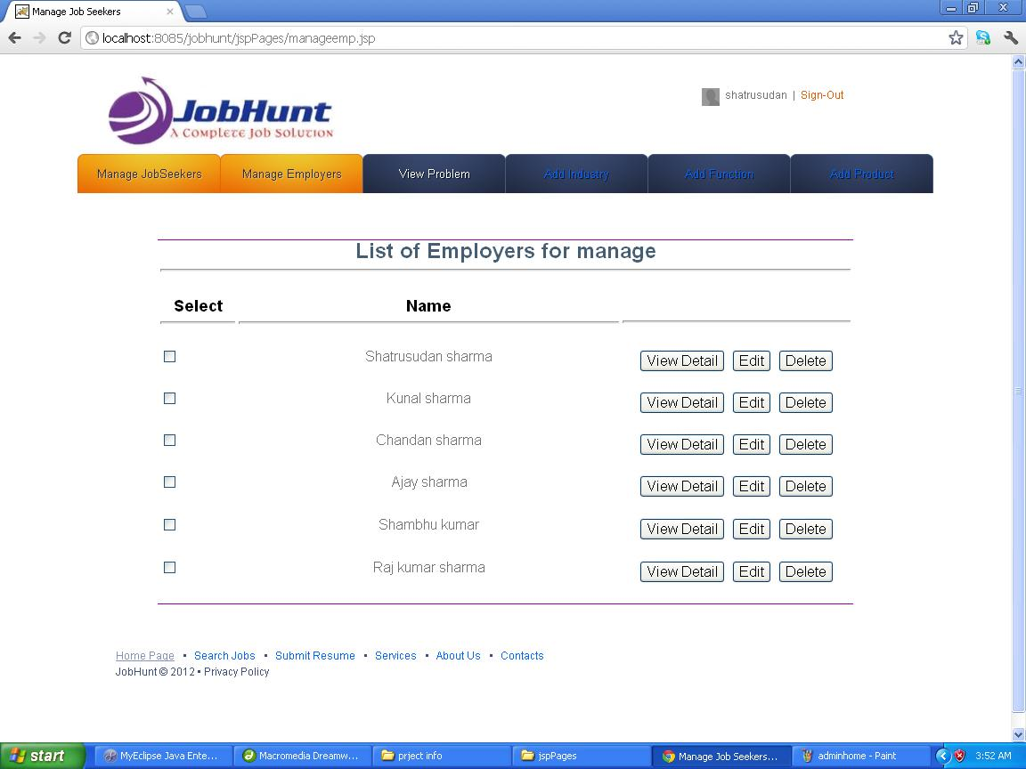
<%@ page import="com.jobhunt.beans.*" %>
<%@ page import="java.util.*" %>

<%
List<emp> list=(Listemp>)request.getAttribute("emp");
Iterator<emp> itr=list.iterator();
%>
<table width="100%" height="50%">
<tr>
<td width="15%">Title</td><td width="25%">Description</td><td width="10%">DOC</td>
<td width="10%">Status</td><td width="10%">Fee</td><td width="5%">Learners</td>
<td width="10%">Lessons</td><td width="15%">Actions</td>
</tr>
<%
while(itr.hasNext())
{
Emp emp=itr.next();
%>
<tr>
<td width="15%"><%=emp.getTitle() %> </td><td width="25%"><%=emp.getDescription() %></td><td width="10%"><%=course.getDoc() %></td>
<td width="10%"><%=emp.getStatus() %></td><td width="10%"><%=course.getFee() %></td><td width="5%"><%=emp.getLearners() %></td>
<td width="10%"><%=emp.getLessons() %></td><td width="15%"><a href="<%="editCourse?id="+emp.getId() %>">edit</a> <a href="<%="deleteCourse?id="+emp.getId() %>">delete</a></td>
</tr>
<%
}

%>
</table>
6.1.10 add industry.jsp
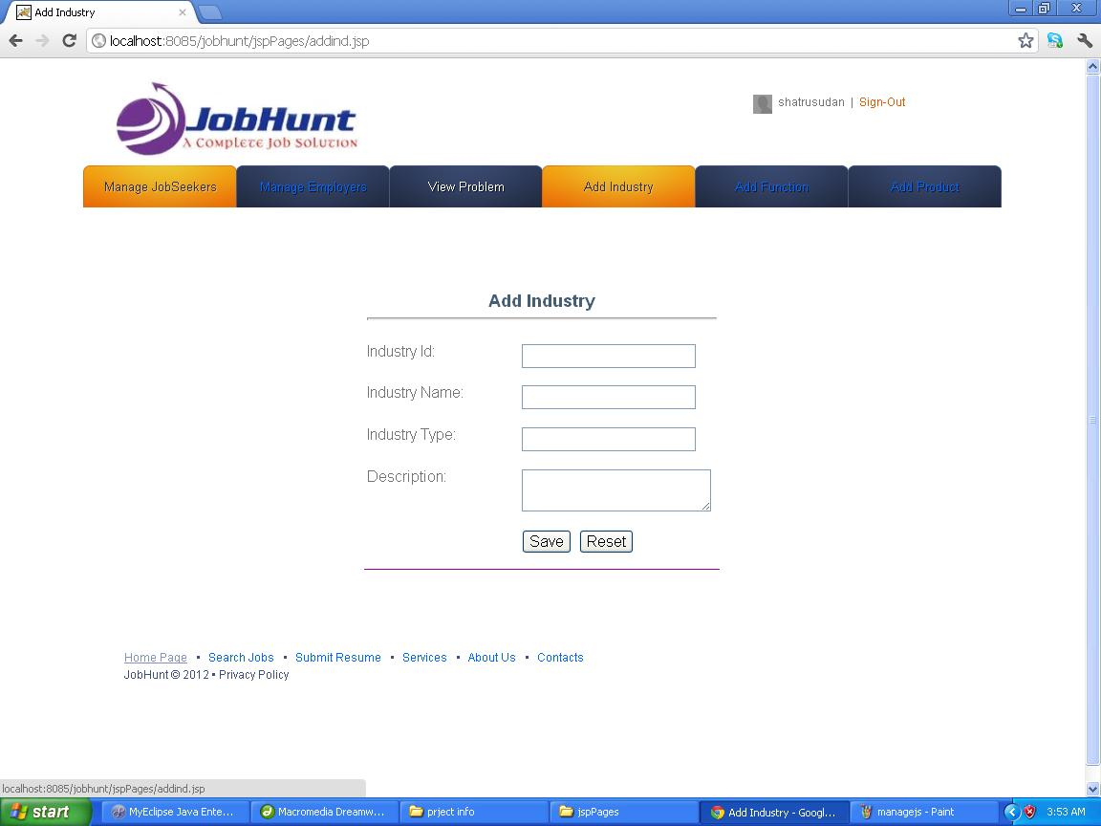
Addindustry.jsp
<%@ page import="com.jobhunt.managers.*" %>
<jsp:useBean id="course" class="com.jobhunt.beans.Course" />
<jsp:setProperty name="ind" property="*" />
<%
System.out.println("In Newind.jsp");
IndManager manager=new indManager();
String result=manager.indCourse(course);
ViewManager vm=new ViewManager();
System.out.println("Invoking viewManager for "+result);
vm.generateView(result,pageContext);
%>

<%@ page contentType="text/html; charset=iso-8859-1" language="java" import="java.sql.*" errorPage="" %>
<!DOCTYPE html PUBLIC "-//W3C//DTD XHTML 1.0 Transitional//EN" "http://www.w3.org/TR/xhtml1/DTD/xhtml1-transitional.dtd">
<html xmlns="http://www.w3.org/1999/xhtml">
<head>
<meta http-equiv="Content-Type" content="text/html; charset=iso-8859-1" />
<title>Add Industry</title>
<style type="text/css">
<!--
.style1 {
font-size: 18px;
font-weight: bold;
}
-->
</style>
</head>

<body>
<p>
<%@ include file="adminheader.html"%>
</p><form id="form1" name="form1" method="post" action="">
<p>&nbsp;</p>
<p>&nbsp;</p>
<table width="372" height="293" border="0" align="center" frame="below" bordercolor="#990099">
<tr>
<td colspan="2"><div align="center" class="style1">Add Industry <hr ></div></td>
</tr>
<tr>
<td width="156">Industry Id: </td>
<td width="206">
<label>
<input type="text" name="textfield" />
</label> </td>
</tr>
<tr>
<td>Industry Name: </td>
<td><input type="text" name="textfield2" /></td>
</tr>
<tr>
<td>Industry Type: </td>
<td><input type="text" name="textfield3" /></td>
</tr>
<tr>
<td>Description:</td>
<td><label>
<textarea name="textarea" cols="25"></textarea>
</label></td>
</tr>
<tr>
<td>&nbsp;</td>
<td><label>
<input type="submit" name="Submit" value="Save" />
<input type="reset" name="Submit2" value="Reset" />
</label></td>
</tr>
</table>
</form>
<p>&nbsp;</p>
<p>&nbsp;</p>
<p>
<%@ include file="footer.html"%>
</p>
</body>
</html>

6.1.11 add function.jsp
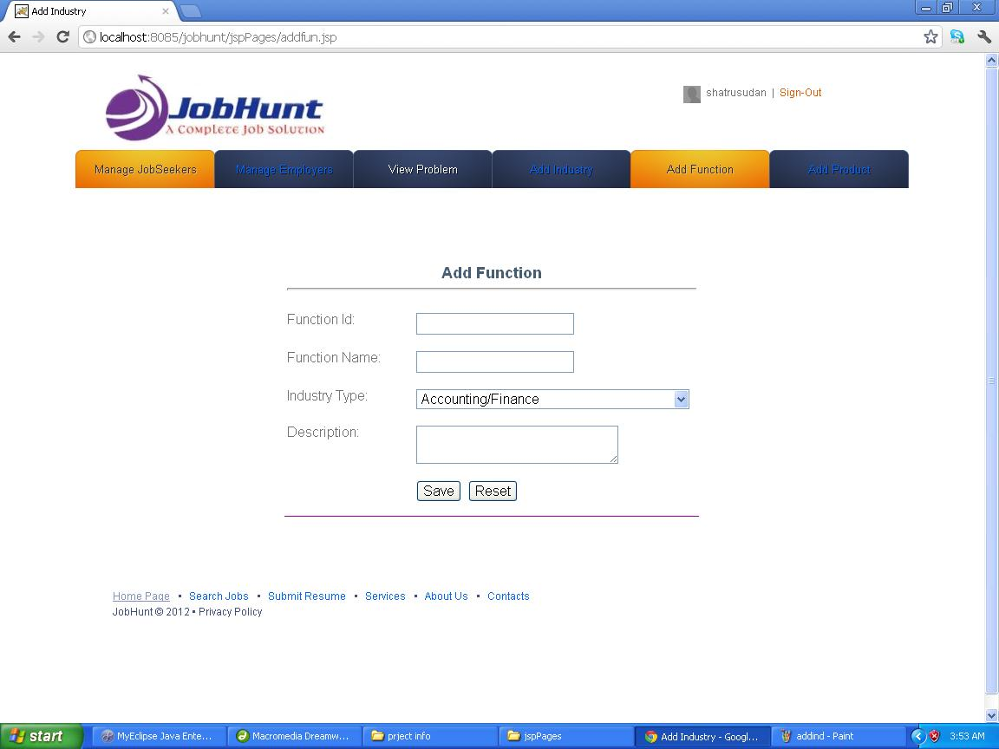
Addfunction.jsp
<%@ page import="com.jobhunt.managers.*" %>
<jsp:useBean id="fun" class="com.jobhunt.beans.fun" />
<jsp:setProperty name="fun" property="*" />
<%
System.out.println("In Newfun.jsp");
funManager manager=new funManager();
String result=manager.function(fun);
ViewManager vm=new ViewManager();
System.out.println("Invoking viewManager for "+result);
vm.generateView(result,pageContext);
%>
<%@ page contentType="text/html; charset=iso-8859-1" language="java" import="java.sql.*" errorPage="" %>
<!DOCTYPE html PUBLIC "-//W3C//DTD XHTML 1.0 Transitional//EN" "http://www.w3.org/TR/xhtml1/DTD/xhtml1-transitional.dtd">
<html xmlns="http://www.w3.org/1999/xhtml">
<head>
<meta http-equiv="Content-Type" content="text/html; charset=iso-8859-1" />
<title>Add Industry</title>
<style type="text/css">
<!--
.style1 {
font-size: 18px;
font-weight: bold;
}
-->
</style>
</head>

<body>
<p>
<%@ include file="adminheader.html"%>
</p><form id="form1" name="form1" method="post" action="">
<p>&nbsp;</p>
<p>&nbsp;</p>
<table width="478" height="293" border="0" align="center" frame="below" bordercolor="#990099">
<tr>
<td colspan="2"><div align="center" class="style1">Add Function <hr ></div></td>
</tr>
<tr>
<td width="143">Function Id: </td>
<td width="325">
<label>
<input type="text" name="textfield" />
</label> </td>
</tr>
<tr>
<td>Function Name: </td>
<td><input type="text" name="textfield2" /></td>
</tr>
<tr>
<td>Industry Type: </td>
<td><select name="industry" id="industry">
<option>Hotels/Restaurants/Airlines/Travel</option>
<option>Textiles/Garments/Accessories</option>
<option>Auto/Auto Ancillary</option>
<option>Chemicals/PetroChemical/Plastic/Rubber</option>
<option selected="selected">Accounting/Finance</option>
<option>FMCG/Foods/Beverage</option>
<option>Construction/Engineering/Cement/Metals</option>
<option>Banking/Financial Services/Broking</option>
<option>Export/Import</option>
<option>IT-Hardware &amp; Networking</option>
<option>Industrial Products/Heavy Machinery</option>
<option>Courier/Transportation/Freight</option>
<option>Media/Dotcom/Entertainment</option>
<option>Office Equipment/Automation</option>
<option>Oil and Gas/Power/Infrastructure/Energy</option>
<option>IT-Software/Software Services</option>
<option>Education/Teaching/Training</option>
<option>Architecture/Interior Designing</option>
<option>Agriculture/Dairy</option>
<option>NGO/Social Services</option>
<option>KPO / Research /Analytics</option>
<option>Electricals / Switchgears</option>
<option>Wellness/Fitness/Sports</option>
<option>Heat Ventilation Air Conditioning</option>
</select></td>
</tr>
<tr>
<td>Description:</td>
<td><label>
<textarea name="textarea" cols="30"></textarea>
</label></td>
</tr>
<tr>
<td>&nbsp;</td>
<td><label>
<input type="submit" name="Submit" value="Save" />
<input type="reset" name="Submit2" value="Reset" />
</label></td>
</tr>
</table>
</form>
<p>&nbsp;</p>
<p>&nbsp;</p>
<p>
<%@ include file="footer.html"%>
</p>
</body>
</html>
6.1.12 add product.jsp
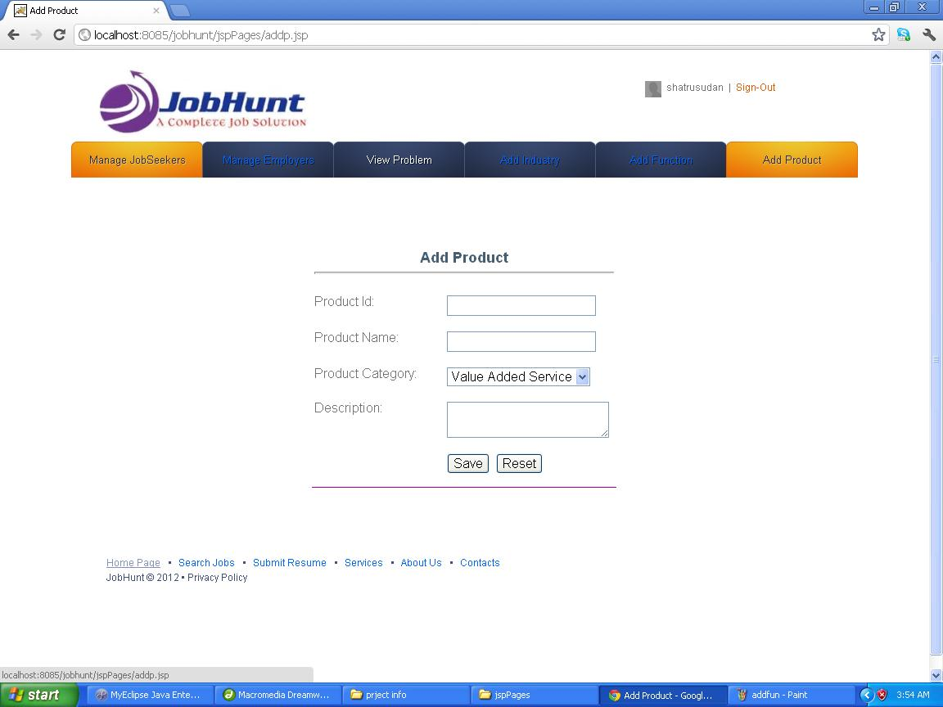
Addpro.jsp
<%@ page import="com.jobhunt.managers.*" %>
<jsp:useBean id="fun" class="com.jobhunt.beans.fun" />
<jsp:setProperty name="fun" property="*" />
<%
System.out.println("In Newfun.jsp");
funManager manager=new funManager();
String result=manager.function(fun);
ViewManager vm=new ViewManager();
System.out.println("Invoking viewManager for "+result);
vm.generateView(result,pageContext);
%>

<%@ page contentType="text/html; charset=iso-8859-1" language="java" import="java.sql.*" errorPage="" %>
<!DOCTYPE html PUBLIC "-//W3C//DTD XHTML 1.0 Transitional//EN" "http://www.w3.org/TR/xhtml1/DTD/xhtml1-transitional.dtd">
<html xmlns="http://www.w3.org/1999/xhtml">
<head>
<meta http-equiv="Content-Type" content="text/html; charset=iso-8859-1" />
<title>Add Product</title>
<style type="text/css">
<!--
.style1 {
font-size: 18px;
font-weight: bold;
}
-->
</style>
</head>

<body>
<p>
<%@ include file="adminheader.html"%>
</p><form id="form1" name="form1" method="post" action="">
<p>&nbsp;</p>
<p>&nbsp;</p>
<table width="372" height="293" border="0" align="center" frame="below" bordercolor="#990099">
<tr>
<td colspan="2"><div align="center" class="style1">Add Product <hr ></div></td>
</tr>
<tr>
<td width="156">Product Id: </td>
<td width="206">
<label>
<input type="text" name="textfield" />
</label> </td>
</tr>
<tr>
<td>Product Name: </td>
<td><input type="text" name="textfield2" /></td>
</tr>
<tr>
<td>Product Category: </td>
<td><label>
<select name="select">
<option>Value Added Service</option>
<option>Mail service</option>
<option>Message service</option>
</select>
</label></td>
</tr>
<tr>
<td>Description:</td>
<td><label>
<textarea name="textarea" cols="25"></textarea>
</label></td>
</tr>
<tr>
<td>&nbsp;</td>
<td><label>
<input type="submit" name="Submit" value="Save" />
<input type="reset" name="Submit2" value="Reset" />
</label></td>
</tr>
</table>
</form>
<p>&nbsp;</p>
<p>&nbsp;</p>
<p>
<%@ include file="footer.html"%>
</p>
</body>
</html>
6.1.13 searchu job.jsp (jobseekers)
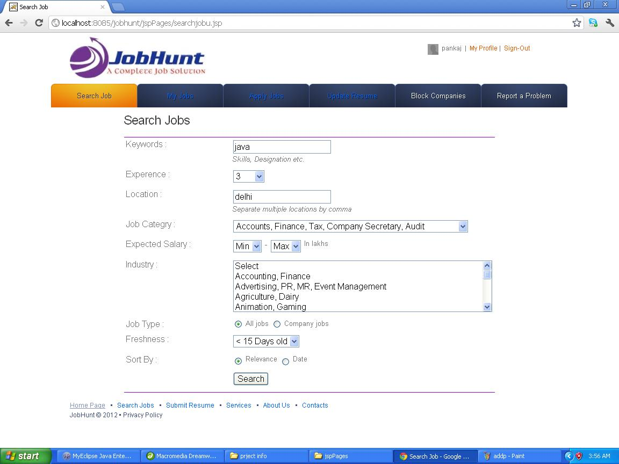
<%@ page import="com.jobhunt.managers.*" %>
<jsp:useBean id="user" class="com.jobhunt.beans.User" scope="session"/>
<jsp:setProperty name="job" property="keyword" />
<jsp:setProperty name="job" property="location" />
<jsp:setProperty name="job" property="expercience" />
<jsp:setProperty name="job" property="eligibility" />
<jsp:setProperty name="job" property="industrytype" />
<jsp:setProperty name="job" property="category" />

<%
System.out.println("In search.jsp");
JobManager manager=new JobManager();
String result=manager.login(job);
ViewManager vm=new ViewManager();
System.out.println("Invoking viewManager for "+result);
vm.generateView(result,pageContext);
%>

<%@ page contentType="text/html; charset=iso-8859-1" language="java" import="java.sql.*" errorPage="" %>
<!DOCTYPE html PUBLIC "-//W3C//DTD XHTML 1.0 Transitional//EN" "http://www.w3.org/TR/xhtml1/DTD/xhtml1-transitional.dtd">
<html xmlns="http://www.w3.org/1999/xhtml">
<head>
<meta http-equiv="Content-Type" content="text/html; charset=iso-8859-1" />
<title>Search Job</title>
<link rel="stylesheet" href="../css/reset.css" type="text/css" media="all">
<link rel="stylesheet" href="../css/style.css" type="text/css" media="all">
<style type="text/css">
<!--
.style2 {font-size: x-large; color: #000000;}
.style4 {font-size: small}
-->
</style>
</head>

<body>
<%@ include file="header.html"%>
<form method="get" action="search.jsp">
<div style=" margin-top:10px; margin-left:230px;"><h2>Search Jobs</h2></div>
<table width="690" height="476" align="center" bordercolor="#9900CC" frame="hsides">

<tr>
<td width="198">Keywords :</td>
<td width="378"><label>
<input type="text" name="textfield" />
<br />
<em class="dispBlk style4">Skills, Designation etc.</em></label></td>
</tr>
<tr>
<td>Experence :</td>
<td><select name="qe" id="expSL">
<option value="" selected="selected">Exp.</option>
<option value="0">0</option>
<option value="1">1</option>
<option value="2">2</option>
<option value="3">3</option>
<option value="4">4</option>
<option value="5">5</option>
<option value="6">6</option>
<option value="7">7</option>
<option value="8">8</option>
<option value="9">9</option>
<option value="10">10</option>
<option value="11">11</option>
<option value="12">12</option>
<option value="13">13</option>
<option value="14">14</option>
<option value="15">15</option>
<option value="16">16</option>
<option value="17">17</option>
<option value="18">18</option>
<option value="19">19</option>
<option value="20">20</option>
<option value="21">21</option>
<option value="22">22</option>
<option value="23">23</option>
<option value="24">24</option>
<option value="25">25</option>
<option value="26">26</option>
<option value="27">27</option>
<option value="28">28</option>
<option value="29">29</option>
<option value="30">30</option>
</select>
</td>
</tr>
<tr>
<td>Location :</td>
<td><label>
<input type="text" name="textfield2" />
<br />
<em class="dispBlk style4">Separate multiple locations by comma</em></label></td>
</tr>
<tr>
<td>Job Categry : </td>
<td><span class="errR">
<select name="qf[]" onchange="removeError(new Array('qp','ql','eo','idqi'),'form',1);" id="fareaSL">
<option value="" selected="selected">Select</option>
<optgroup label="Top Categories"></optgroup>
<option value="1">Accounts, Finance, Tax, Company Secretary, Audit</option>
<option value="6">Financial Services, Banking, Investments, Insurance</option>
<option value="8">ITES, BPO, KPO, LPO, Customer Service, Operations</option>
<option value="12">HR, Recruitment, Administration, IR</option>
<option value="15">Marketing, Advertising, MR, PR, Media Planning</option>
<option value="19">Production, Manufacturing, Maintenance</option>
<option value="20">Site Engineering, Project Management</option>
<option value="21">Engineering Design, R&amp;D</option>
<option value="22">Sales, Retail, Business Development</option>
<option value="24">IT Software - All Jobs</option>
<optgroup label="IT Software Categories"></optgroup>
<option value="24.01">Application Programming, Maintenance</option>
<option value="24.02">Client / Server Programming</option>
<option value="24.03">DBA, Datawarehousing</option>
<option value="24.04">ERP, CRM</option>
<option value="24.05">Embedded, EDA, VLSI, ASIC, Chip Design</option>
<option value="24.06">Network Administration, Security</option>
<option value="24.08">QA &amp; Testing</option>
<option value="24.09">System Programming</option>
<option value="24.10">Telecom Software</option>
<option value="24.11">Systems, EDP, MIS</option>
<option value="24.12">eCommerce, Internet Technologies</option>
<option value="24.13">Mainframe</option>
<option value="24.14">Mobile</option>
<option value="24.15">Middleware</option>
<option value="24.07">Other</option>
<optgroup label="More Categories"></optgroup>
<option value="catid_2">Top Management - IT Jobs</option>
<option value="catid_1">Top Management - Non IT</option>
<option value="2">Architecture, Interior Design</option>
<option value="3">Design, Creative, User Experience</option>
<option value="4">Hotels, Restaurants</option>
<option value="5">Journalism, Editing, Content</option>
<option value="7">Strategy, Management Consulting, Corporate Planning</option>
<option value="9">Self Employed, Entrepreneur, Independent Consultant</option>
<option value="10">Export, Import, Merchandising</option>
<option value="11">Executive Assistant, Front Office, Data Entry</option>
<option value="13">Legal, Regulatory, Intellectual Property</option>
<option value="14">Supply Chain, Logistics, Purchase, Materials</option>
<option value="16">Medical, Healthcare, R&amp;D, Pharmaceuticals, Biotechnology</option>
<option value="18">Packaging</option>
<option value="36">Teaching, Education, Training, Counselling</option>
<option value="37">IT Hardware, Technical Support, Telecom Engineering</option>
<option value="42">Fashion Designing, Merchandising</option>
<option value="43">TV, Films, Production, Broadcasting</option>
<option value="44">Travel, Tours, Ticketing, Airlines</option>
<option value="45">Defence Forces, Security Services</option>
<option value="catid_28">Government, Defence</option>
<option value="catid_29">Overseas, International Jobs</option>
<option value="catid_57">Retail, Wholesale</option>
<option value="catid_31">Pharma, Biotechnology, Clinical Research</option>
<option value="catid_22">Freshers</option>
<option value="41">Others</option>
</select>
</span></td>
</tr>
<tr>
<td>Expected Salary : </td>
<td><select name="qm" id="minSalSL" onchange="change_qx('on');" ;="">
<option value="-1">Min</option>
<option value="12477">&lt; .5</option>
<option value="1">1</option>
<option value="2">2</option>
<option value="3">3</option>
<option value="4">4</option>
<option value="5">5</option>
<option value="6">6</option>
<option value="7">7</option>
<option value="8">8</option>
<option value="9">9</option>
<option value="10">10</option>
<option value="11">11</option>
<option value="12">12</option>
<option value="13">13</option>
<option value="14">14</option>
<option value="15">15</option>
<option value="16">16</option>
<option value="17">17</option>
<option value="18">18</option>
<option value="19">19</option>
<option value="20">20</option>
<option value="21">21</option>
<option value="22">22</option>
<option value="23">23</option>
<option value="24">24</option>
<option value="25">25</option>
<option value="26">26</option>
<option value="27">27</option>
<option value="28">28</option>
<option value="29">29</option>
<option value="30">30</option>
<option value="31">31</option>
<option value="32">32</option>
<option value="33">33</option>
<option value="34">34</option>
<option value="35">35</option>
<option value="36">36</option>
<option value="37">37</option>
<option value="38">38</option>
<option value="39">39</option>
<option value="40">40</option>
<option value="41">41</option>
<option value="42">42</option>
<option value="43">43</option>
<option value="44">44</option>
<option value="45">45</option>
<option value="46">46</option>
<option value="47">47</option>
<option value="48">48</option>
<option value="49">49</option>
<option value="50">50</option>
</select>
-
<select name="qx" id="maxSalSL">
<option value="-1" selected="selected">Max</option>
</select>
<span class="style4">In lakhs </span></td>
</tr>
<tr>
<td>Industry : </td>
<td><span class="errR">
<select name="qi[]" id="idqi" size="5" class="list" multiple="multiple" onchange="removeError(new Array('ql','qp','eo','idqi'),'form',1); return checkCat(this,2);">
<option value="">Select</option>
<option value="8">Accounting, Finance</option>
<option value="32">Advertising, PR, MR, Event Management</option>
<option value="33">Agriculture, Dairy</option>
<option value="56">Animation, Gaming</option>
<option value="30">Architecture, Interior Design</option>
<option value="4">Automobile, Auto Anciliary, Auto Components</option>
<option value="46">Aviation, Aerospace, Aeronautical</option>
<option value="14">Banking, Financial Services, Broking</option>
<option value="7">BPO, Call Centre, ITeS</option>
<option value="50">Brewery, Distillery</option>
<option value="60">Ceramics, Sanitary Ware</option>
<option value="6">Chemicals, PetroChemical, Plastics, Rubber</option>
<option value="12">Construction, Engineering, Cement, Metals</option>
<option value="10">Consumer Electronics, Appliances, Durables</option>
<option value="18">Courier, Transportation, Freight , Warehousing</option>
<option value="42">Government, Defence</option>
<option value="26">Education, Teaching, Training</option>
<option value="55">Electricals, Switchgear</option>
<option value="13">Export, Import</option>
<option value="47">Facility Management</option>
<option value="41">Fertilizers, Pesticides</option>
<option value="9">FMCG, Foods, Beverage</option>
<option value="57">Food Processing</option>
<option value="31">Fresher, Trainee, Entry Level</option>
<option value="35">Gems, Jewellery</option>
<option value="49">Glass, Glassware</option>
<option value="61">Heat Ventilation, Air Conditioning</option>
<option value="2">Travel, Hotels, Restaurants, Airlines, Railways</option>
<option value="16">Industrial Products , Heavy Machinery</option>
<option value="17">Insurance</option>
<option value="25">IT Software, Software Services</option>
<option value="15">IT Hardware, Networking</option>
<option value="48">KPO, Research, Analytics</option>
<option value="27">Telecom, ISP</option>
<option value="36">Legal</option>
<option value="19">Media, Entertainment, Internet</option>
<option value="20">Medical, Healthcare, Hospitals</option>
<option value="54">Mining, Quarrying</option>
<option value="37">NGO, Social Services, Regulators, Industry Associations</option>
<option value="21">Office Equipment, Automation</option>
<option value="23">Oil and Gas, Energy, Power, Infrastructure</option>
<option value="43">Pulp and Paper</option>
<option value="22">Pharma, Biotechnology, Clinical Research</option>
<option value="38">Packaging, Printing</option>
<option value="58">Publishing</option>
<option value="39">Real Estate, Property</option>
<option value="34">Recruitment, Staffing</option>
<option value="24">Retail, Wholesale</option>
<option value="40">Security, Law Enforcement</option>
<option value="28">Semiconductors, Electronics</option>
<option value="44">Shipping, Marine</option>
<option value="53">Iron and Steel</option>
<option value="52">Strategy, Management Consulting</option>
<option value="3">Textiles, Garments, Fashion, Accessories</option>
<option value="45">Tyres</option>
<option value="51">Water Treatment, Waste Management</option>
<option value="59">Wellness, Fitness, Sports</option>
<option value="29">Other</option>
</select>
</span></td>
</tr>
<tr>
<td>Job Type : </td>
<td><label>
<input name="radiobutton" type="radio" value="radiobutton" />
<span class="style4">All jobs</span>
<input name="radiobutton" type="radio" value="radiobutton" />
<span class="style4">Company jobs</span></label></td>
</tr>
<tr>
<td>Freshness :</td>
<td><select name="qo">
<option value="" selected="selected">Select</option>
<option value="30">&lt; 30 Days old</option>
<option value="15">&lt; 15 Days old</option>
<option value="7">&lt; 7 Days old</option>
<option value="2">&lt; 3 Days old</option>
<option value="1">1 Day</option>
</select></td>
</tr>
<tr>
<td>Sort By : </td>
<td><input type="radio" name="qs" id="relV" class="rad" value="r" checked="checked" />
<span class="style4"> Relevance
<label>
<input name="radiobutton" type="radio" value="radiobutton" />
Date</label>
</span></td>
</tr>
<tr>
<td>&nbsp;</td>
<td><label>
<input type="submit" name="Submit" value="Search" />
</label></td>
</tr>
</table>
</form>
<%@ include file="footer.html"%>
</body>
</html>
6.1.14 myjob.jsp
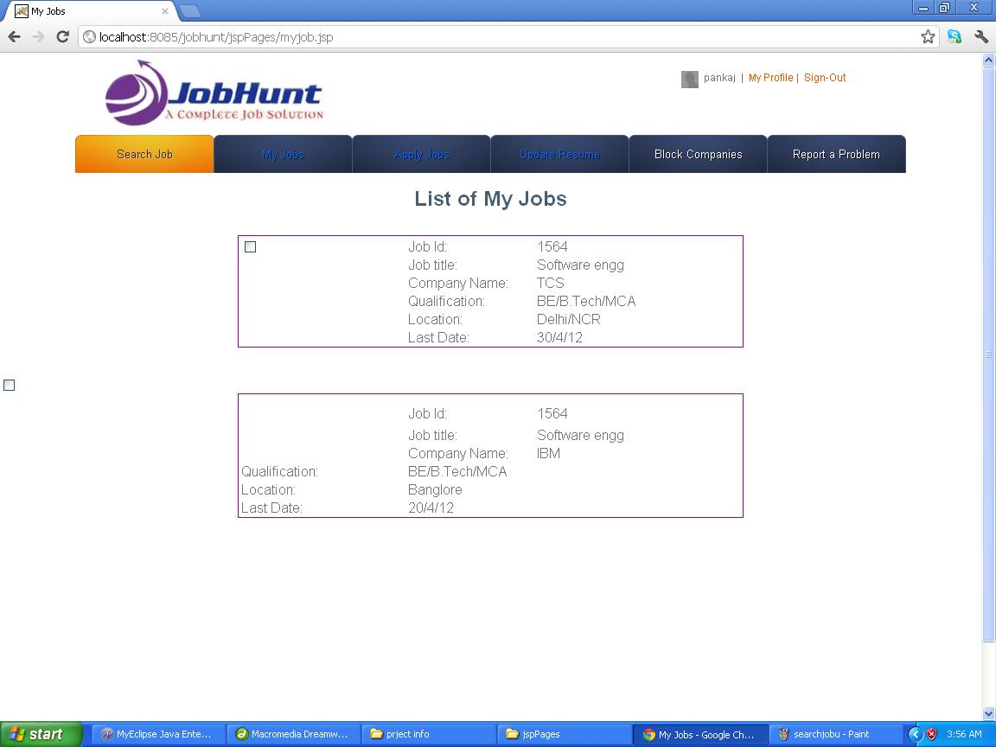

<%@ page contentType="text/html; charset=iso-8859-1" language="java" import="java.sql.*" errorPage="" %>
<!DOCTYPE html PUBLIC "-//W3C//DTD XHTML 1.0 Transitional//EN" "http://www.w3.org/TR/xhtml1/DTD/xhtml1-transitional.dtd">
<html xmlns="http://www.w3.org/1999/xhtml">
<head>
<meta http-equiv="Content-Type" content="text/html; charset=iso-8859-1" />
<title>My Jobs</title>
<style type="text/css">
<!--
.style1 {
font-size: 24px;
font-weight: bold;
color: #000000;
}
-->
</style>
</head>

<body>
<%@ include file="userheader.html"%>
<div align="center" class="style1" style="margin-top:20px;">List of My Jobs</div>

<p>&nbsp;</p>
<%@ page import="com.techmentro.lms.beans.*" %>
<%@ page import="java.util.*" %>

<%
List<Course> list=(List<Course>)request.getAttribute("courses");
Iterator<Course> itr=list.iterator();
%>
<table width="585" height="112" border="0" align="center" frame="box" bordercolor="#990099">
<form id="form1" name="form1" method="post" action="">
<tr>
<td width="158" rowspan="6"><form id="form1" name="form1" method="post" action="">
<label>
<input type="checkbox" name="checkbox" value="checkbox" />
</label>

</td>
<td width="121">Job Id: </td>
<td width="195">1564</td>
</tr>
<tr>
<td>Job title: </td>
<td>Software engg </td>
</tr>
<tr>
<td>Company Name: </td>
<td>TCS</td>
</tr>
<tr>
<td>Qualification:</td>
<td>BE/B.Tech/MCA</td>
</tr>
<tr>
<td>Location:</td>
<td>Delhi/NCR</td>
</tr>
<tr>
<td>Last Date: </td>
<td>30/4/12</td>
</tr>

</table>

<p>
<%@ include file="footer.html"%>
</p>
</body>
</html>
6.1.15 apply jobs.jsp
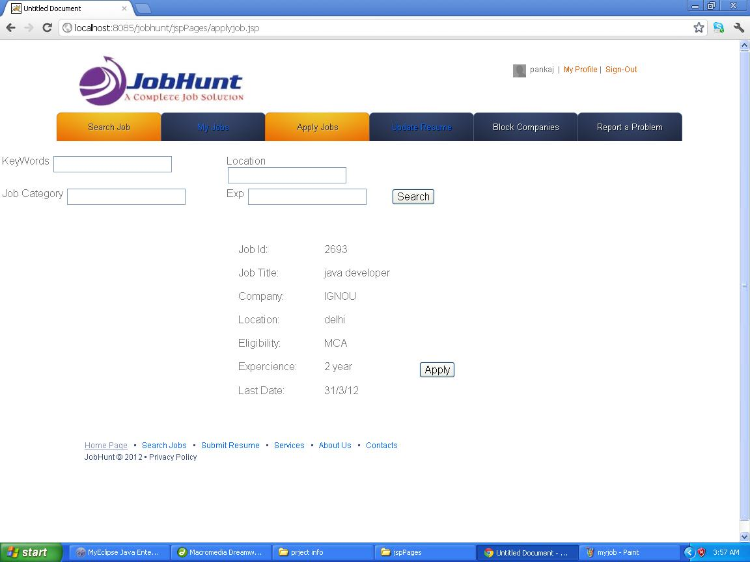
<%@ page contentType="text/html; charset=iso-8859-1" language="java" import="java.sql.*" errorPage="" %>
<!DOCTYPE html PUBLIC "-//W3C//DTD XHTML 1.0 Transitional//EN" "http://www.w3.org/TR/xhtml1/DTD/xhtml1-transitional.dtd">
<html xmlns="http://www.w3.org/1999/xhtml">
<head>
<meta http-equiv="Content-Type" content="text/html; charset=iso-8859-1" />
<title>Untitled Document</title>
</head>

<body>
<p>
<%@ include file="userheader.html"%>
</p>
<form id="form1" name="form1" method="post" action="">
<label></label>
<%@ page import="com.techmentro.lms.beans.*" %>
<%@ page import="java.util.*" %>

<%
List<Course> list=(List<Course>)request.getAttribute("courses");
Iterator<Course> itr=list.iterator();
%>

<table width="732" height="69">
<tr>
<td width="341" height="35">KeyWords
<input type="text" name="textfield" /></td>
<td width="247"><label>Location</label>
<input type="text" name="textfield2" /></td>
<td width="128">&nbsp;</td>
</tr>
<tr>
<td height="26"><label>Job Category </label>
<label></label>
<input type="text" name="textfield3" /></td>
<td><label>Exp</label>
<label></label>
<input type="text" name="textfield4" /></td>
<td><input type="submit" name="Submit" value="Search" /></td>
</tr>
</table>
<label></label>
<label></label>
<p>
<label></label>
</p>

<p>&nbsp;</p>
<table width="409" height="256" border="0" align="center">
<tr>
<td width="128">Job Id: </td>
<td width="140">2693</td>
<td width="127">&nbsp;</td>
</tr>
<tr>
<td>Job Title: </td>
<td><%=course.getjobtitle() %></td>
<td>&nbsp;</td>
</tr>
<tr>
<td>Company:</td>
<td><%=course.getcompany() %></td>
<td>&nbsp;</td>
</tr>
<tr>
<td>Location:</td>
<td><%=course.getlocation() %></td>
<td>&nbsp;</td>
</tr>
<tr>
<td>Eligibility:</td>
<td><%=course.getEligibility() %></td>
<td>&nbsp;</td>
</tr>
<tr>
<td>Expercience:</td>
<td>2 year </td>
<td rowspan="2"><label>
<input type="submit" name="Submit2" value="Apply" />
</label></td>
</tr>
<tr>
<td>Last Date: </td>
<td>31/3/12</td>
</tr>
</table>
<p>&nbsp;</p>
</form>
<p>
<%@ include file="footer.html"%>
</p>
</body>
</html>
6.1.16 update resume.jsp
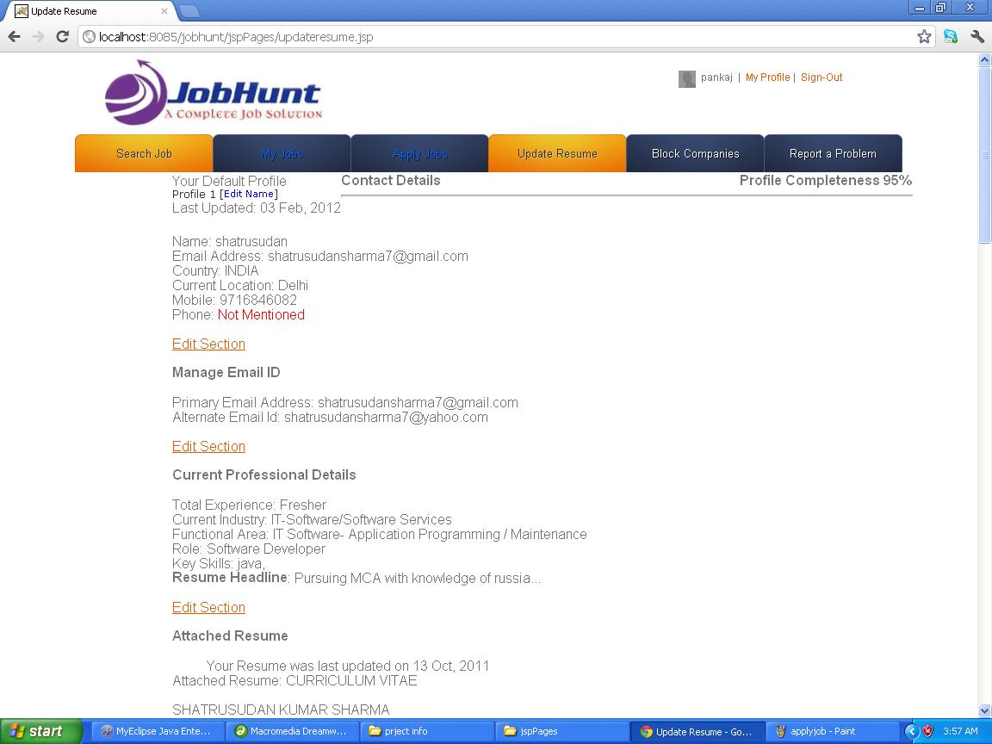
<%@ page import="com.jobhunt.managers.*" %>
<%
System.out.println("In Editresume.jsp");
int id=Integer.parseInt(request.getParameter("id"));
resumeManager manager=new ResumeManager();
String result=manager.getCourse(id,pageContext);
ViewManager vm=new ViewManager();
System.out.println("Invoking viewManager for "+result);
vm.generateView(result,pageContext);
%>
<%@ page contentType="text/html; charset=iso-8859-1" language="java" import="java.sql.*" errorPage="" %>
<!DOCTYPE html PUBLIC "-//W3C//DTD XHTML 1.0 Transitional//EN" "http://www.w3.org/TR/xhtml1/DTD/xhtml1-transitional.dtd">
<html xmlns="http://www.w3.org/1999/xhtml">
<head>
<meta http-equiv="Content-Type" content="text/html; charset=iso-8859-1" />
<title>Registration</title>
<link rel="stylesheet" href="../css/reset.css" type="text/css" media="all">
<link rel="stylesheet" href="../css/style.css" type="text/css" media="all">
</head>

<body>
<%@ include file="header.html"%>
<div align="center" ><h2>Become a Member of JobHunt and find the right job. Create your Profile now, Free!</h2></div>
<form method="get" action="reg.jsp">
<table width="817" frame="hsides" align="center" bordercolor="#990099">
<tr>
<td colspan="2"><h4><strong>Create Login Details</strong></h4>
<hr ></td>
</tr>

<tr>
<td width="297">Enter your Email: </td>
<td width="440"><label>
<input name="textfield" type="text" size="30" />
</label></td>
</tr>
<tr>
<td> Create a Password for your account: </td>
<td><input name="textfield" type="text" size="30" /></td>
</tr>
<tr>
<td> Confirm the Password: </td>
<td><input name="textfield" type="text" size="30" /></td>
</tr>
<tr>
<td colspan="2"><hr><h4><strong>Your Contact Information</strong></h4>
<hr ></td>
</tr>
<tr>
<td> Please mention your Full Name: </td>
<td><input name="textfield" type="text" size="30" /></td>
</tr>
<tr>
<td>Where are you Currently Located?: </td>
<td><label>
<select name="CITY" id="city" style="width:190px" class="" onkeydown="return trapKey(event,this)">
<option value="-1" label="Select">Select</option>
<optgroup label="----Top Metropolitan Cities----" style="background-color: rgb(208, 224, 241); ">Top Metropolitan Cities</optgroup>
<option value="2" selected="selected" label="Ahmedabad">Ahmedabad</option>
<option value="3" label="Bengaluru / Bangalore">Bengaluru / Bangalore</option>
<option value="4" label="Chandigarh">Chandigarh</option>
<option value="5" label="Chennai">Chennai</option>
<option value="6" label="Delhi">Delhi</option>
<option value="7" label="Gurgaon">Gurgaon</option>
<option value="8" label="Hyderabad / Secunderabad">Hyderabad / Secunderabad</option>
<option value="9" label="Kolkata">Kolkata</option>
<option value="10" label="Mumbai">Mumbai</option>
<option value="11" label="Noida">Noida</option>
<option value="12" label="Pune">Pune</option>
<optgroup label="----Andhra Pradesh----" style="background-color: rgb(208, 224, 241); ">Andhra Pradesh</optgroup>
<option value="14" label="Anantapur">Anantapur</option>
<option value="15" label="Guntakal">Guntakal</option>
<option value="16" label="Guntur">Guntur</option>
<option value="17" label="Hyderabad / Secunderabad">Hyderabad / Secunderabad</option>
<option value="18" label="Kakinada">Kakinada</option>
<option value="19" label="Kurnool">Kurnool</option>
<option value="20" label="Nellore">Nellore</option>
<option value="21" label="Nizamabad">Nizamabad</option>
<option value="22" label="Rajahmundry">Rajahmundry</option>
<option value="24" label="Tirupati">Tirupati</option>
<option value="25" label="Vijayawada">Vijayawada</option>
<option value="26" label="Visakhapatnam">Visakhapatnam</option>
<option value="27" label="Warangal">Warangal</option>
<option value="28" label="Andhra Pradesh - Other">Andhra Pradesh - Other</option>
<optgroup label="----Arunachal Pradesh----" style="background-color: rgb(208, 224, 241); ">Arunachal Pradesh</optgroup>
<option value="30" label="Itanagar">Itanagar</option>
<option value="31" label="Arunachal Pradesh - Other">Arunachal Pradesh - Other</option>
<optgroup label="----Assam----" style="background-color: rgb(208, 224, 241); ">Assam</optgroup>
<option value="33" label="Guwahati">Guwahati</option>
<option value="34" label="Silchar">Silchar</option>
<option value="35" label="Assam - Other">Assam - Other</option>
<optgroup label="----Bihar----" style="background-color: rgb(208, 224, 241); ">Bihar</optgroup>
<option value="37" label="Bhagalpur">Bhagalpur</option>
<option value="38" label="Patna">Patna</option>
<option value="39" label="Bihar - Other">Bihar - Other</option>
<optgroup label="----Chhattisgarh----" style="background-color: rgb(208, 224, 241); ">Chhattisgarh</optgroup>
<option value="41" label="Bhillai">Bhillai</option>
<option value="42" label="Bilaspur">Bilaspur</option>
<option value="43" label="Raipur">Raipur</option>
<option value="44" label="Chhattisgarh - Other">Chhattisgarh - Other</option>
<optgroup label="----Goa----" style="background-color: rgb(208, 224, 241); ">Goa</optgroup>
<option value="46" label="Panjim / Panaji">Panjim / Panaji</option>
<option value="48" label="Vasco Da Gama">Vasco Da Gama</option>
<option value="49" label="Goa - Other">Goa - Other</option>
<optgroup label="----Gujarat----" style="background-color: rgb(208, 224, 241); ">Gujarat</optgroup>
<option value="51" label="Ahmedabad">Ahmedabad</option>
<option value="52" label="Anand">Anand</option>
<option value="53" label="Ankleshwar">Ankleshwar</option>
<option value="55" label="Bharuch">Bharuch</option>
<option value="56" label="Bhavnagar">Bhavnagar</option>
<option value="57" label="Bhuj">Bhuj</option>
<option value="58" label="Gandhinagar">Gandhinagar</option>
<option value="59" label="Gir">Gir</option>
<option value="60" label="Jamnagar">Jamnagar</option>
<option value="61" label="Kandla">Kandla</option>
<option value="62" label="Porbandar">Porbandar</option>
<option value="63" label="Rajkot">Rajkot</option>
<option value="64" label="Surat">Surat</option>
<option value="65" label="Vadodara / Baroda">Vadodara / Baroda</option>
<option value="66" label="Valsad">Valsad</option>
<option value="67" label="Vapi">Vapi</option>
<option value="68" label="Gujarat - Other">Gujarat - Other</option>
<optgroup label="----Haryana----" style="background-color: rgb(208, 224, 241); ">Haryana</optgroup>
<option value="70" label="Ambala">Ambala</option>
<option value="71" label="Chandigarh">Chandigarh</option>
<option value="72" label="Faridabad">Faridabad</option>
<option value="73" label="Gurgaon">Gurgaon</option>
<option value="74" label="Hisar">Hisar</option>
<option value="75" label="Karnal">Karnal</option>
<option value="76" label="Kurukshetra">Kurukshetra</option>
<option value="77" label="Panipat">Panipat</option>
<option value="78" label="Rohtak">Rohtak</option>
<option value="79" label="Haryana - Other">Haryana - Other</option>
<optgroup label="----Himachal Pradesh----" style="background-color: rgb(208, 224, 241); ">Himachal Pradesh</optgroup>
<option value="81" label="Dalhousie">Dalhousie</option>
<option value="82" label="Dharmasala">Dharmasala</option>
<option value="83" label="Kulu/Manali">Kulu/Manali</option>
<option value="84" label="Shimla">Shimla</option>
<option value="85" label="Himachal Pradesh - Other">Himachal Pradesh - Other</option>
<optgroup label="----Jammu &amp; Kashmir----" style="background-color: rgb(208, 224, 241); ">Jammu &amp; Kashmir</optgroup>
<option value="87" label="Jammu">Jammu</option>
<option value="88" label="Srinagar">Srinagar</option>
<option value="89" label="Jammu and Kashmir - Other">Jammu and Kashmir - Other</option>
<optgroup label="----Jharkhand----" style="background-color: rgb(208, 224, 241); ">Jharkhand</optgroup>
<option value="91" label="Bokaro">Bokaro</option>
<option value="92" label="Dhanbad">Dhanbad</option>
<option value="93" label="Jamshedpur">Jamshedpur</option>
<option value="94" label="Ranchi">Ranchi</option>
<option value="95" label="Jharkhand - Other">Jharkhand - Other</option>
<optgroup label="----Karnataka----" style="background-color: rgb(208, 224, 241); ">Karnataka</optgroup>
<option value="97" label="Bengaluru / Bangalore">Bengaluru / Bangalore</option>
<option value="98" label="Belgaum">Belgaum</option>
<option value="99" label="Bellary">Bellary</option>
<option value="100" label="Bidar">Bidar</option>
<option value="101" label="Dharwad">Dharwad</option>
<option value="102" label="Gulbarga">Gulbarga</option>
<option value="103" label="Hubli">Hubli</option>
<option value="104" label="Kolar">Kolar</option>
<option value="105" label="Mangalore">Mangalore</option>
<option value="106" label="Mysoru / Mysore">Mysoru / Mysore</option>
<option value="107" label="Karnataka - Other">Karnataka - Other</option>
<optgroup label="----Kerala----" style="background-color: rgb(208, 224, 241); ">Kerala</optgroup>
<option value="109" label="Calicut">Calicut</option>
<option value="110" label="Cochin">Cochin</option>
<option value="111" label="Ernakulam">Ernakulam</option>
<option value="112" label="Kannur">Kannur</option>
<option value="113" label="Kochi">Kochi</option>
<option value="114" label="Kollam">Kollam</option>
<option value="115" label="Kottayam">Kottayam</option>
<option value="116" label="Kozhikode">Kozhikode</option>
<option value="117" label="Palakkad">Palakkad</option>
<option value="118" label="Palghat">Palghat</option>
<option value="119" label="Thrissur">Thrissur</option>
<option value="120" label="Trivandrum">Trivandrum</option>
<option value="121" label="Kerala - Other">Kerala - Other</option>
<optgroup label="----Madhya Pradesh----" style="background-color: rgb(208, 224, 241); ">Madhya Pradesh</optgroup>
<option value="123" label="Bhopal">Bhopal</option>
<option value="124" label="Gwalior">Gwalior</option>
<option value="125" label="Indore">Indore</option>
<option value="126" label="Jabalpur">Jabalpur</option>
<option value="127" label="Ujjain">Ujjain</option>
<option value="128" label="Madhya Pradesh - Other">Madhya Pradesh - Other</option>
<optgroup label="----Maharashtra----" style="background-color: rgb(208, 224, 241); ">Maharashtra</optgroup>
<option value="130" label="Ahmednagar">Ahmednagar</option>
<option value="131" label="Aurangabad">Aurangabad</option>
<option value="132" label="Jalgaon">Jalgaon</option>
<option value="133" label="Kolhapur">Kolhapur</option>
<option value="134" label="Mumbai">Mumbai</option>
<option value="135" label="Mumbai Suburbs">Mumbai Suburbs</option>
<option value="136" label="Nagpur">Nagpur</option>
<option value="137" label="Nasik">Nasik</option>
<option value="138" label="Navi Mumbai">Navi Mumbai</option>
<option value="139" label="Pune">Pune</option>
<option value="140" label="Solapur">Solapur</option>
<option value="141" label="Maharashtra - Other">Maharashtra - Other</option>
<optgroup label="----Manipur----" style="background-color: rgb(208, 224, 241); ">Manipur</optgroup>
<option value="143" label="Imphal">Imphal</option>
<option value="144" label="Manipur - Other">Manipur - Other</option>
<optgroup label="----Meghalaya----" style="background-color: rgb(208, 224, 241); ">Meghalaya</optgroup>
<option value="146" label="Shillong">Shillong</option>
<option value="147" label="Meghalaya - Other">Meghalaya - Other</option>
<optgroup label="----Mizoram----" style="background-color: rgb(208, 224, 241); ">Mizoram</optgroup>
<option value="149" label="Aizawal">Aizawal</option>
<option value="150" label="Mizoram - Other">Mizoram - Other</option>
<optgroup label="----Nagaland----" style="background-color: rgb(208, 224, 241); ">Nagaland</optgroup>
<option value="152" label="Dimapur">Dimapur</option>
<option value="153" label="Nagaland - Other">Nagaland - Other</option>
<optgroup label="----Orissa----" style="background-color: rgb(208, 224, 241); ">Orissa</optgroup>
<option value="155" label="Bhubaneshwar">Bhubaneshwar</option>
<option value="156" label="Cuttack">Cuttack</option>
<option value="157" label="Paradeep">Paradeep</option>
<option value="158" label="Puri">Puri</option>
<option value="159" label="Rourkela">Rourkela</option>
<option value="160" label="Orissa - Other">Orissa - Other</option>
<optgroup label="----Punjab----" style="background-color: rgb(208, 224, 241); ">Punjab</optgroup>
<option value="162" label="Amritsar">Amritsar</option>
<option value="163" label="Bathinda">Bathinda</option>
<option value="164" label="Chandigarh">Chandigarh</option>
<option value="165" label="Jalandhar">Jalandhar</option>
<option value="166" label="Ludhiana">Ludhiana</option>
<option value="167" label="Mohali">Mohali</option>
<option value="168" label="Pathankot">Pathankot</option>
<option value="169" label="Patiala">Patiala</option>
<option value="170" label="Punjab - Other">Punjab - Other</option>
<optgroup label="----Rajasthan----" style="background-color: rgb(208, 224, 241); ">Rajasthan</optgroup>
<option value="172" label="Ajmer">Ajmer</option>
<option value="173" label="Jaipur">Jaipur</option>
<option value="174" label="Jaisalmer">Jaisalmer</option>
<option value="175" label="Jodhpur">Jodhpur</option>
<option value="176" label="Kota">Kota</option>
<option value="177" label="Udaipur">Udaipur</option>
<option value="178" label="Rajasthan - Other">Rajasthan - Other</option>
<optgroup label="----Sikkim----" style="background-color: rgb(208, 224, 241); ">Sikkim</optgroup>
<option value="180" label="Gangtok">Gangtok</option>
<option value="181" label="Sikkim - Other">Sikkim - Other</option>
<optgroup label="----Tamil Nadu----" style="background-color: rgb(208, 224, 241); ">Tamil Nadu</optgroup>
<option value="183" label="Chennai">Chennai</option>
<option value="184" label="Coimbatore">Coimbatore</option>
<option value="185" label="Cuddalore">Cuddalore</option>
<option value="186" label="Erode">Erode</option>
<option value="187" label="Hosur">Hosur</option>
<option value="188" label="Madurai">Madurai</option>
<option value="189" label="Nagercoil">Nagercoil</option>
<option value="190" label="Ooty">Ooty</option>
<option value="191" label="Salem">Salem</option>
<option value="192" label="Thanjavur">Thanjavur</option>
<option value="193" label="Tirunalveli">Tirunalveli</option>
<option value="194" label="Trichy">Trichy</option>
<option value="195" label="Tuticorin">Tuticorin</option>
<option value="196" label="Vellore">Vellore</option>
<option value="197" label="Tamil Nadu - Other">Tamil Nadu - Other</option>
<optgroup label="----Tripura----" style="background-color: rgb(208, 224, 241); ">Tripura</optgroup>
<option value="199" label="Agartala">Agartala</option>
<option value="200" label="Tripura - Other">Tripura - Other</option>
<optgroup label="----Union Territories----" style="background-color: rgb(208, 224, 241); ">Union Territories</optgroup>
<option value="202" label="Chandigarh">Chandigarh</option>
<option value="203" label="Dadra &amp; Nagar Haveli - Silvassa">Dadra &amp; Nagar Haveli - Silvassa</option>
<option value="204" label="Daman &amp; Diu">Daman &amp; Diu</option>
<option value="205" label="Delhi">Delhi</option>
<option value="206" label="Pondicherry">Pondicherry</option>
<optgroup label="----Uttar Pradesh----" style="background-color: rgb(208, 224, 241); ">Uttar Pradesh</optgroup>
<option value="208" label="Agra">Agra</option>
<option value="209" label="Aligarh">Aligarh</option>
<option value="210" label="Allahabad">Allahabad</option>
<option value="211" label="Bareilly">Bareilly</option>
<option value="212" label="Faizabad">Faizabad</option>
<option value="213" label="Ghaziabad">Ghaziabad</option>
<option value="214" label="Gorakhpur">Gorakhpur</option>
<option value="215" label="Kanpur">Kanpur</option>
<option value="216" label="Lucknow">Lucknow</option>
<option value="217" label="Mathura">Mathura</option>
<option value="218" label="Meerut">Meerut</option>
<option value="219" label="Moradabad">Moradabad</option>
<option value="220" label="Noida">Noida</option>
<option value="221" label="Varanasi / Banaras">Varanasi / Banaras</option>
<option value="222" label="Uttar Pradesh - Other">Uttar Pradesh - Other</option>
<optgroup label="----Uttaranchal----" style="background-color: rgb(208, 224, 241); ">Uttaranchal</optgroup>
<option value="224" label="Dehradun">Dehradun</option>
<option value="225" label="Roorkee">Roorkee</option>
<option value="226" label="Uttaranchal - Other">Uttaranchal - Other</option>
<optgroup label="----West Bengal----" style="background-color: rgb(208, 224, 241); ">West Bengal</optgroup>
<option value="228" label="Asansol">Asansol</option>
<option value="229" label="Durgapur">Durgapur</option>
<option value="230" label="Haldia">Haldia</option>
<option value="231" label="Kharagpur">Kharagpur</option>
<option value="232" label="Kolkata">Kolkata</option>
<option value="233" label="Siliguri">Siliguri</option>
<option value="234" label="West Bengal - Other">West Bengal - Other</option>
<optgroup label="----Other----" style="background-color: rgb(208, 224, 241); ">Other</optgroup>
<option value="9999" label="Other">Other</option>
</select>
</label></td>
</tr>
<tr>
<td> Enter your Mobile Number: </td>
<td><input name="textfield" type="text" size="30" /></td>
</tr>
<tr>
<td colspan="2"><hr><h4><strong>Your Current Employment Details</strong></h4>
<hr ></td>
</tr>
<tr>
<td> How much Work Experience do you have?: </td>
<td><label>
<select style="width: 70px;" name="EXPYEAR" id="expyear" class="">
<option value="-1">Select</option>
<option value="99" selected="selected">Fresher</option>
<option value="0" label="0">0</option>
<option value="1" label="1">1</option>
<option value="2" label="2">2</option>
<option value="3" label="3">3</option>
<option value="4" label="4">4</option>
<option value="5" label="5">5</option>
<option value="6" label="6">6</option>
<option value="7" label="7">7</option>
<option value="8" label="8">8</option>
<option value="9" label="9">9</option>
<option value="10" label="10">10</option>
<option value="11" label="11">11</option>
<option value="12" label="12">12</option>
<option value="13" label="13">13</option>
<option value="14" label="14">14</option>
<option value="15" label="15">15</option>
<option value="16" label="16">16</option>
<option value="17" label="17">17</option>
<option value="18" label="18">18</option>
<option value="19" label="19">19</option>
<option value="20" label="20">20</option>
<option value="21" label="21">21</option>
<option value="22" label="22">22</option>
<option value="23" label="23">23</option>
<option value="24" label="24">24</option>
<option value="25" label="25">25</option>
<option value="26" label="26">26</option>
<option value="27" label="27">27</option>
<option value="28" label="28">28</option>
<option value="29" label="29">29</option>
<option value="30" label="30">30</option>
<option value="31">30+</option>
</select>
year
<strong id="expmonthtop" class="stgnor">
<select style="width: 90px;" name="EXPMONTH" id="expmonth" class="">
<option value="-1" selected="selected">Select</option>
<option value="0" label="0">0</option>
<option value="1" label="1">1</option>
<option value="2" label="2">2</option>
<option value="3" label="3">3</option>
<option value="4" label="4">4</option>
<option value="5" label="5">5</option>
<option value="6" label="6">6</option>
<option value="7" label="7">7</option>
<option value="8" label="8">8</option>
<option value="9" label="9">9</option>
<option value="10" label="10">10</option>
<option value="11" label="11">11</option>
</select>
</strong>
month

</label></td>
</tr>
<tr>
<td> What are your Key Skills?: </td>
<td><label>
<textarea name="skill" cols="50" id="skill"></textarea>
</label></td>
</tr>
<tr>
<td>Enter the Headline for your Profile: </td>
<td><input name="textfield" type="text" size="30" /></td>
</tr>
<tr>
<td> Which Industry does your Company belong to?: </td>
<td><label>
<select name="industry" id="industry">
<option>Hotels/Restaurants/Airlines/Travel</option>
<option>Textiles/Garments/Accessories</option>
<option>Auto/Auto Ancillary</option>
<option>Chemicals/PetroChemical/Plastic/Rubber</option>
<option selected="selected">Accounting/Finance</option>
<option>FMCG/Foods/Beverage</option>
<option>Construction/Engineering/Cement/Metals</option>
<option>Banking/Financial Services/Broking</option>
<option>Export/Import</option>
<option>IT-Hardware &amp; Networking</option>
<option>Industrial Products/Heavy Machinery</option>
<option>Courier/Transportation/Freight</option>
<option>Media/Dotcom/Entertainment</option>
<option>Office Equipment/Automation</option>
<option>Oil and Gas/Power/Infrastructure/Energy</option>
<option>IT-Software/Software Services</option>
<option>Education/Teaching/Training</option>
<option>Architecture/Interior Designing</option>
<option>Agriculture/Dairy</option>
<option>NGO/Social Services</option>
<option>KPO / Research /Analytics</option>
<option>Electricals / Switchgears</option>
<option>Wellness/Fitness/Sports</option>
<option>Heat Ventilation Air Conditioning</option>
</select>
</label></td>
</tr>
<tr>
<td>Which Functional Area do you work in?: </td>
<td><label>
<select name="function" id="function">
<option>Accounts / Finance / Tax / CS / Audit</option>
<option>Architecture / Interior Design</option>
<option>Web / Graphic Design / Visualiser</option>
<option>Hotels / Restaurants</option>
<option>Content / Journalism</option>
<option>Banking / Insurance</option>
<option>ITES / BPO / KPO / Customer Service / Operations</option>
<option>Self Employed / Consultants</option>
<option>Pharma / Biotech / Healthcare / Medical / R&amp;D</option>
<option>Site Engineering / Project Management</option>
<option>IT- Hardware / Telecom / Technical Staff / Support</option>
<option>Fashion / Garments / Merchandising</option>
<option>TV / Films / Production</option>
<option>Ticketing / Travel / Airlines</option>
<option>Guards / Security Services</option>
<option>IT Software- Application Programming / Maintenance</option>
<option>IT Software - Client Server</option>
<option>IT Software - Mobile</option>
<option>IT Software - Middleware</option>
<option>IT Software- E-Commerce / Internet Technologies</option>
</select>
</label></td>
</tr>
<tr>
<td colspan="2"><hr><h4><strong>Your Education Background</strong></h4>
<hr ></td>
</tr>
<tr>
<td> Please select your Basic Education: </td>
<td><label>
<select name="UGCOURSE" id="ugcourse" style="width:180px;" class="">
<option value="-1" label="Select">Select</option>
<option value="1" label="Not Pursuing Graduation">Not Pursuing Graduation</option>
<option value="2" selected="selected" label="B.A">B.A</option>
<option value="3" label="B.Arch">B.Arch</option>
<option value="4" label="BCA">BCA</option>
<option value="5" label="B.B.A">B.B.A</option>
<option value="6" label="B.Com">B.Com</option>
<option value="7" label="B.Ed">B.Ed</option>
<option value="8" label="BDS">BDS</option>
<option value="9" label="BHM">BHM</option>
<option value="10" label="B.Pharma">B.Pharma</option>
<option value="11" label="B.Sc">B.Sc</option>
<option value="12" label="B.Tech/B.E.">B.Tech/B.E.</option>
<option value="13" label="LLB">LLB</option>
<option value="14" label="MBBS">MBBS</option>
<option value="15" label="Diploma">Diploma</option>
<option value="16" label="BVSC">BVSC</option>
<option value="9999" label="Other">Other</option>
</select>
</label></td>
</tr>
<tr>
<td> Please select your Masters Education: </td>
<td><label>
<select name="PGCOURSE" id="pgcourse" style="width:180px;" class="">
<option value="-1" label="Select">Select</option>
<option value="1" label="CA">CA</option>
<option value="2" label="CS">CS</option>
<option value="3" label="ICWA">ICWA</option>
<option value="4" label="Integrated PG">Integrated PG</option>
<option value="5" label="LLM">LLM</option>
<option value="6" label="M.A">M.A</option>
<option value="7" label="M.Arch">M.Arch</option>
<option value="8" label="M.Com">M.Com</option>
<option value="9" label="M.Ed">M.Ed</option>
<option value="12" label="M.Tech">M.Tech</option>
<option value="13" label="MBA/PGDM">MBA/PGDM</option>
<option value="14" label="MCA">MCA</option>
<option value="15" label="MS">MS</option>
<option value="16" label="PG Diploma">PG Diploma</option>
<option value="17" label="MVSC">MVSC</option>
<option value="18" label="MCM">MCM</option>
<option value="9999" label="Other">Other</option>
</select>
</label></td>
</tr>
<tr>
<td> Please select your Doctorate Education: </td>
<td><label>
<select class="textboxnits" name="PPGCOURSE" id="ppgcourse" style="width:180px;">
<option value="-1" label="Select">Select</option>
<option value="1" label="Ph.D/Doctorate">Ph.D/Doctorate</option>
<option value="2" label="MPHIL">MPHIL</option>
<option value="9999" label="Other">Other</option>
</select>
</label></td>
</tr>
<tr>
<td colspan="2"><hr><h4><strong>Please upload a Resume if you have one ready</strong></h4>
<hr ></td>
</tr>
<tr>
<td> Upload your Resume Document: </td>
<td><label>
<textarea name="resume" cols="50" id="resume"></textarea>
</label></td>
</tr>
<tr>
<td colspan="2"><label>
<div align="center">
<input type="submit" name="Submit" value="Create my Account" />
</div>
</label></td>
</tr>
</table>
</form>
<%@ include file="footer.html"%>
</body>
</html>

6.1.17 block company.jsp
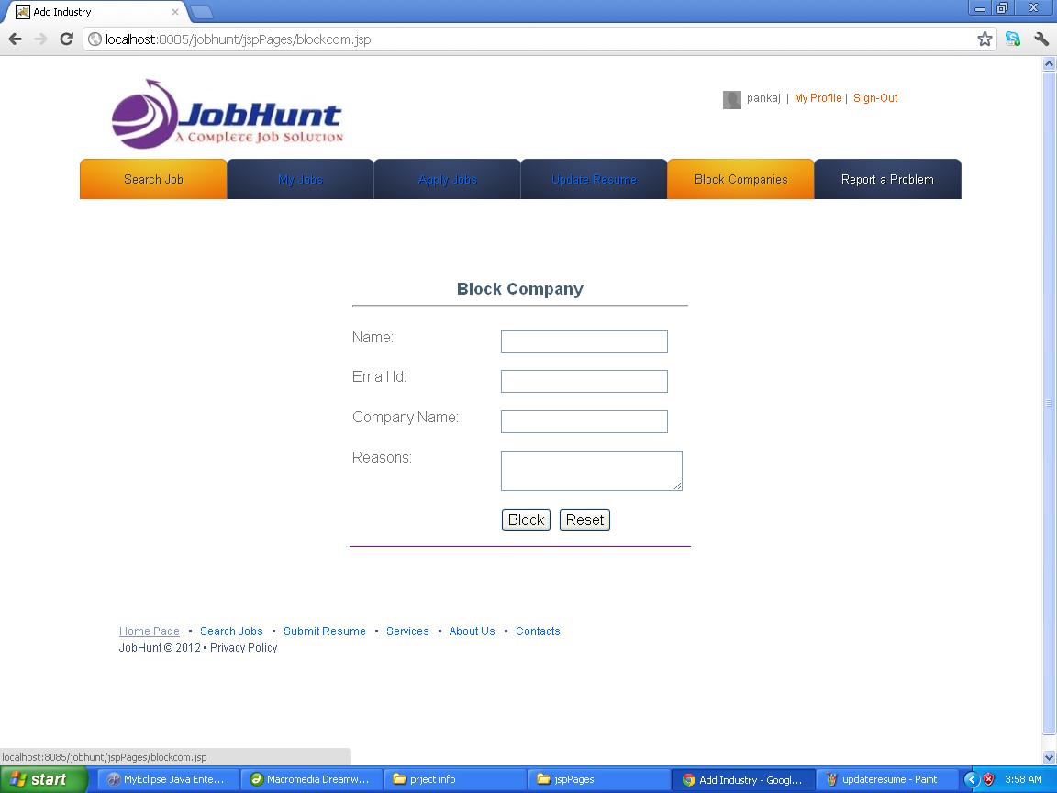
<%@ page contentType="text/html; charset=iso-8859-1" language="java" import="java.sql.*" errorPage="" %>
<!DOCTYPE html PUBLIC "-//W3C//DTD XHTML 1.0 Transitional//EN" "http://www.w3.org/TR/xhtml1/DTD/xhtml1-transitional.dtd">
<html xmlns="http://www.w3.org/1999/xhtml">
<head>
<meta http-equiv="Content-Type" content="text/html; charset=iso-8859-1" />
<title>Add Industry</title>
<style type="text/css">
<!--
.style1 {
font-size: 18px;
font-weight: bold;
}
-->
</style>
</head>

<body>
<p>
<%@ include file="userheader.html"%>
</p><form id="form1" name="form1" method="post" action="">
<p>&nbsp;</p>
<p>&nbsp;</p>
<table width="372" height="293" border="0" align="center" frame="below" bordercolor="#990099">
<tr>
<td colspan="2"><div align="center" class="style1">Block Company
<hr ></div></td>
</tr>
<tr>
<td width="156">Name:</td>
<td width="206">
<label>
<input type="text" name="textfield" />
</label> </td>
</tr>
<tr>
<td>Email Id: </td>
<td><input type="text" name="textfield2" /></td>
</tr>
<tr>
<td>Company Name: </td>
<td><input type="text" name="textfield3" /></td>
</tr>
<tr>
<td>Reasons:</td>
<td><label>
<textarea name="textarea" cols="25"></textarea>
</label></td>
</tr>
<tr>
<td>&nbsp;</td>
<td><label>
<input type="submit" name="Submit" value="Block" />
<input type="reset" name="Submit2" value="Reset" />
</label></td>
</tr>
</table>
</form>
<p>&nbsp;</p>
<p>&nbsp;</p>
<p>
<%@ include file="footer.html"%>
</p>
</body>
</html>
6.1.18 postjobs.jsp
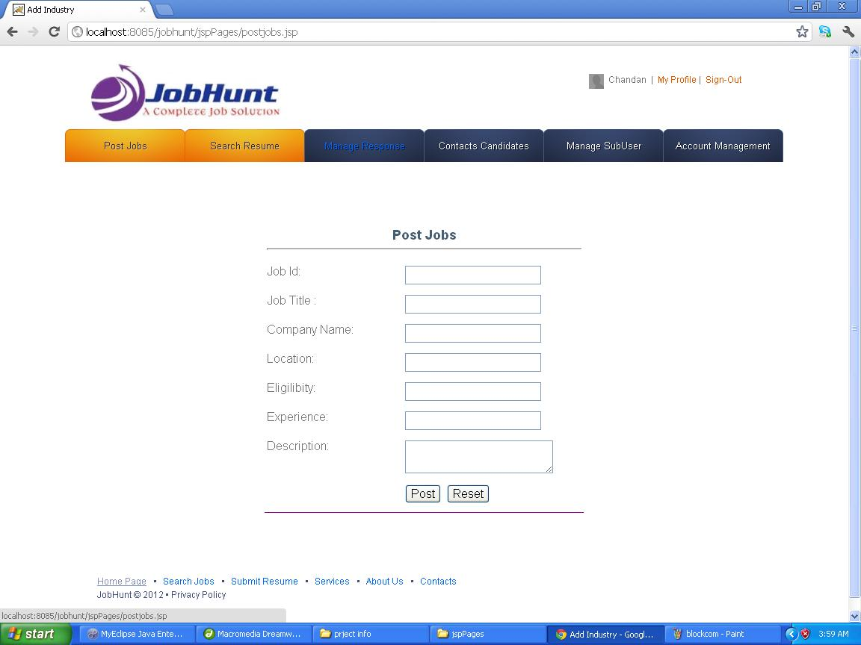
<%@ page import="com.jobhunt.managers.*" %>
<jsp:useBean id="course" class="com.jobhunt.beans.Course" />
<jsp:setProperty name="jobp" property="*" />
<%
System.out.println("In Newjobp.jsp");
jobpManager manager=new jobpManager();
String result=manager.jobPost(jobp);
ViewManager vm=new ViewManager();
System.out.println("Invoking viewManager for "+result);
vm.generateView(result,pageContext);
%>

<%@ page contentType="text/html; charset=iso-8859-1" language="java" import="java.sql.*" errorPage="" %>
<!DOCTYPE html PUBLIC "-//W3C//DTD XHTML 1.0 Transitional//EN" "http://www.w3.org/TR/xhtml1/DTD/xhtml1-transitional.dtd">
<html xmlns="http://www.w3.org/1999/xhtml">
<head>
<meta http-equiv="Content-Type" content="text/html; charset=iso-8859-1" />
<title>Add Industry</title>
<style type="text/css">
<!--
.style1 {
font-size: 18px;
font-weight: bold;
}
-->
</style>
</head>

<body>
<p>
<%@ include file="employerheader.html"%>
</p><form id="form1" name="form1" method="post" action="">
<p>&nbsp;</p>
<p>&nbsp;</p>
<table width="427" height="384" border="0" align="center" frame="below" bordercolor="#990099">
<tr>
<td colspan="2"><div align="center" class="style1">Post Jobs <hr ></div></td>
</tr>
<tr>
<td width="156">Job Id: </td>
<td width="206">
<label>
<input type="text" name="textfield" />
</label> </td>
</tr>
<tr>
<td>Job Title : </td>
<td><input type="text" name="textfield2" /></td>
</tr>
<tr>
<td>Company Name: </td>
<td><input type="text" name="textfield3" /></td>
</tr>
<tr>
<td>Location:</td>
<td><label>
<input type="text" name="textfield32" />
</label></td>
</tr>
<tr>
<td>Eligilibity:</td>
<td><input type="text" name="textfield33" /></td>
</tr>
<tr>
<td>Experience:</td>
<td><input type="text" name="textfield34" /></td>
</tr>
<tr>
<td>Description:</td>
<td><textarea name="textarea" cols="25"></textarea></td>
</tr>
<tr>
<td>&nbsp;</td>
<td><label>
<input type="submit" name="Submit" value="Post" />
<input type="reset" name="Submit2" value="Reset" />
</label></td>
</tr>
</table>
</form>
<p>&nbsp;</p>
<p>&nbsp;</p>
<p>
<%@ include file="footer.html"%>
</p>
</body>
</html>

6.1.19 manage response.jsp
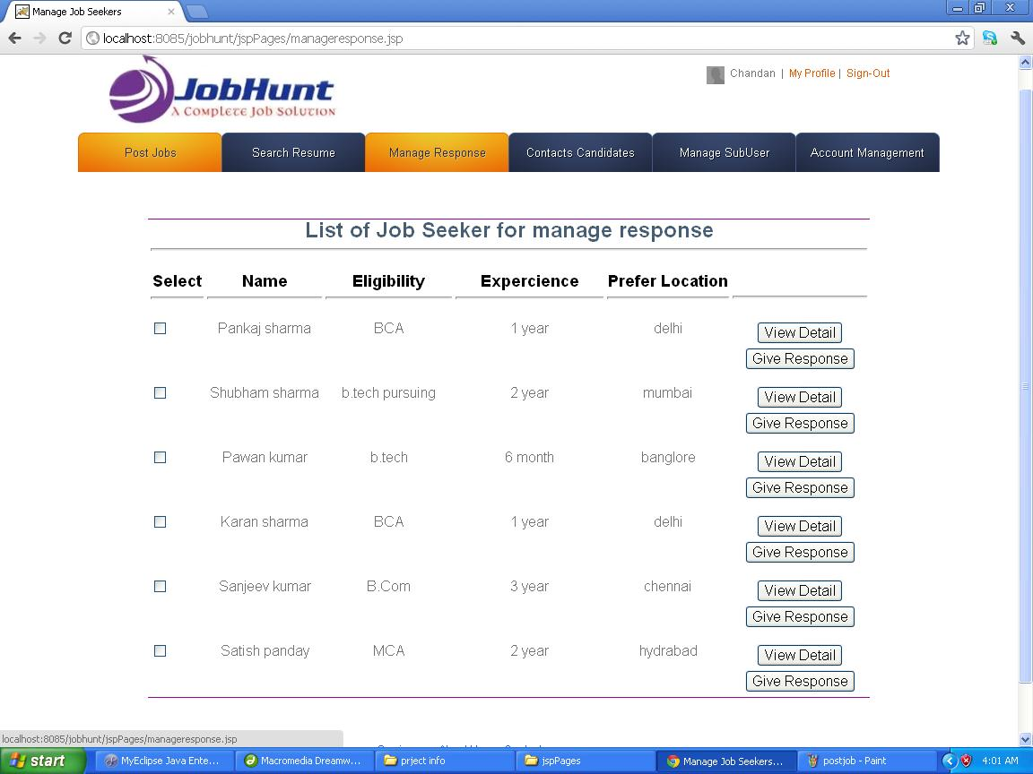
<%@ page import="com.jobhunt.beans.*" %>
<%@ page import="java.util.*" %>

<%
List<emp> list=(Listemp>)request.getAttribute("emp");
Iterator<emp> itr=list.iterator();
%>
<td width="84">
<label>
<input type="checkbox" name="checkbox" value="checkbox" />
</label> </td>
<table width="100%" height="50%">
<tr>
<td width="15%">Title</td><td width="25%">name</td><td width="10%">DOC</td>
<td width="10%">Status</td><td width="10%">eligibility</td><td width="5%">Learners</td>
<td width="10%">Lessons</td><td width="15%">expercience</td>
<td width="10%">Lessons</td><td width="15%">location</td>

</tr>
<%
while(itr.hasNext())
{
Emp emp=itr.next();
%>
<tr>
<td width="15%"><%=emp.getTitle() %> </td><td width="25%"><%=emp.getName() %></td><td width="10%"><%=course.getDoc() %></td>
<td width="10%"><%=emp.getStatus() %></td><td width="10%"><%=course.getLocation() %></td><td width="5%"><%=emp.getexpercience() %></td>
<td width="10%"><%=emp.geteligibility() %></td><td width="15%"><a href="<%="editCourse?id="+emp.getId() %>">edit</a> <a href="<%="deleteCourse?id="+emp.getId() %>">delete</a></td>
</tr>
<div align="center">
<input type="submit" name="Submit3" value="View Detail" />
<input type="submit" name="Submit2" value="Give Response" />
</div>
<%
}

%>
</table>
7.TESTING
Testing Techniques and Testing Strategies
7.1 OBJECTIVE OF SYSTEM TESTING
Testing is vital to the success of any system, Testing is done at different stages within the development phase. System testing makes a logical assumption that if all parts of the system are correct, the goals will be achieved successfully, inadequate tests or no testing leads to errors that may come up after when correction would be extremely difficult. Another objective of testing is its utility as a user-oriented vehicle before implementation.

Unit Testing | Each module will be tested individually so as to make the individual component error free. Also other attached modules will also be error free.
Integration Testing | Each module will be tested of its effect on other modules by integrating the modules. This will remove further errors from the system and may also result in some changes in the individual; modules.
Validation Testing | Now testing is done to ensure that if users enter any superfluous data, it does not reach to the database but are asked to record the data in the acceptable format.
System Testing | Here, the whole system is tested fully. The errors now should be meager. This will ensure flawless working of the system at the user’s site rather than giving troubles after installation.
System Testing | Here, the whole system is tested fully. The errors now should be meager. This will ensure flawless working of the system at the user’s site rather than giving troubles after installation.
White box testing | This testing is predicated on close examinations of procedural details. Providing test cases that exercise specific sets of condition or loops tests logical paths through the software.
Black Box Testing | This Testing method focuses on the functional requirements of the proposed software.
Condition Testing | It is a test case design method that exercise the logical conditions contained in a program module.
Data flow Testing | This method selects paths of a program according to the locations of definitions and uses of variables in the program.

The testing of the system was done on both artificial and live data. The following types of tests are performed.
7.2 Unit Testing
This testing focuses verification on the module. Using procedural design description as a Guide; important control paths are tested to uncover errors with in the boundaries of the module. The relative complexity of tests and uncovered errors is limited by the constraints scope established for unit testing. The unit testing can be conducted in parallel for several modules.

7.3 Integration Testing
Generally a combined approach known as sandwich testing using features of top down testing strategy for upper levels of the program structure, coupled with the bottom up strategy for subordinate modules.
7.4 Functional testing
This is done for each module/sub module of the system. Functional testing serves as a means of validating weather the functionality of the system confirms the original user requirement i.e. done the module do what is supposed to do. The separate schedules were made for functional testing .it involves preparation of bugs listing for non-conformities.
7.5 System Testing
System testing is done when the entire system has been fully integrated. The purpose of the system testing is to test how the different modules interact with each other and whether the system provides the functionality that was expected.
It consists of the following steps.
1. Program Testing
2. String Testing
3. System Testing
4. System Documentation
5. User Acceptance Testing
Validations and verifications
Testing
Testing presents an interesting anomaly for the software engineer. During earlier software engineering activities, the engineer attempts to build software from an abstract concept to a tangible product. Now comes testing. The engineer creates a series of test cases that are intended to “demolish” the software that has been built. In fact, testing is the one step in the software process that could be viewed (psychologically, at least) as destructive rather than constructive.
Software engineers are by their nature constructive people. Testing requires that the developer discard preconceived notions of the “correctness” of software just developed and overcome a conflict of interest that occurs when errors are uncovered.
If testing is conducted successfully (according to the objectives stated previously), it will uncover errors in the software. As a secondary benefit, testing demonstrates that software functions appear to be working according to specification, that behavioral and performance requirements appear to have been met. In addition, data collected as testing is conducted provide a good indication of software reliability and some indication of software quality as a whole. But testing cannot show the absence of errors and defects, it can show only that software errors and defects are present. It is important to keep this (rather gloomy) statement in mind as testing is being conducted.
Testing principles:
Before applying methods to design effective test cases, a software engineer must understand the basic principle that guide software testing.
All tests should be traceable to customer requirements.
Tests should be planned long before testing begins.
80 percent of all errors uncovered during testing will likely be traceable to 20 percent of all program components. The problem, of course, is to isolate these suspect components and to thoroughly test them.
Testing should being “in the small” and progress toward testing “in the large”.
Exhaustive testing is not possible.
To be most effective an independent third party should conduct testing.
A rich variety of test case design methods have evolved for software. These methods provide the developer with a systematic approach to testing. More important, methods provide a mechanism that can help to ensure the completeness of tests and provide the highest likelihood for uncovering errors in software.
Any engineered product (and most other things) can be tested in one of two ways.
(1) Knowing the specified function that a product has been designed to perform, tests can be conducted that demonstrate each function is fully operational while at the same time searching for errors in each function.
(2) Knowing the internal working of a product, tests can be conducted to ensure that “all gears mesh,” that is, internal operations are performed according to specifications and all internal components have been adequately exercised. The first test approach is called black box testing and the second, white-box testing.
White box testing, sometimes called glass-box testing is a test case design method that uses the control structure of the procedural design to derive test cases. Using white-box testing methods, the software engineer can derive test cases that
(1) Guarantee that all independent paths within a module have been exercised at least once,
(2) Exercise all logical decisions on their true and false sides,
(3) Execute all loops at their boundaries and within their operational bounds, and
(4) Exercise internal data structures to ensure their validity.
White-box testing of software is predicated on close examination of procedural detail. Providing test cases that exercise specific sets of conditions and/or loops tests logical paths through the software. The “status of the program” may be examined at various points to determine if the expected or asserted status corresponds to the actual status. Basis path testing is a white-box testing technique first proposed by Tom McCabe. The basis path method enables the test case designer to derive a logical complexity measure of a procedural design and use this measure as a guide for defining a basis set of execution paths. Test cases derived to exercise the basis set are guaranteed to execute every statement in the program at least one time during testing.
Black box testing, also called behavioral testing, focuses on the functional requirements of the software. That is, black box testing enables the software engineer to derive sets of input conditions that will fully exercise all functional requirements for a program. Black box testing is not an alternative to white-box techniques. Rather, it is a complementary approach that is likely to uncover a different class of error than white-box methods. When computer software is considered, black box testing alludes to tests that are conducted at the software interface. Although they are designed to uncover errors, black-box tests are used to demonstrate that software functions are operational, that input is properly accepted and output is correctly produced and that the integrity of external information is maintained. A black-box test examines some fundamental aspect of a system with a little regard for the internal logical structure of the software. Black box testing attempts to find errors in the following categories:
(1) Incorrect or missing functions,
(2) Interface errors,
(3) Errors in data structures or external database access,
(4) Behavior or performance errors, and
(5) Initialization and termination errors.
By applying black-box techniques, we derive a set of test cases that satisfy the following criteria:
- Test cases that reduce, by a count that is greater than one, the number of additional test cases that must be designed to achieve reasonable testing and
- Test cases that tell us something about the presence or absence of classes of errors, rather than an error associated only with the specific test at hand.
White-box testing should not, however, be dismissed as impractical. A limited number of important logical paths can be selected and exercised. Important data structures can be probed for validity. The attributes of both black and white box testing can be combined to provide an approach that validates the software interface and selectively ensures that the internal workings of the software are correct.

7.6 VALIDATION CHECKS
Case 1:
Do:Enter the mobile no in alphabetic digit and go to nest process.
Result :a java script alert will be show and message is “enter a valid mobile number”.

Case 2:
Do:leave all the field blank on the form and click on submit.
Result: A java script alert message will be show “form can not be blank”.

Case 3:
Do: apply ouydated job.
Result:a message will be show job is out of date.

Case 4:
Do: login by jobseekers and enter the address of administrator page in address bar
Result:show the unauthorized page.

7.7.Test case design and Test reports
Unit testing of the modules is done so as to check that each of the modules works, as they should be. Following is the module wise testing of this project:
TEST CASE ID | DO | EXPECTED RESULT
1 | Enter the user id in the text box specified enter the password in login form and click on login button | Successfully login into the system if values are found in the database
2 | enter the meaningful data in search job form. | If the data is matched with our database.result show on the web page.
3 | Enter the search criteria of resume form and click on search | If the given criteria match then output the result
4 | Enter the job id, title, description, location, eligibility, experience etc | If all data found in the database then post job succfully and show the message.
5 | Enter the industry id, title, description, type, function area, company etc | If all data found in the database then add industry succfully and show the message.
6 | Select check box in the list of job.that is match for you. | If select check box properly. Show maeesge is that you have successfully applied selected job
7 | Select check box in the list of resume of job seekers.that is match of your job detail. | If select check box properly. Show maeesge is that you have successfully response selected job seekers
8 | Enter edit button of update resume, and modify your data and then click on update button. | If no problem in network then your modify data is successfully saved and updated.
9 | Enter the function id, title, industry type, type, function area, company etc | If all data found in the database then add ifunction area succfully and show the message.
10 | Click on the manage job seekers tab in admin home . show the list of available jobseekers who have registered in your system. Click on view detail of that job seekers. | If network is properly worked then show the detail of all job seekers in the page.
11 | Login by any user and leave the page without user interaction for 15 min | After 15 min the system will be automatically logout.
12 | Click on the manage employer tab in admin home . show the list of available employer who have registered in your system. Click on view detail of that employer. | If network is properly worked then show the detail of all employer in the page.

8.SYSTEM SECURITY MEASURES
Security is the main feature of any software application. In this project there are only one type of security and one type of restriction the security is that the Administrator create the new user then system generate the new userid and password the administrator send the user id and password to the user by secure mail. But when the user first time create login then the system force the user to change this password for security purpose.
Database and Data Security
Database is secure with the DataBase userId and Password. Use the firewall and packet filtering routers for database serversecurity.and use of digital signatures. And digital certificate on web server.
Use Secure Socket Layer (SSL)
SSL, or Secure Socket Layer, is a technology, which allows web browsers and webservers to communicate over a secured connection. This means that the data being sent isencrypted by one side, transmitted, and then decrypted by the other side beforeprocessing. This is a two-way process, meaning that both the server AND the browserencrypt all traffic before sending out data.Another important aspect of the SSL protocol is Authentication. This means that duringyour initial attempt to communicate with a web server over a secure connection, thatserver will present your web browser with a set of credentials, in the form of a"Certificate", as proof that site is who and what it claims to be. In certain cases, the servermay also request a Certificate from your web browser, asking for proof that you are whoyou claim to be. This is known as "Client Authentication," SSL uses public key encryption for encrypting data. The figure below will give a better understanding about public key encryption.
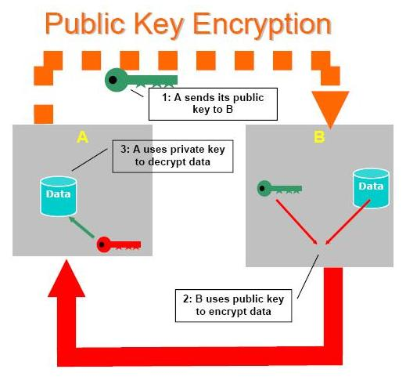

9.RISK ANALYSIS
Operational risk:
Operational risk, also referred to as transactional risk is the most common form of riskassociated with i-banking. It takes the form of inaccurate processing of transactions,non enforceability of contracts, compromises in data integrity, data privacy andconfidentiality, unauthorized access / intrusion to bank’s systems and transactions etc.Such risks can arise out of weaknesses in design, implementation and monitoring ofbanks’ information system. Besides inadequacies in technology, human factors likenegligence by customers and employees, fraudulent activity of employees and crackers /hackers etc. can become potential source of operational risk. Often there is thin line ofdifference between operational risk and security risk and both terminologies are usedinterchangeably.

Security Risk
Security risk arises on account of unauthorized access to a bank’s critical informationstores like accounting system, risk management system, portfolio management system,etc. A breach of security could result in direct financial loss to the bank. For example,hackers operating via the Internet, could access, retrieve and use confidential customerinformation and also can implant virus. This may result in loss of data, theft of ortampering with customer information, disabling of a significant portion of bank’sinternal computer system thus denying service, cost of repairing these etc.
Reputational risk
Reputational risk is the risk of getting significant negative public opinion, which mayresult in a critical loss of funding or customers. Such risks arise from actions whichcause major loss of the public confidence in the banks' ability to perform critical
functions or impair bank-customer relationship. It may be due to banks’ own action ordue to third party action.
Other risk
Traditional banking risks such as credit risk, liquidity risk, interest rate risk and marketrisk are also present in Internet banking. These risks get intensified due to the verynature of Internet banking on account of use of electronic channels as well as absenceof geographical limits. However, their practical consequences may be of a differentmagnitude for banks and supervisors than operational, reputational and legal risks. This
may be particularly true for banks that engage in a variety of banking activities, ascompared to banks or bank subsidiaries that specialize in Internet banking.
10.FUTURE SCOPE AND FURTHER ENHANCEMENT

limitation of project
The limitation of my project is the project can not transaction with other bank cheque online,this project work only simple transactions in the bank.my project not calculate the interest of current and saving account.this project finally a simple bank web application.

Furture Scope and further enhancement
In our daily life there are very importance of banking so we can say the new inhencement of technology with banking sector is the great achievement.so its future scope is better.
Further Enhancement : we can remove the all the limitation of the project Enhance the technology such as use the Hibernate,Spring,Ejb with this application add the new modules for example transaction withother bank and provide internet banking to the customer.
11.BIBLIOGRAPHY
Java projects bpb publication
Servlet and JSP sun curriculum
Java script and html wrox publication
Introduction to Oracle9i: SQL Oracle Corporation
Instructor Guide • Volume 1
40049GC11
Production
REFERENCE

http://www.Java.sun.com | Project support page of java website. and java software page
http://www.oracle.com | Home page of oracle , the developer of oracle
http://www.apache.org | Download apache web server
Survey of Technologies for Web Application  Development | Barry Doyle, University of California, Irvine and Cristina Videira Lopez,  University of California,  Irvine, ACM Journal,
IEEE Std 830-1998 : IEEE Recommended practice for Software Requirements Specifications | Software Engineering Standards Committee of the IEEE Society
IEEE Std 1016-1998 : IEEE Recommended practice for Software Design Descriptions - | Software Engineering Standards  Committee of the IEEE Society
IEEE Std 829-1998 : IEEE Standard for Software Test Documentation- | Standards Committee of the IEEE Society
IEEE Std 1016-1998 : IEEE Standard for Software Unit Testing | Software Engineering Standards Committee of the IEEE Society
IEEE Std 1063-2001 : IEEE Standard for Software User Documentation | Software Engineering Standards Committee of the IEEE Society

GLOSSARY

Apache
A popular Web-server used to host websites in the World Wide Web. A WEB Server (or Services). This is the standard web server can be installed on Windows (from NT4 onwards) or other platform.

ASP
Active Server Pages. A specification for a dynamically created web page. Allows a script or ASP application to be executed on a web server to generate a web page sent to a viewer. Requires IIS. Pages generated using ASP generally has the file extension of .asp

CGI
Common Gateway Interface. Interface standard allowing programs to interface to web servers. CGI programs can be written in any compile able language. CGI programs are executed on the server, normally in response to some input from a web page

Data Dictionary
A collection of descriptions of the data objects or items in a data model for the benefit of programmers and others who need to refer to them

Data flow diagram
A data flow diagram (DFD) is a graphical representation of the "flow" of data through an information system

Entity-Relationship Diagram
A data modeling technique that creates a graphical representation of the entities, and the relationships between entities, within an information system

GANTT chart
A Gantt chart is a horizontal bar chart developed as a production control tool in 1917 by Henry L. Gantt, an American engineer and social scientist. Frequently used in project management, a Gantt chart provides a graphical illustration of a schedule that helps to plan, coordinate, and track specific tasks in a project. Gantt charts may be simple versions created on graph paper or more complex automated versions created using project management applications such as Microsoft Project or Excel

GUI
A graphical (rather than purely textual) user interface to a computer

DB Layer
DB layer manage the relation among table eith the help of relational database server.

DAO
DAO design pattern is used to centerlized the access od data in an application. A DAO represent a class which provide method for persisting business object as well as for obtaining and changing the state of business object.
In an application same business object may be used in different use cases.

DTO
DTO represent a simple java bean which contain data of a domain object. DTO are used to transfer data from one layer to another.

Business Component
Usually implementation of business component is provided in the form of java bean which contain business method. Each business method represent the implementation od use case.

Work Flow
Each request involves some sequence of steps which must be fulfill in order to process it. The component which control the sequence of request processing is called work flow manager. Usually in web application work is control with the help of servlet of filter.

Presentation layer
Presentation layer is responsible for presenting the data to the end user, that is this layer responsible for generating for view.

Use case
A use case represent function or task of the system of the end user perspective.
End user can be human user, it can be an application or it can be an internal application event.

Actor
From modeling point of view user of use case are called actor.

IEEE
Abbreviation of Institute of Electrical and Electronics Engineers, pronounced I-triple-E. Founded in 1884 as the AIEE, the IEEE was formed in 1963 when AIEE merged with IRE. IEEE is an organization composed of engineers, scientists, and students. The IEEE is best known for developing standards for the computer and electronics industry

Integration Testing
Also known as integration and testing (I&T), is a software development process which program units are combined and tested as groups in multiple ways. In this context, a unit is defined as the smallest testable part of an application. Integration testing can expose problems with the interfaces among program components before trouble occurs in real-world program execution

JSP
Java Server Pages. A specification for a dynamically created web page. Allows a script or JSP application to be executed on a web server to generate a web page sent to a viewer. Requires java enabled web server. Pages generated using JSP generally has the file extension of .jsp

PERT
A PERT chart is a project management tool used to schedule, organize, and coordinate tasks within a project. PERT stands for Program Evaluation Review Technique, a methodology developed by the U.S. Navy in the 1950s to manage the Polaris submarine missile program. A similar methodology, the Critical Path Method (CPM) was developed for project management in the private sector at about the same time

Schema
The organization or structure for a database. The activity of data modeling leads to a schema. (The plural form is schemata. The term is from a Greek word for "form" or "figure." Another word from the same source is "schematic.") The term is used in discussing both relational databases and object-oriented databases. The term sometimes seems to refer to a visualization of a structure and sometimes to a formal text-oriented description

SRS
Software Requirement Specification as per IEEE 830-1998, which is the latest revision
A comprehensive description of the intended purpose and environment for software under development. The SRS fully describes what the software will do and how it will be expected to perform. Methods of defining an SRS are described by the IEEE (Institute of Electrical and Electronics Engineers) specification 8301998

Unit Testing
Unit testing is a software development process in which the smallest testable parts of an application, called units, are individually and independently scrutinized for proper operation. Unit testing is often automated but it can also be done manually

URL
Uniform Resource Locator, the unique address of any resource on the web

W3C
The W3C is an industry consortium which seeks to promote standards for the evolution of the Web and interoperability between WWW products by producing specifications and reference software. Although W3C is funded by industrial members, it is vendor-neutral, and its products are freely available to all

